CSE 581 Introduction to Database Management Systems (Spring 2023)



# Project 2: University Medical Center Database

*Submitted by*

PAVAN JIGNESH PANDYA

SUID: 340197894

*Table Of Contents*

*Abstract……………..….………………………………………………………………………………. 03*

*Instruction……………….……………………………………………………………………… ……. 03*

*Section: A - Design setup ….……………………………………………………………………….. 04*

*Section: B – Implementation……...…………………………………………………………………16*

*Section C – Testing ……………..……………………………………………………………………66*

*Section D – Conclusion……. ……………………………………………………………………….89*

Appendix……………………………………………………………………………………………….90

***Abstract***

*To retain the data of University Medical Center, the project's goal is to develop, implement, and test a database management system. The typical operations in a hospital setting will also be further explored by this database, which will take into account a number of base tables for the medical staff as well as linking tables for patient appointments, doctor and nurse schedules, schedules for operating rooms, schedules for inpatient rooms, and schedules for equipment reservations.*

***Introduction***

*The three phases of this project are design, implementation, and testing. The many Entity Relationships and the pertinent tables are part of the design. We'll also go over potential business transactions and logics to think about, as well as how to include them into the design. Executing code to build tables, views, triggers, procedures, etc. is referred to as implementation. Finally, running different scenarios to assess the database's complexity is part of the testing step.*

SECTION A:

DESIGN THE DATABASE

As I didn’t have a windows, I had a Mac Instead of setting up SQL Management Studio I set up Azure Data studio.

Step 1: I Installed Docker

Step 2: I Installed Azure Data Studio and configured it with my docker.

Step 3: After the Configuration I just imported the scripts given in the lab question and then I created a server called localhost to run them all.

Step 4: all the scripts imported are now up and running.

The Screenshots for the steps are given below.

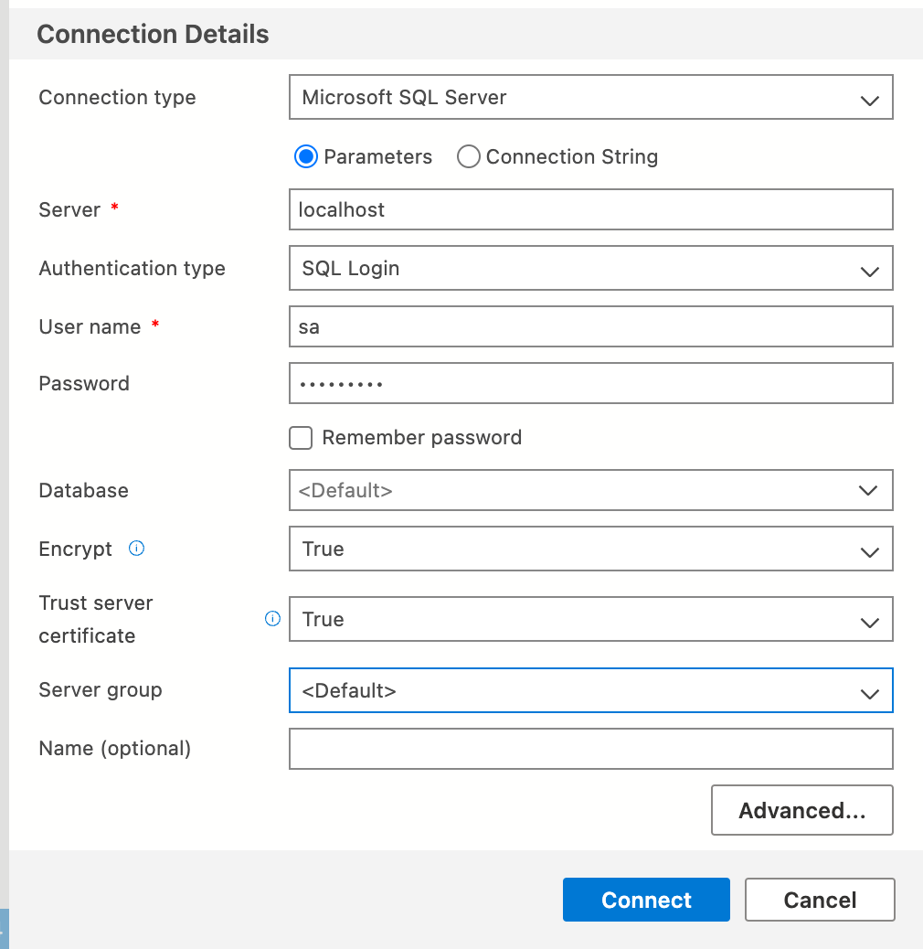

Azure Data studio connection details

Server: - localhost

Username: - sa

Password: - Pawan@123

## ***DESIGN CONSIDERATIONS***

*Table 1: Entity – Attributes*

|  |  |  |
| --- | --- | --- |
| **Table No.** | **Entity** | **Attributes** |
| **1** | **PatientInfo1** | * Id [PK] * LastName * FirstName * HouseNo * Street * PostalCode * City * PhoneNumber * LocationId * PrimaryCarePhysician * DateofBirth * InsuranceNumber [FK] * InsuranceGroupId |
| **2** | **PatientRecords** | * Id [PK] * PatientId [FK] * PatientWeight * PatientHeight * BloodPressure * Temperature * CheckInTime * CheckOutTime * LocationId * Diagnosis * ProcedureId [FK] * EmployeeId [FK] * PhysicianId [FK] * MedicationId [FK] * ImagingTestId [FK] * LabTestId [FK] |
| **3** | **PatientPreScreen1** | * **1**Id [PK] * PatientRecordId [FK] * Temperature * AnySympotoms * Vaccinated |
| **4** | **Admitted Patients1** | * Id [PK] * PatientId [FK] * FacilityId [FK] * AdmitDate |
| **5** | **ProcedureInfo1** | * Id [PK] * ProcedureName * ProcedureDuration * Cost |
| **6** | **MedicationInfo1** | * Id [PK] * PrescriptionId [FK] * MedicationName * Refills * DozesPerDay * Notes |
| **7** | **PrescriptionInfo1** | * Id [PK] * PharmacyId [FK] * Cost * CurrentStatus |
| **8** | **PhysicianInfo1** | * Id [PK] * EmpId [FK] * LicenseNumber [FK] * LocationId * TakingNewPatients * Active * Retired * Position |
| **9** | **PhysicianSchedule1** | * Id [PK] * PhysicianId [FK] * PatientId [FK] * ScheduleDetails [FK] * NurseId [FK] |
| **10** | **ScheduleDetails1** | * Id [PK] * StartTime * Duration * FacilityId [FK] * RoomNumber * EquipmentNeeded |
| **11** | **LicenseInfo1** | * LicenseNumber [PK] * IssuedBy * IssuedOn * ValidTill |
| **12** | **InsuranceInfo1** | * InsuranceNumber [PK] * IssuedBy * IssuedOn * ValidTill * Copay * CovergePercentage * BaseCoverage |
| **13** | **NurseInfo1** | * Id [PK] * EmpId [FK] * LocationId |
| **14** | **EmployeeInfo1** | * Id [PK] * LastName * FirstName [FK] * Street * PostalCode * City * PhoneNumber * DateofBirth * Department |
| **15** | **EmployeeBenefits1** | * EmpId [PK] [FK] * Salary * Benefits * Schedule * ContractTerms |
| **16** | **FacilityInfo1** | * Id [PK] * FacilityName * Street * PostalCode * City * PhoneNumber |
| **17** | **Facilitydetails1** | * Id [PK] * FacilityId [FK] * LocationHours * Departments * RoomsAvailable * ICUBeds * CCUBeds * TraumaCenterAvailability * VentilatorsAvailable * OxygenCylindersAvailable |
| **18** | **PharmacyInfo1** | * Id [PK] * PharmacyName [FK] * LocationHours * RentalEquipment * Street * PostalCode * City |
| **19** | **VisitorInfo** | * Id [PK] * LastName * FirstName * Street * PostalCode * City * PhoneNumber * FacilityId * PatientId * CheckInTime * CheckOutTime * TemperatureAtCheckin |
| **20** | **LabTestInfo** | * Id [PK] * TestName * Cost * PaymentMethod |
| **21** | **LabTestResults1** | * Id [PK] * TestId [FK] * Results * ReportToState * ReportToCounty |
| **22** | **ImagineTestInfo1** | * Id [PK] * TestName * Cost * PaymentMethod |
| **21** | **ImagineTestResults1** | * Id [PK] * TestId [FK] * Results |
| **23** | **Billing1** | * BillingID [PK] * PatientID [FK] * PrescriptioID [FK] * ImagingTestId [FK] * MedicationID [FK] * LabTestID [FK] * BillingDate * BillingAmount |

*\*PK – Primary Key, *FK – Foreign Key*

### ENTITY RELATIONSHIP

This relationship as shown in the figure below is incorporated in the 3NF. There is 20+ tables shown here.

 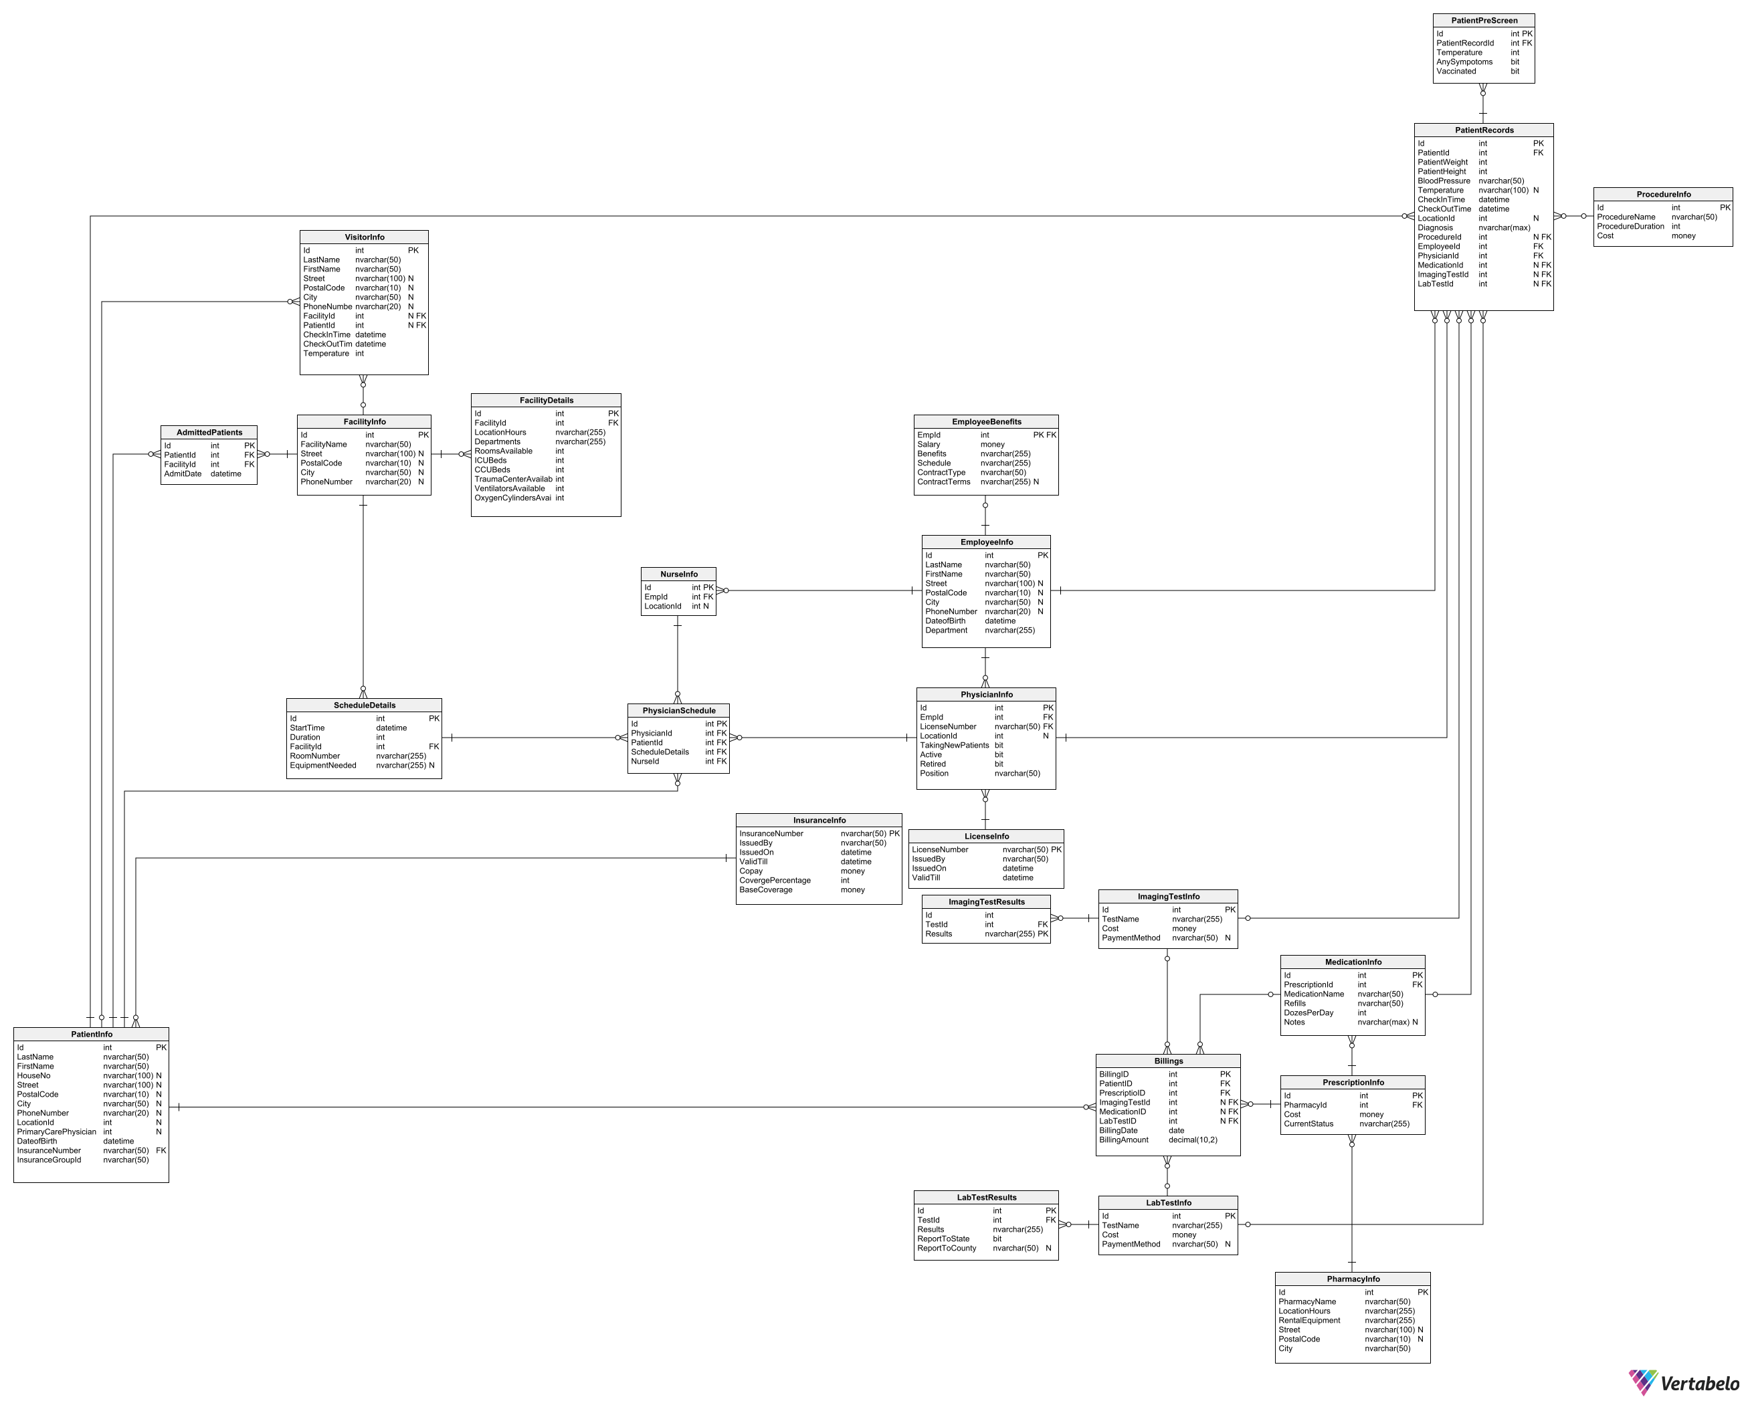

*Figure 2: Entity Relationship Diagram*

#### Choices

The choices which I made for entity and attributes can be shown in the entity relationship diagram which I did make from vertabelo.com, According to the choices made all the relationship between tables is also shown in the ER Diagram. There are a total of 23 tables for my design implementation and then all the tables are normalized into third normal form(3NF).

the University Medical Center database consists of 23 main tables and all the other tables are referenced with them. Those 23 tables are shows as

These are some of the logics and scenarios behind our business decisions for the design implementation.

This SQL script creates a database schema for a university medical center. The schema consists of multiple tables to store information about patients, their medical records, procedures, medications, physicians, nurses, employees, facilities, and more. Here is a brief overview of each table

- PatientInfo: stores information about patients, including their names, addresses, phone numbers, date of birth, and insurance information.

- PatientRecords: stores medical records for patients, including vital signs, diagnoses, procedures, medications, imaging and lab tests, and more.

- PatientPreScreen: stores pre-screening information for patients before they are admitted, including temperature, symptoms, and vaccination status.

- AdmittedPatients: stores information about patients who have been admitted to a facility, including the date of admission and the facility they were admitted to.

- ProcedureInfo: stores information about medical procedures, including their names, duration, and cost.

- MedicationInfo: stores information about medications prescribed to patients, including their names, refill information, and dosages.

- PrescriptionInfo: stores information about prescriptions, including the pharmacy they were filled at, the cost, and the current status.

- PhysicianInfo: stores information about physicians, including their license numbers, location, availability, and position.

- PhysicianSchedule: stores information about physician schedules, including their patients, schedule details, and nurse assignments.

- ScheduleDetails: stores information about schedule details, including start times, durations, facilities, and equipment needed.

- LicenseInfo: stores information about medical licenses, including the issuing organization, dates, and validity.

- InsuranceInfo: stores information about insurance policies, including their coverage and copay amounts, as well as their validity dates.

- NurseInfo: stores information about nurses, including their locations and employee IDs.

- EmployeeInfo: stores information about employees, including their names, addresses, phone numbers, date of birth, department, and more.

- EmployeeBenefits: stores information about employee benefits, including salaries, benefits packages, and contract details.

- FacilityInfo: stores information about facilities, including their names, addresses, and phone numbers.

* The schema is designed to support a wide range of operations and queries for managing patient care, medical procedures, and staffing. The tables are linked through various foreign key relationships, allowing for complex joins and queries.
* This is a SQL script that creates several tables to store information related to a medical center. The tables include PatientInfo, PatientRecords, PatientPreScreen, AdmittedPatients, ProcedureInfo, MedicationInfo, PrescriptionInfo, PhysicianInfo, PhysicianSchedule, ScheduleDetails, LicenseInfo, InsuranceInfo, NurseInfo, EmployeeInfo, and FacilityInfo.
* The PatientInfo table stores basic patient information such as name, address, phone number, date of birth, insurance number, and group ID. The PatientRecords table stores medical records for each patient, including their weight, height, blood pressure, temperature, check-in time, check-out time, diagnosis, and procedure information.
* The PatientPreScreen table stores information about pre-screening tests that patients undergo, including their temperature, any symptoms they have, and whether they have been vaccinated. The AdmittedPatients table stores information about patients who have been admitted to a facility, including their admission date and the facility they were admitted to.
* The ProcedureInfo table stores information about medical procedures, including their name, duration, and cost. The MedicationInfo table stores information about medications, including their name, dosage, and any notes. The PrescriptionInfo table stores information about prescriptions, including their cost and current status.
* The PhysicianInfo table stores information about physicians, including their employee ID, license number, location, whether they are accepting new patients, and their position. The PhysicianSchedule table stores information about physician schedules, including their ID, patient ID, schedule details, and nurse ID.
* The ScheduleDetails table stores information about schedules, including start time, duration, facility ID, room number, and any necessary equipment. The LicenseInfo table stores information about physician licenses, including their license number, the agency that issued the license, and its validity period.
* The InsuranceInfo table stores information about insurance plans, including the insurance number, the agency that issued the plan, its validity period, copay, coverage percentage, and base coverage. The NurseInfo table stores information about nurses, including their employee ID and location.
* The EmployeeInfo table stores information about employees, including their name, address, phone number, date of birth, and department. The EmployeeBenefits table stores information about employee benefits, including their salary, benefits package, work schedule, and contract terms.
* Finally, the FacilityInfo table stores information about medical facilities, including their name, address, and phone number.

To understand **business reliability and logic**, let's look at some scenarios.

* All IDs for any table need to be unique as they act as either the primary keys or foreign keys. So using UNIQUE ***constraint*** is important. Another constraint to be considered is NOT NULL. empty values have a negative effect on the database, hence, NOT NULL is also an important constraint.
* We will be using **views** to handle scenarios like the total cost billed to each patient, how many days each patient has been checked into the hospital or to find out the top 5 employees at UMC. Data might also be as full name and would be required to be split into first name and last name for the administration. We will be using views to achieve these.
* We might need to check if any patients are at the hospital or are checked in during a given time period or may need to find staff within a desired salary range. For these purposes, we will be using ***stored procedures.*** These procedures can be used for business analysis. We will also create user-defined ***functions*** to perform various operations on the database.
* To deal with correction during insertion of values into tables or to handle missing or empty values, we will use ***triggers***. Any time such an insert query is written it will fire a trigger to handle these errors/issues.
* Suppose we want to make sure that values from a table are not deleted accidentally, we will use ***transactions*** to CATCH the query that deletes the rows and ROLLBACK ensuring it doesn’t happen. This maintains the integrity of the tables.
* We will also use ***scripts*** to grant different permissions to insert, update etc to certain users with given roles only. Thus, creating different security levels. Scripts will also include queries to password protect the database with login information.

SECTION B:

IMPLEMENTATION OF THE DATABASE

In this phase, the following is **achieved**:

* The tables, columns, primary keys, data types, nullabilities, and relationships are determined

● The design is normalized into its 3rd Normal Form.

* And, potential integrity and security issues are also addressed
* **CREATING A DATABASE**

**Source Code: -**

USE master

GO

IF DB_ID('UniversityMedicalCenter') IS NOT NULL

DROP DATABASE UniversityMedicalCenter;

GO

CREATE DATABASE UniversityMedicalCenter;

GO

**Output: -**

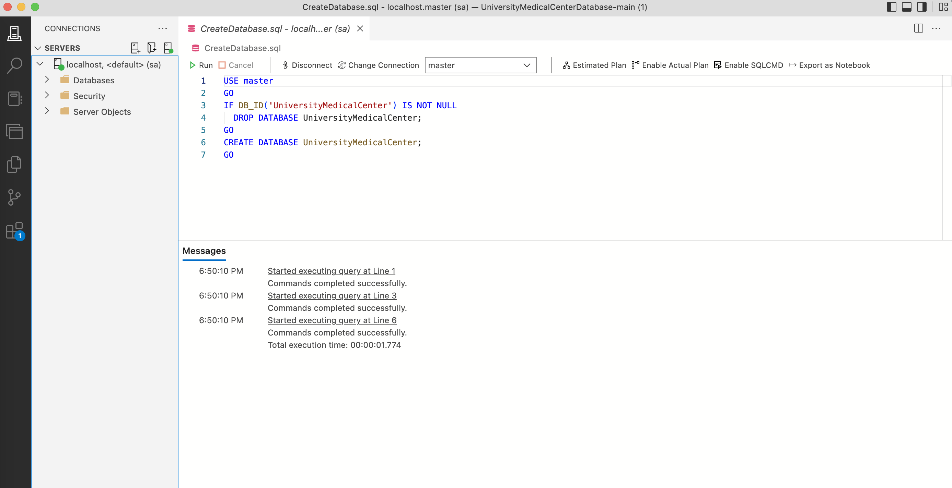

**Remarks: -**

* Here, I have created a new database the sql code for the creating a database is posted above as well as the output and the screenshot of the given code
* You can see all the changes, query and the output in the screenshot provided above.
* **CREATING ALL THE TABLES**

**Source Code: -**

USE universityMedicalCenter;

GO

CREATE TABLE PatientInfo (

Id int NOT NULL,

LastName nvarchar(50) NOT NULL,

FirstName nvarchar(50) NOT NULL,

HouseNo nvarchar(100) NULL,

Street nvarchar(100) NULL,

PostalCode nvarchar(10) NULL,

City nvarchar(50) NULL,

PhoneNumber nvarchar(20) NULL,

LocationId int NULL,

PrimaryCarePhysician int NULL,

DateofBirth datetime NOT NULL,

InsuranceNumber nvarchar(50) NOT NULL,

InsuranceGroupId nvarchar(50) NOT NULL,

CONSTRAINT PK_PatientInfo PRIMARY KEY (Id)

);

**Output: -**

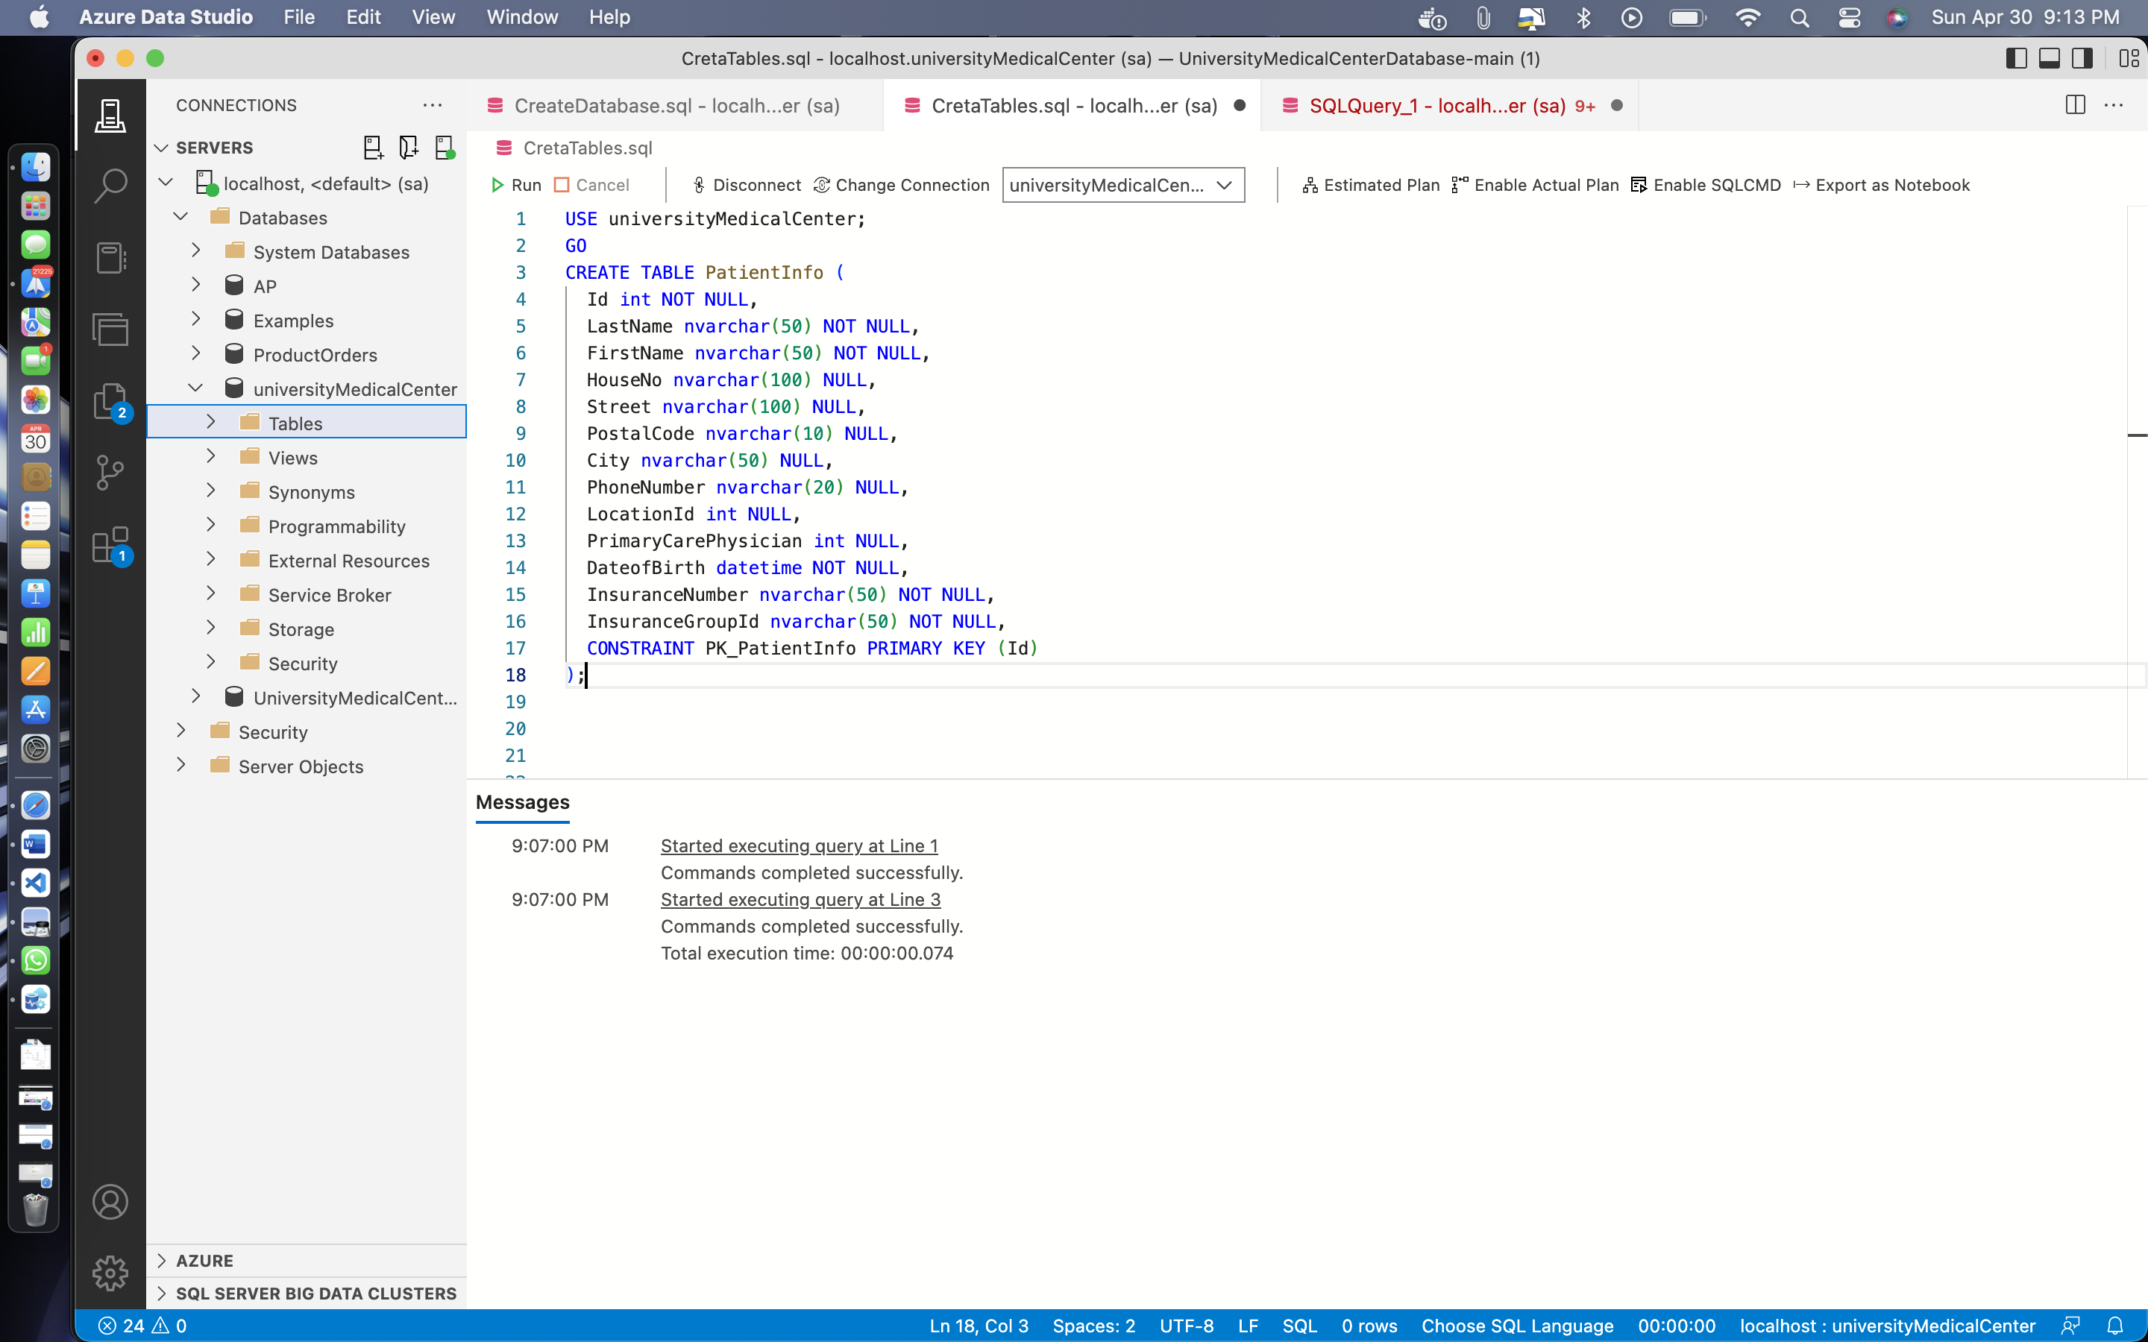

CREATE TABLE PatientRecords (

Id int IDENTITY (1, 1) NOT NULL,

PatientId int NOT NULL,

PatientWeight int NOT NULL,

PatientHeight int NOT NULL,

BloodPressure nvarchar(50) NOT NULL,

Temperature nvarchar(100) NULL,

CheckInTime datetime NOT NULL,

CheckOutTime datetime NOT NULL,

LocationId int NULL,

Diagnosis nvarchar(max) NOT NULL,

ProcedureId int NULL,

EmployeeId int NOT NULL,

PhysicianId int NOT NULL,

MedicationId int NULL,

ImagingTestId int NULL,

LabTestId int NULL,

CONSTRAINT PK_PatientRecords PRIMARY KEY (Id)

);

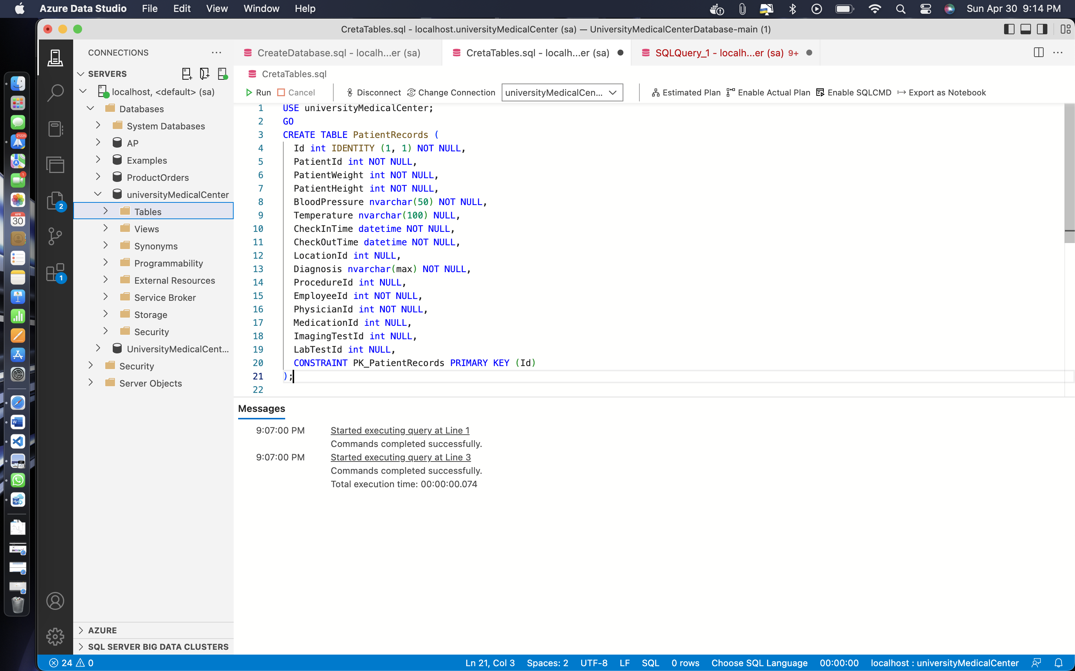

CREATE TABLE PatientPreScreen (

Id int IDENTITY (1, 1) NOT NULL,

PatientRecordId int NOT NULL,

Temperature int NOT NULL,

AnySympotoms bit NOT NULL,

Vaccinated bit NOT NULL,

CONSTRAINT PK_PatientPreScreen PRIMARY KEY (Id)

);

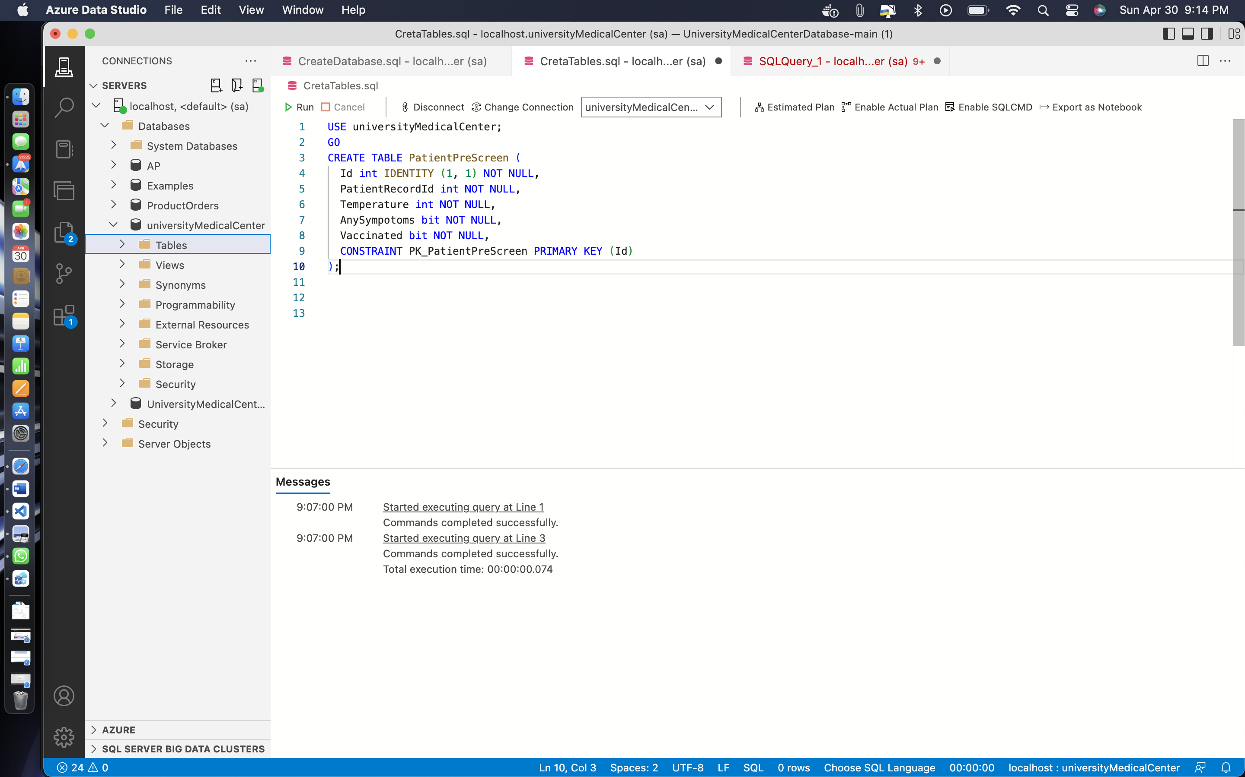

CREATE TABLE AdmittedPatients (

Id int IDENTITY (1, 1) NOT NULL,

PatientId int NOT NULL,

FacilityId int NOT NULL,

AdmitDate datetime NOT NULL,

CONSTRAINT PK_AdmittedPatients PRIMARY KEY (Id)

);

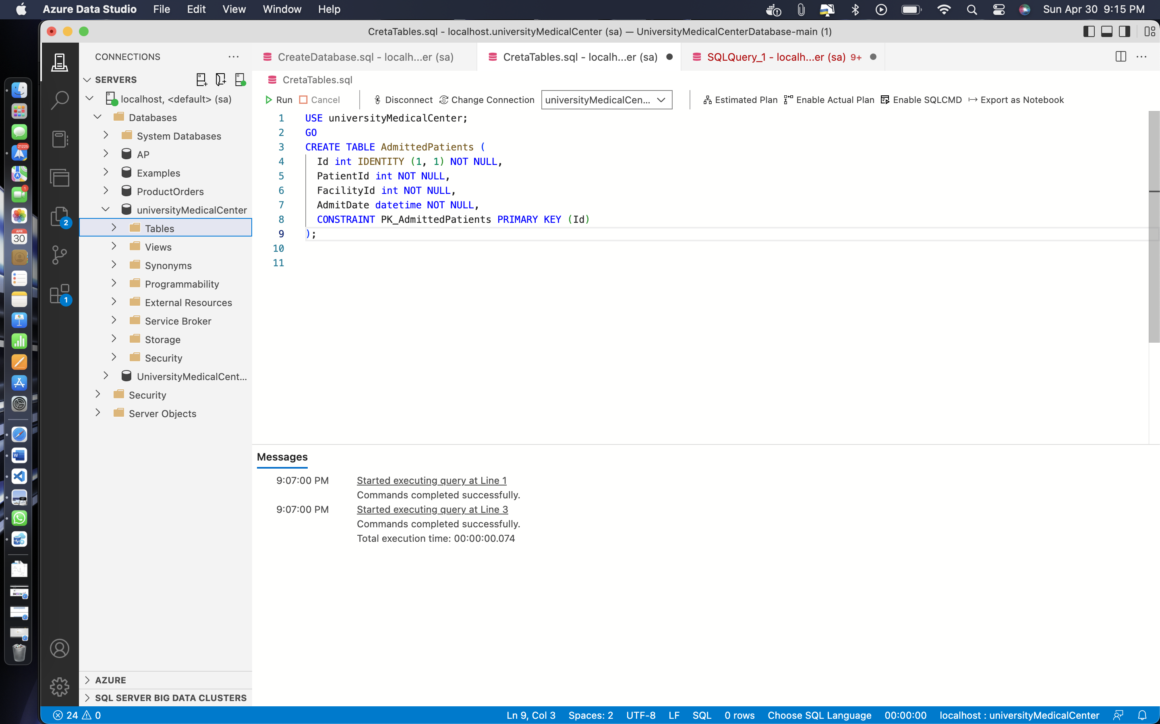

CREATE TABLE ProcedureInfo (

Id int NOT NULL,

ProcedureName nvarchar(50) NOT NULL,

ProcedureDuration int NOT NULL,

Cost money NOT NULL,

CONSTRAINT PK_ProcedureInfo PRIMARY KEY (Id)

);

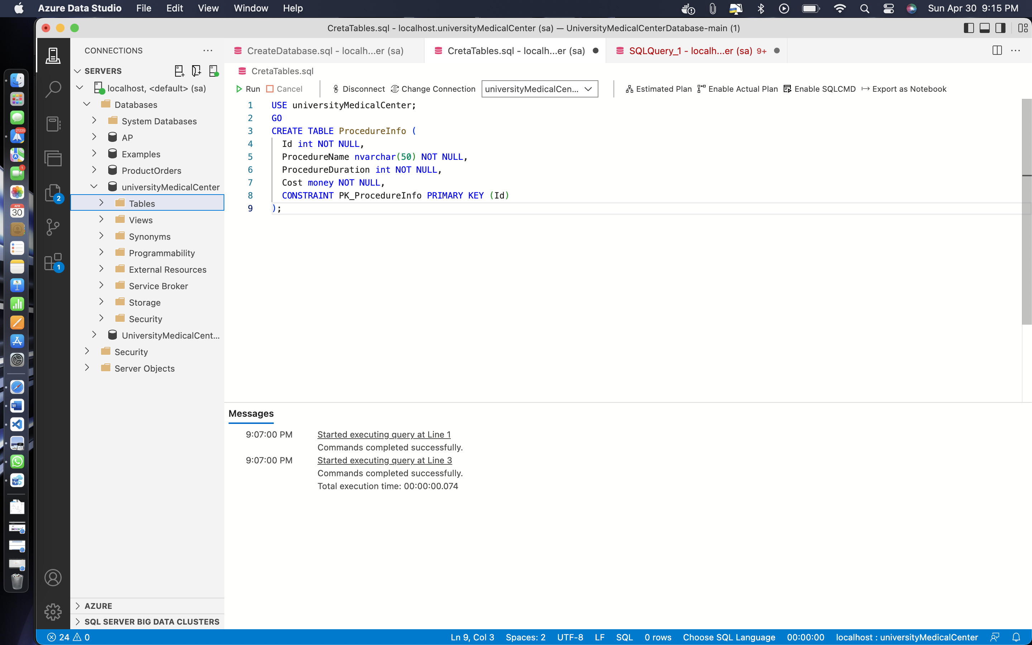

CREATE TABLE MedicationInfo (

Id int NOT NULL,

PrescriptionId int NOT NULL,

MedicationName nvarchar(50) NOT NULL,

Refills nvarchar(50) NOT NULL,

DozesPerDay int NOT NULL,

Notes nvarchar(max) NULL,

CONSTRAINT PK_MedicationInfo PRIMARY KEY (Id)

);

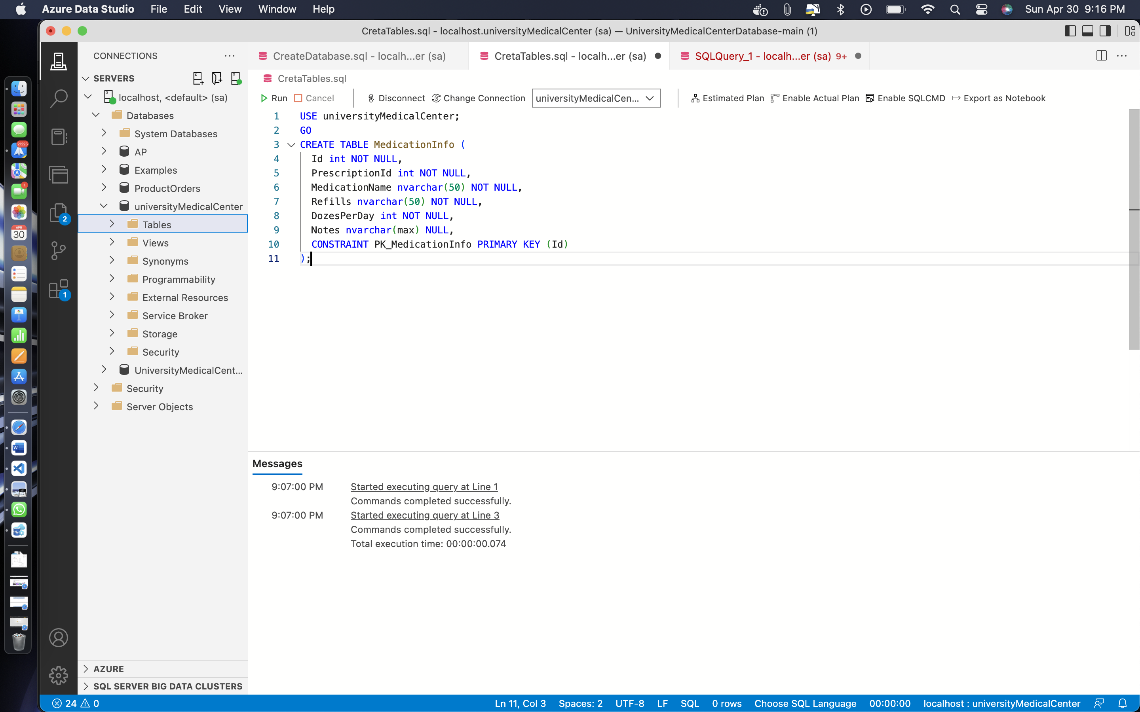

CREATE TABLE PrescriptionInfo (

Id int NOT NULL,

PharmacyId int NOT NULL,

Cost money NOT NULL,

CurrentStatus nvarchar(255) NOT NULL,

CONSTRAINT PK_PrescriptionInfo PRIMARY KEY (Id)

);

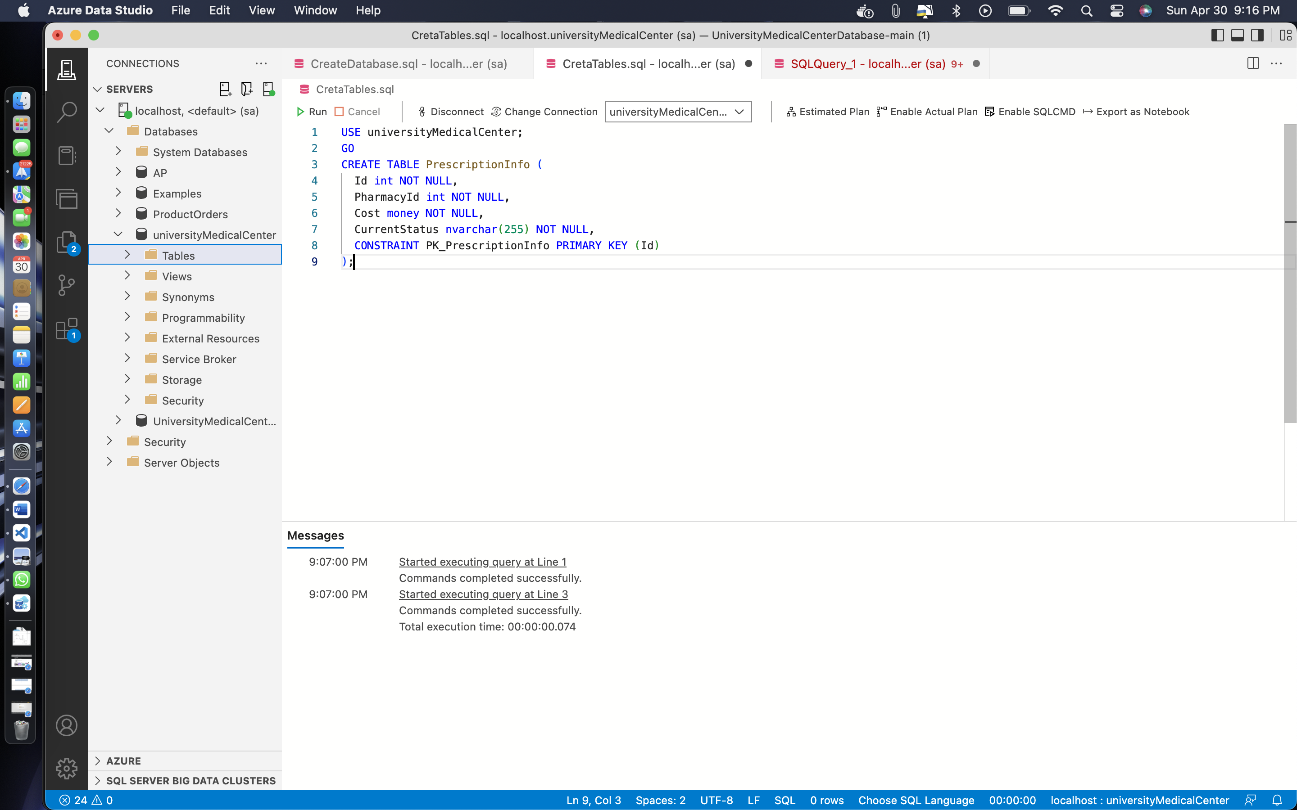

CREATE TABLE PhysicianInfo (

Id int NOT NULL,

EmpId int NOT NULL,

LicenseNumber nvarchar(50) NOT NULL,

LocationId int NULL,

TakingNewPatients bit NOT NULL,

Active bit NOT NULL,

Retired bit NOT NULL,

Position nvarchar(50) NOT NULL,

CONSTRAINT PK_PhysicianInfo PRIMARY KEY (Id)

);

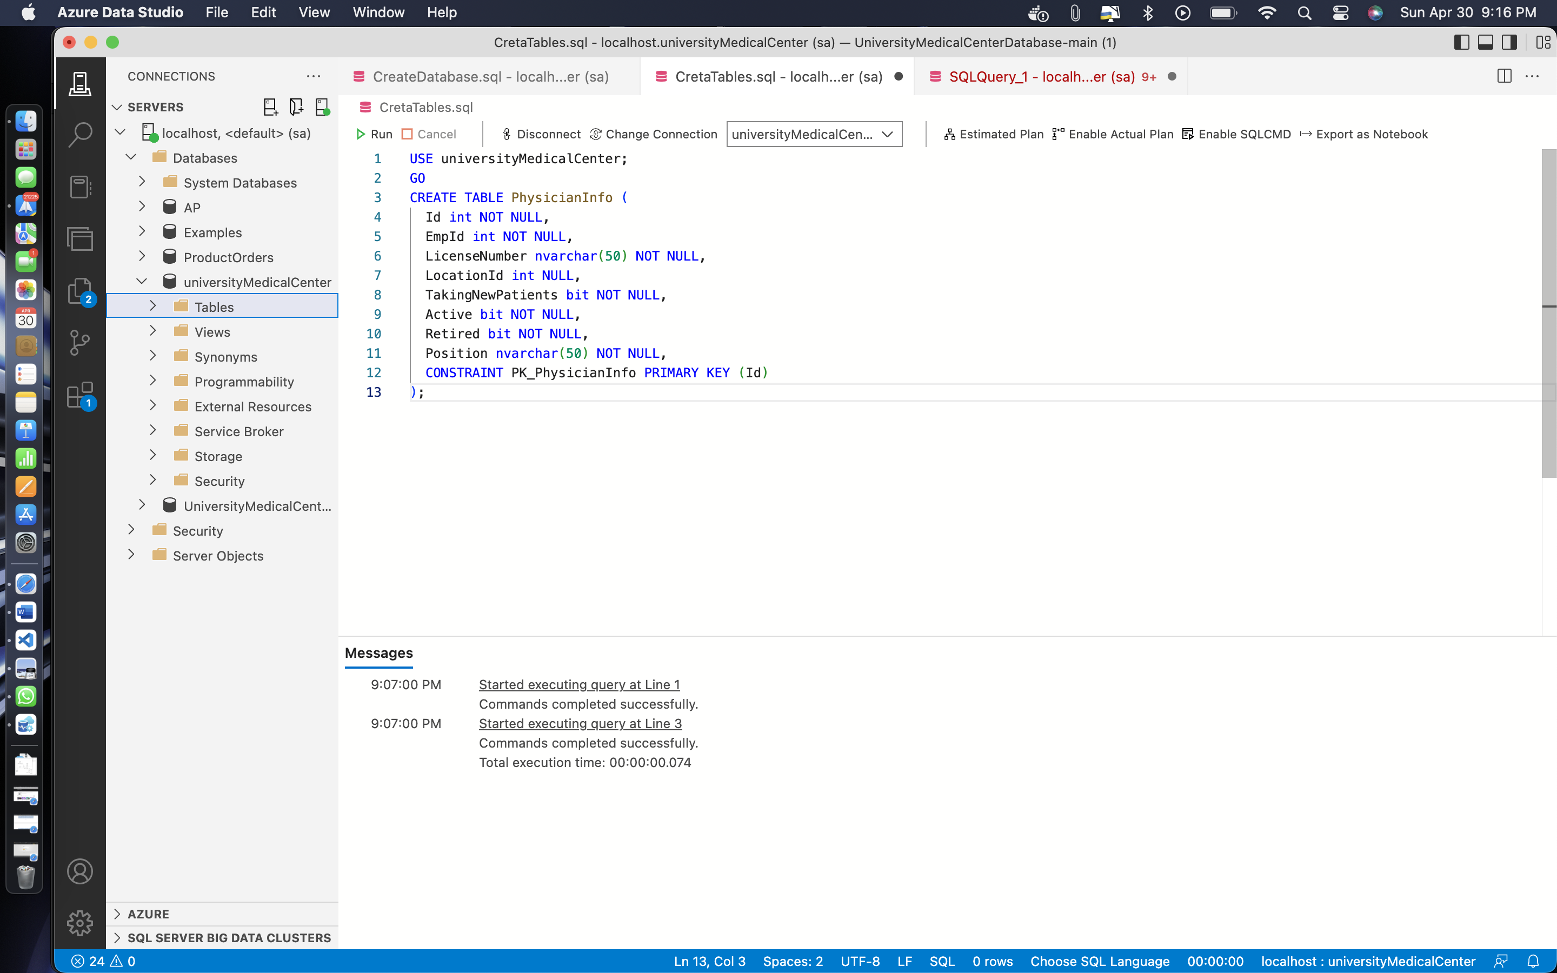

CREATE TABLE PhysicianSchedule (

Id int IDENTITY (1, 1) NOT NULL,

PhysicianId int NOT NULL,

PatientId int NOT NULL,

ScheduleDetails int NOT NULL,

NurseId int NOT NULL,

CONSTRAINT PK_PhysicianSchedule PRIMARY KEY (Id)

);

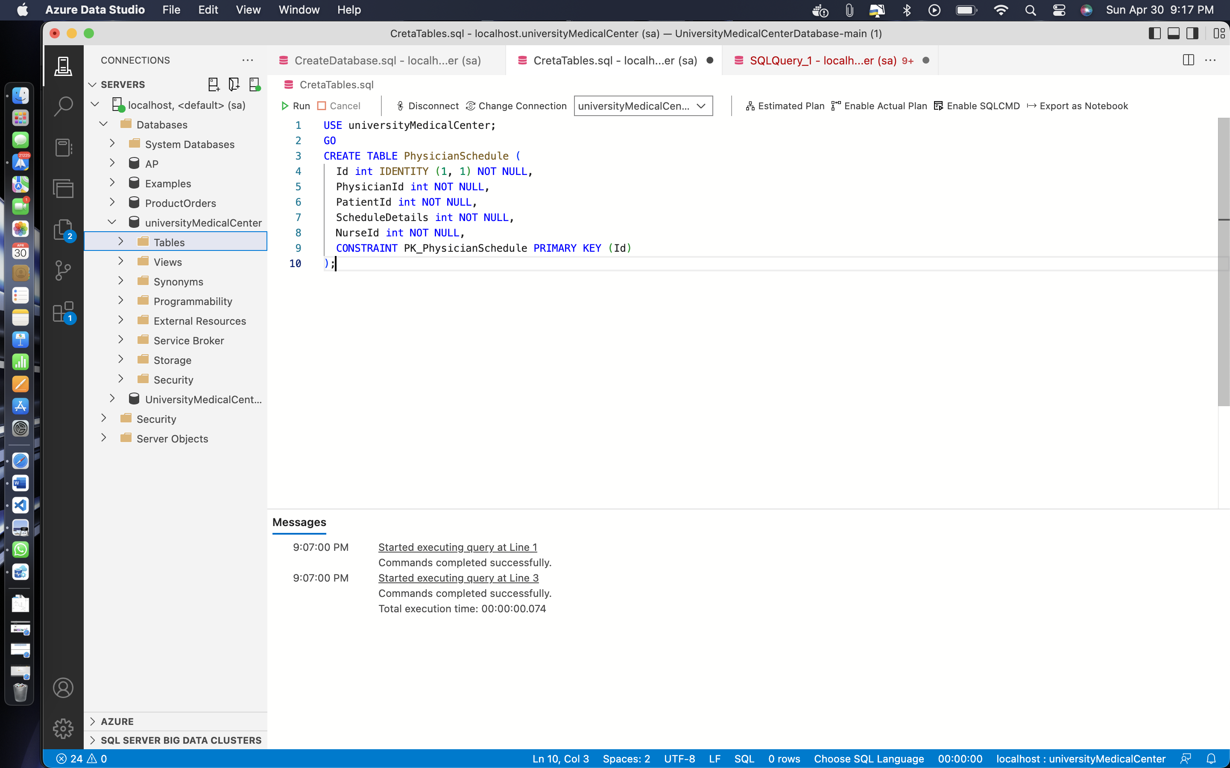

CREATE TABLE ScheduleDetails (

Id int IDENTITY (1, 1) NOT NULL,

StartTime datetime NOT NULL,

Duration int NOT NULL,

FacilityId int NOT NULL,

RoomNumber nvarchar(255) NOT NULL,

EquipmentNeeded nvarchar(255) NULL,

CONSTRAINT PK_ScheduleDetails PRIMARY KEY (Id)

);

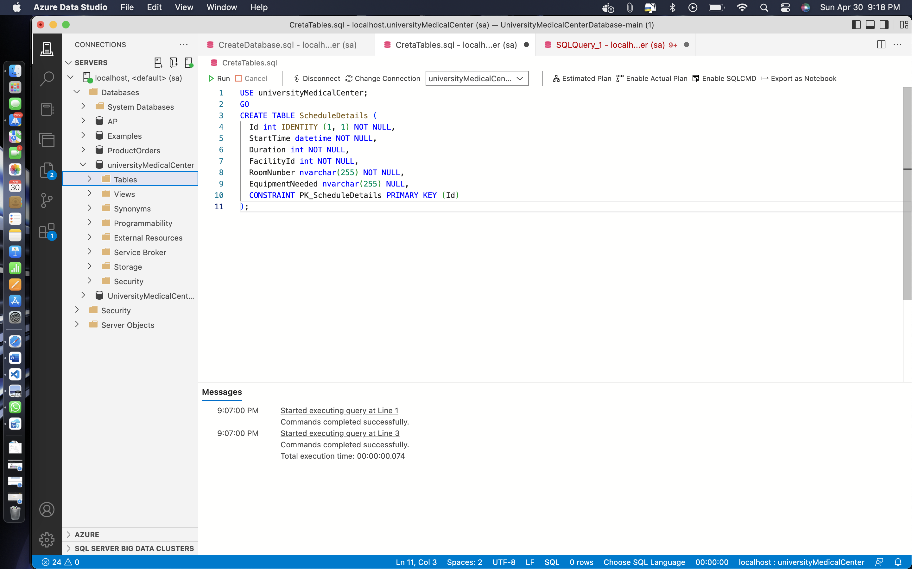

CREATE TABLE LicenseInfo (

LicenseNumber nvarchar(50) NOT NULL,

IssuedBy nvarchar(50) NOT NULL,

IssuedOn datetime NOT NULL,

ValidTill datetime NOT NULL,

CONSTRAINT PK_LicenseInfo PRIMARY KEY (LicenseNumber)

);

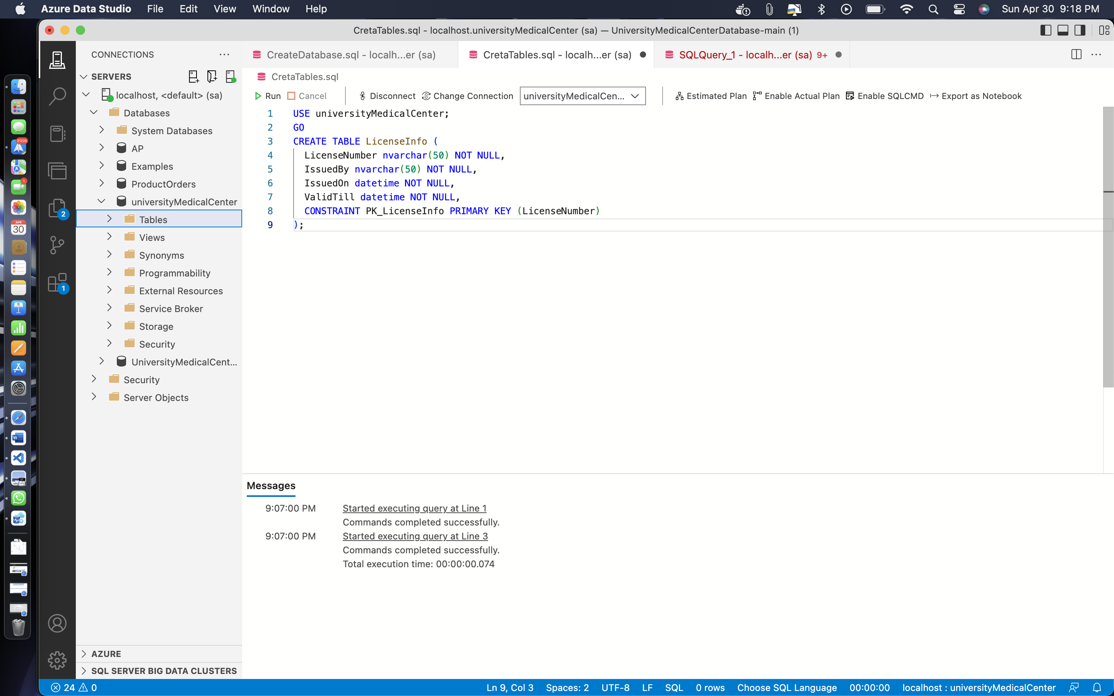

CREATE TABLE InsuranceInfo (

InsuranceNumber nvarchar(50) NOT NULL,

IssuedBy nvarchar(50) NOT NULL,

IssuedOn datetime NOT NULL,

ValidTill datetime NOT NULL,

Copay money NOT NULL,

CovergePercentage int NOT NULL,

BaseCoverage money NOT NULL,

CONSTRAINT PK_InsuranceInfo PRIMARY KEY (InsuranceNumber)

);

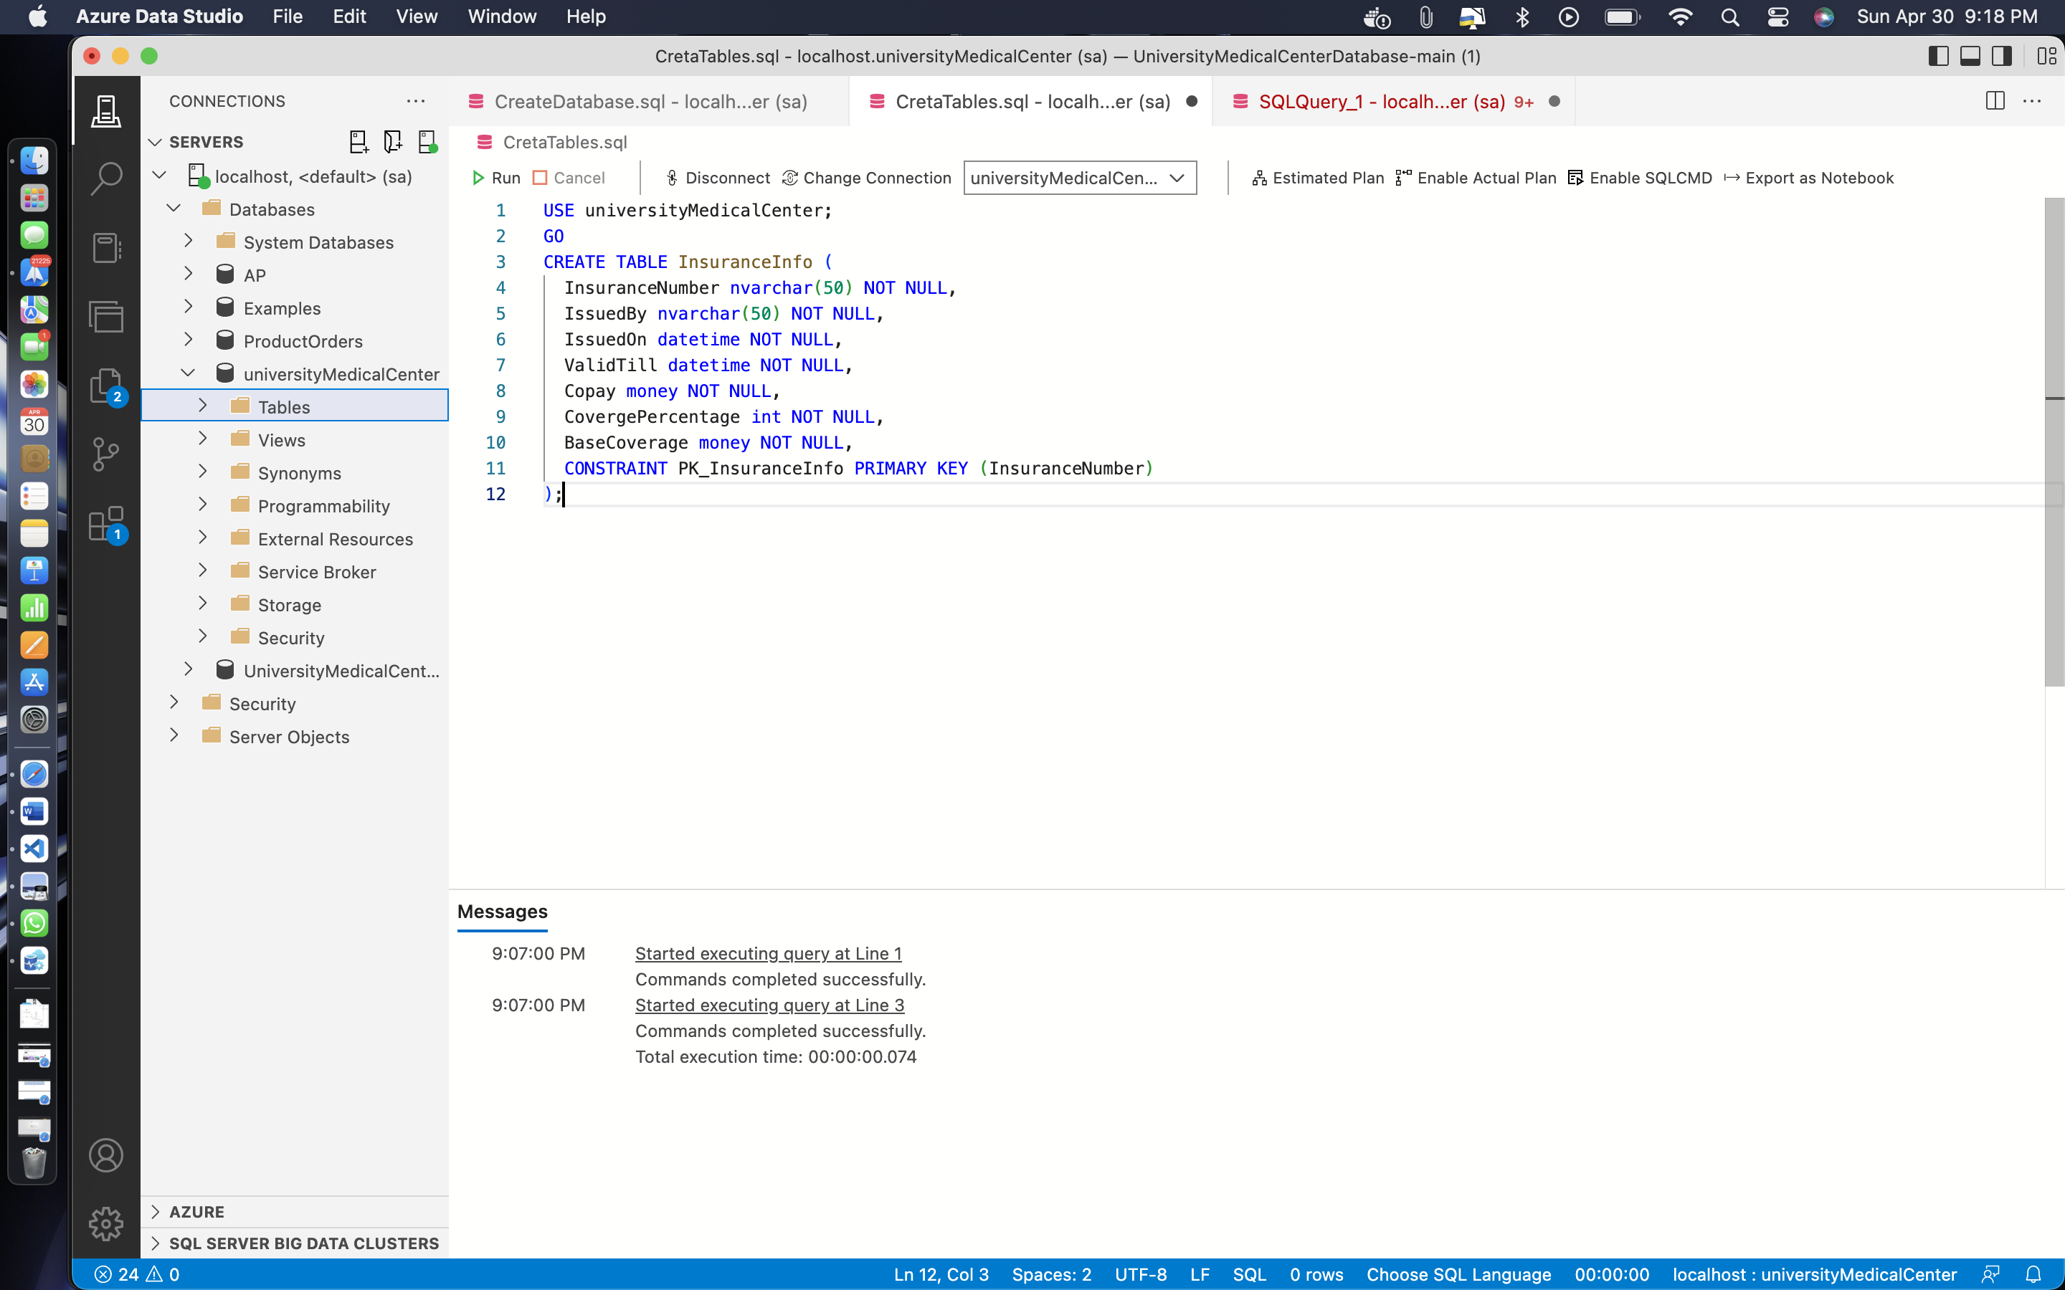

CREATE TABLE NurseInfo (

Id int NOT NULL,

EmpId int NOT NULL,

LocationId int NULL,

CONSTRAINT PK_NurseInfo PRIMARY KEY (Id)

);

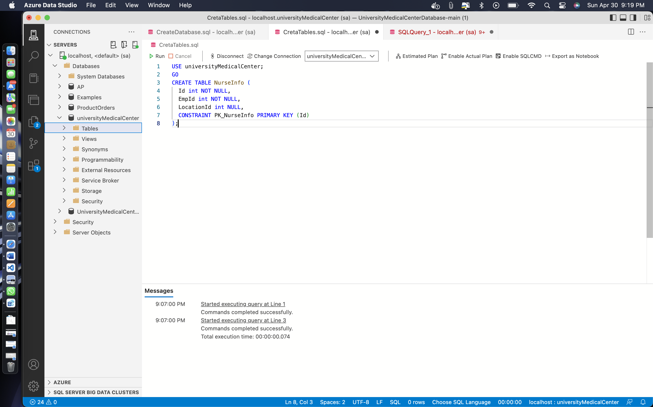

CREATE TABLE EmployeeInfo (

Id int NOT NULL,

LastName nvarchar(50) NOT NULL,

FirstName nvarchar(50) NOT NULL,

Street nvarchar(100) NULL,

PostalCode nvarchar(10) NULL,

City nvarchar(50) NULL,

PhoneNumber nvarchar(20) NULL,

DateofBirth datetime NOT NULL,

Department nvarchar(255) NOT NULL,

CONSTRAINT PK_EmployeeInfo PRIMARY KEY (Id)

);

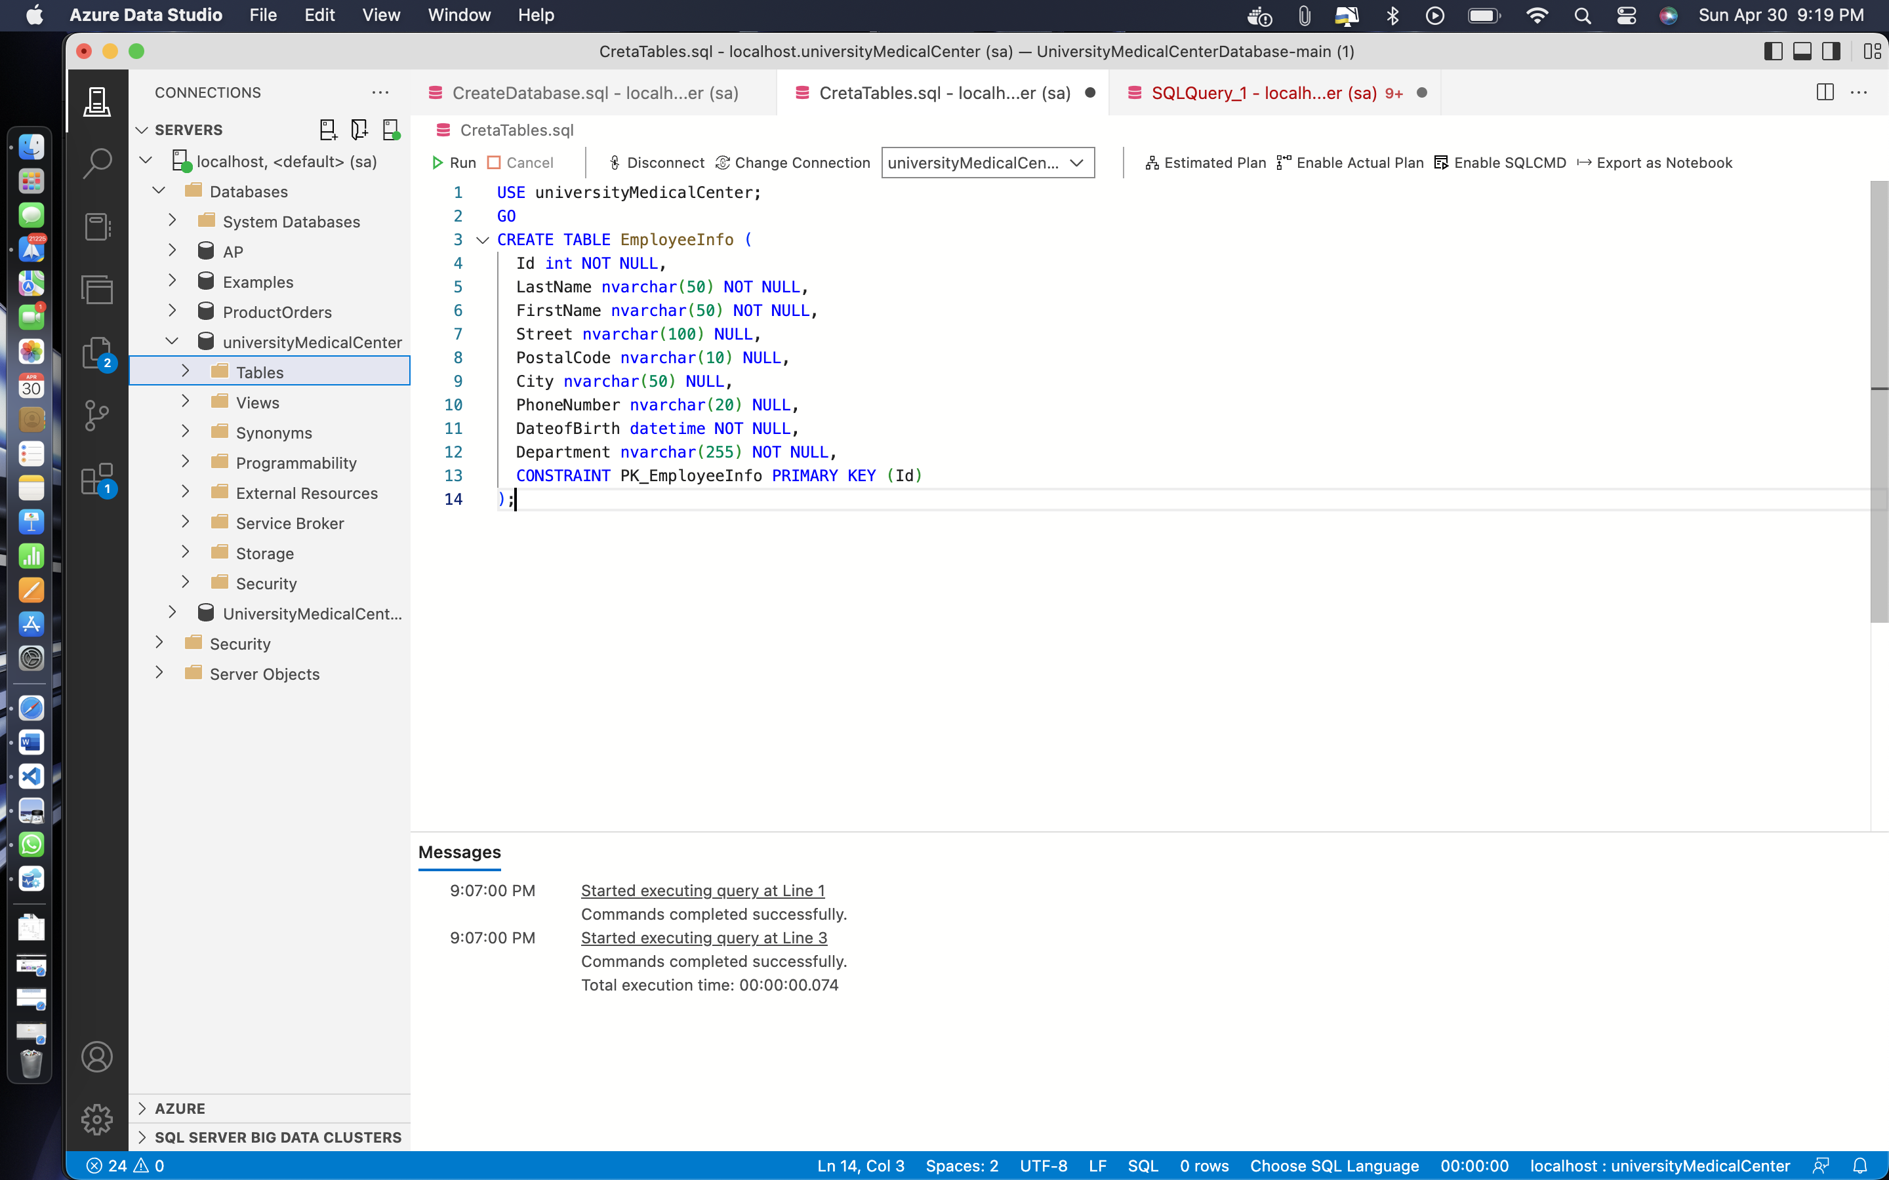

CREATE TABLE EmployeeBenefits (

EmpId int NOT NULL,

Salary money NOT NULL,

Benefits nvarchar(255) NOT NULL,

Schedule nvarchar(255) NOT NULL,

ContractType nvarchar(50) NOT NULL,

ContractTerms nvarchar(255) NULL,

CONSTRAINT PK_EmployeeBenefits PRIMARY KEY (EmpId)

);

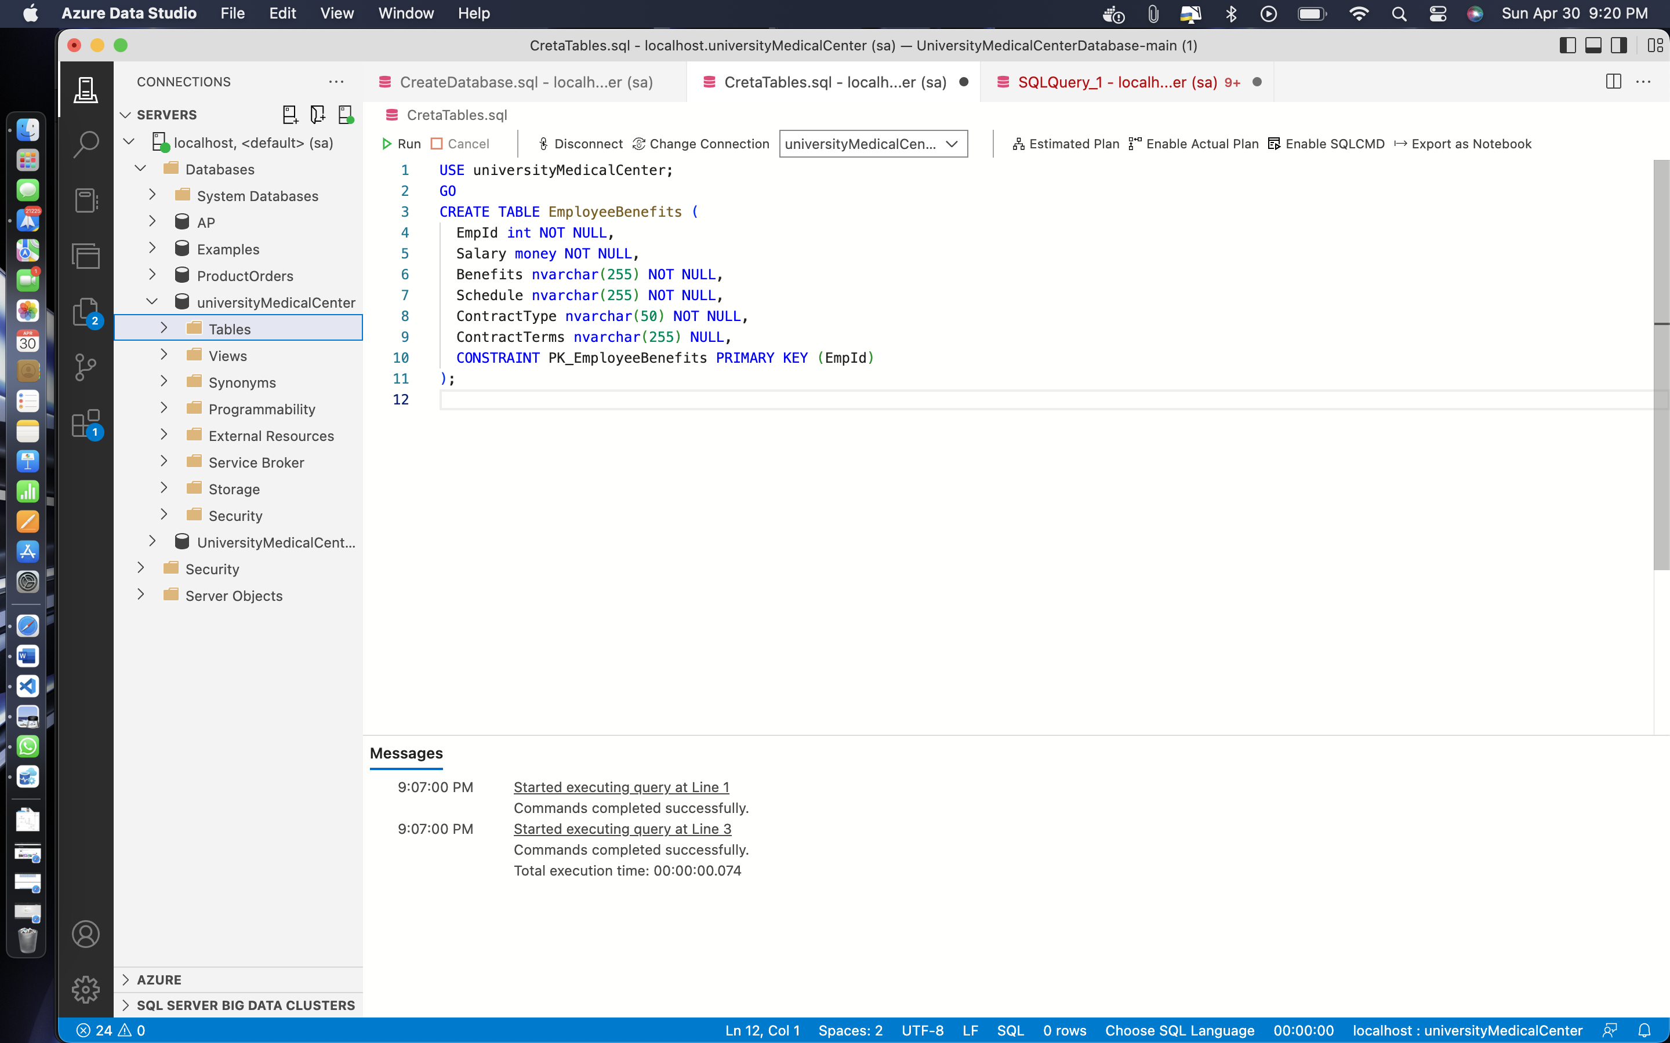

CREATE TABLE FacilityInfo (

Id int NOT NULL,

FacilityName nvarchar(50) NOT NULL,

Street nvarchar(100) NULL,

PostalCode nvarchar(10) NULL,

City nvarchar(50) NULL,

PhoneNumber nvarchar(20) NULL,

CONSTRAINT PK_FacilityInfo PRIMARY KEY (Id)

);

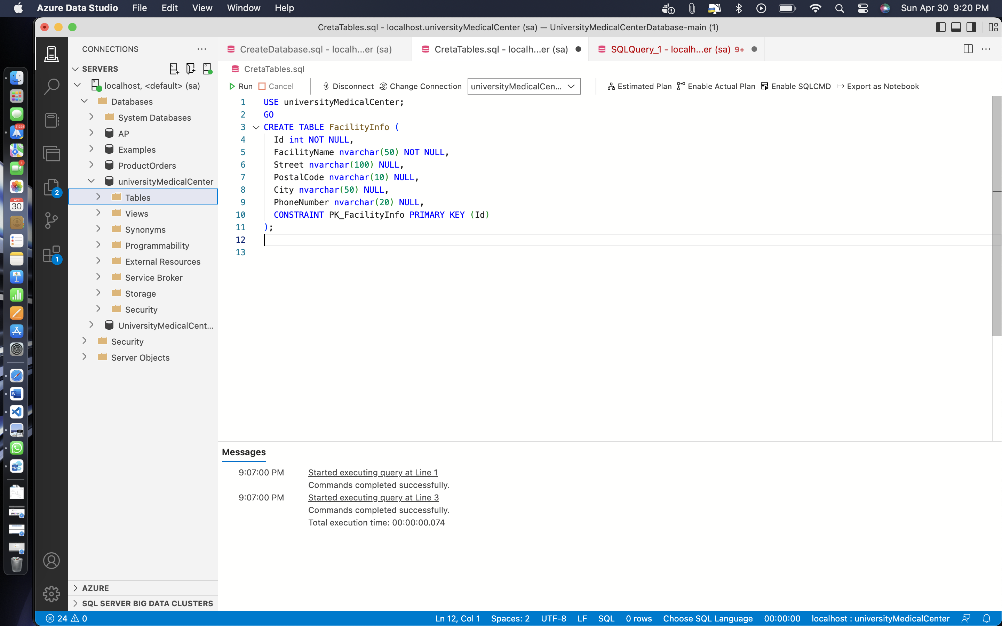

CREATE TABLE FacilityDetails (

Id int NOT NULL,

FacilityId int NOT NULL,

LocationHours nvarchar(255) NOT NULL,

Departments nvarchar(255) NOT NULL,

RoomsAvailable int NOT NULL,

ICUBeds int NOT NULL,

CCUBeds int NOT NULL,

TraumaCenterAvailability int NOT NULL,

VentilatorsAvailable int NOT NULL,

OxygenCylindersAvailable int NOT NULL,

CONSTRAINT PK_FacilityDetails PRIMARY KEY (Id)

);

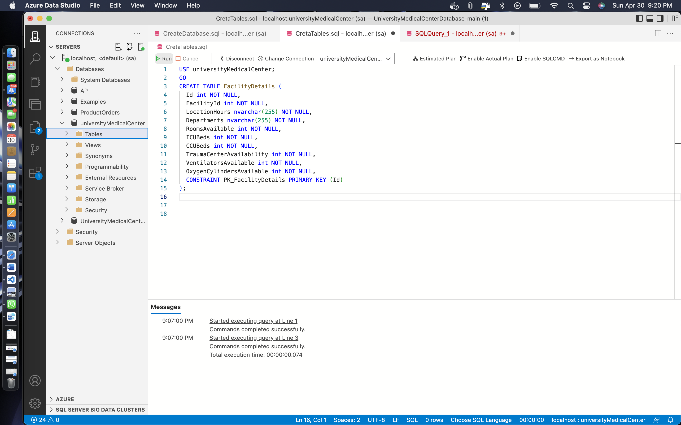

CREATE TABLE PharmacyInfo (

Id int NOT NULL,

PharmacyName nvarchar(50) NOT NULL,

LocationHours nvarchar(255) NOT NULL,

RentalEquipment nvarchar(255) NOT NULL,

Street nvarchar(100) NULL,

PostalCode nvarchar(10) NULL,

City nvarchar(50) NULL

CONSTRAINT PK_PharmacyInfo PRIMARY KEY (Id)

);

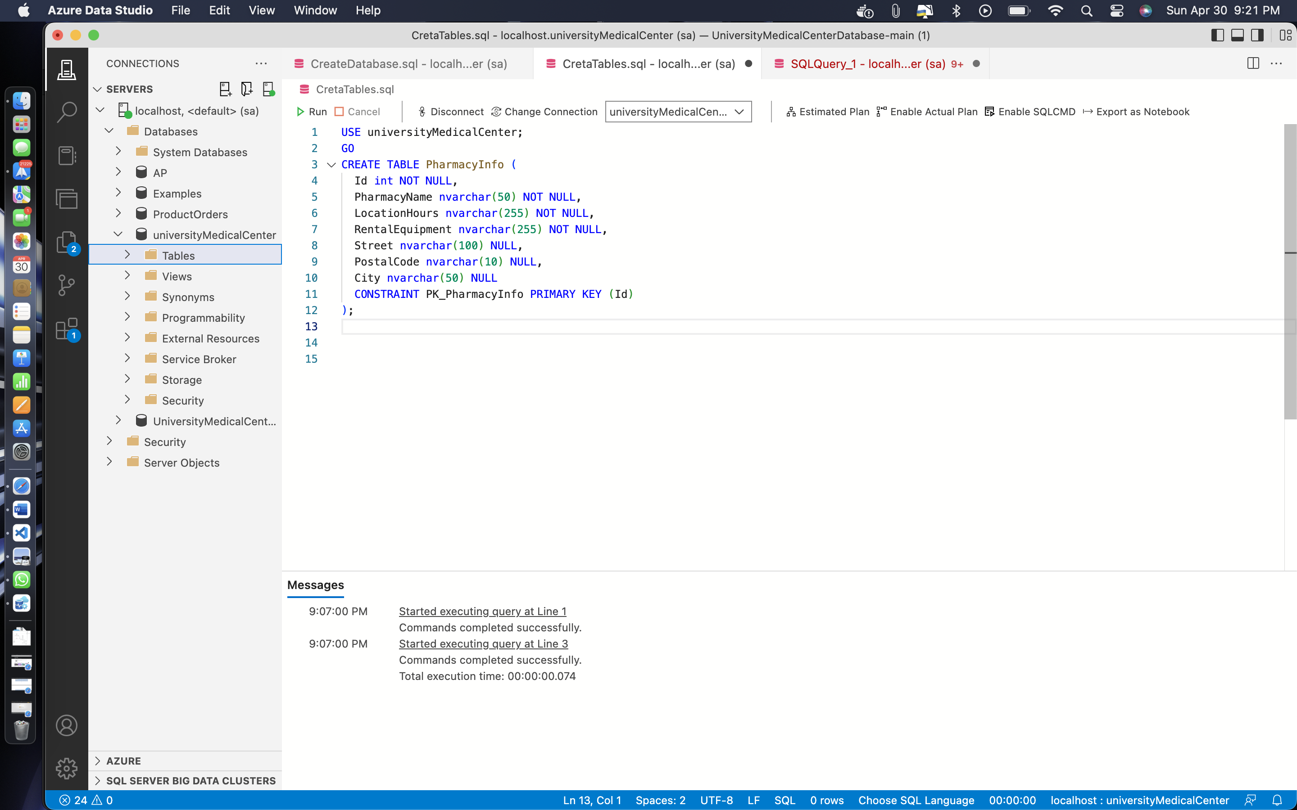

CREATE TABLE VisitorInfo (

Id int IDENTITY (1, 1) NOT NULL,

LastName nvarchar(50) NOT NULL,

FirstName nvarchar(50) NOT NULL,

Street nvarchar(100) NULL,

PostalCode nvarchar(10) NULL,

City nvarchar(50) NULL,

PhoneNumber nvarchar(20) NULL,

FacilityId int NULL,

PatientId int NULL,

CheckInTime datetime NOT NULL,

CheckOutTime datetime NOT NULL,

TemperatureAtCheckin int NOT NULL,

CONSTRAINT PK_VisitorInfo PRIMARY KEY (Id)

);

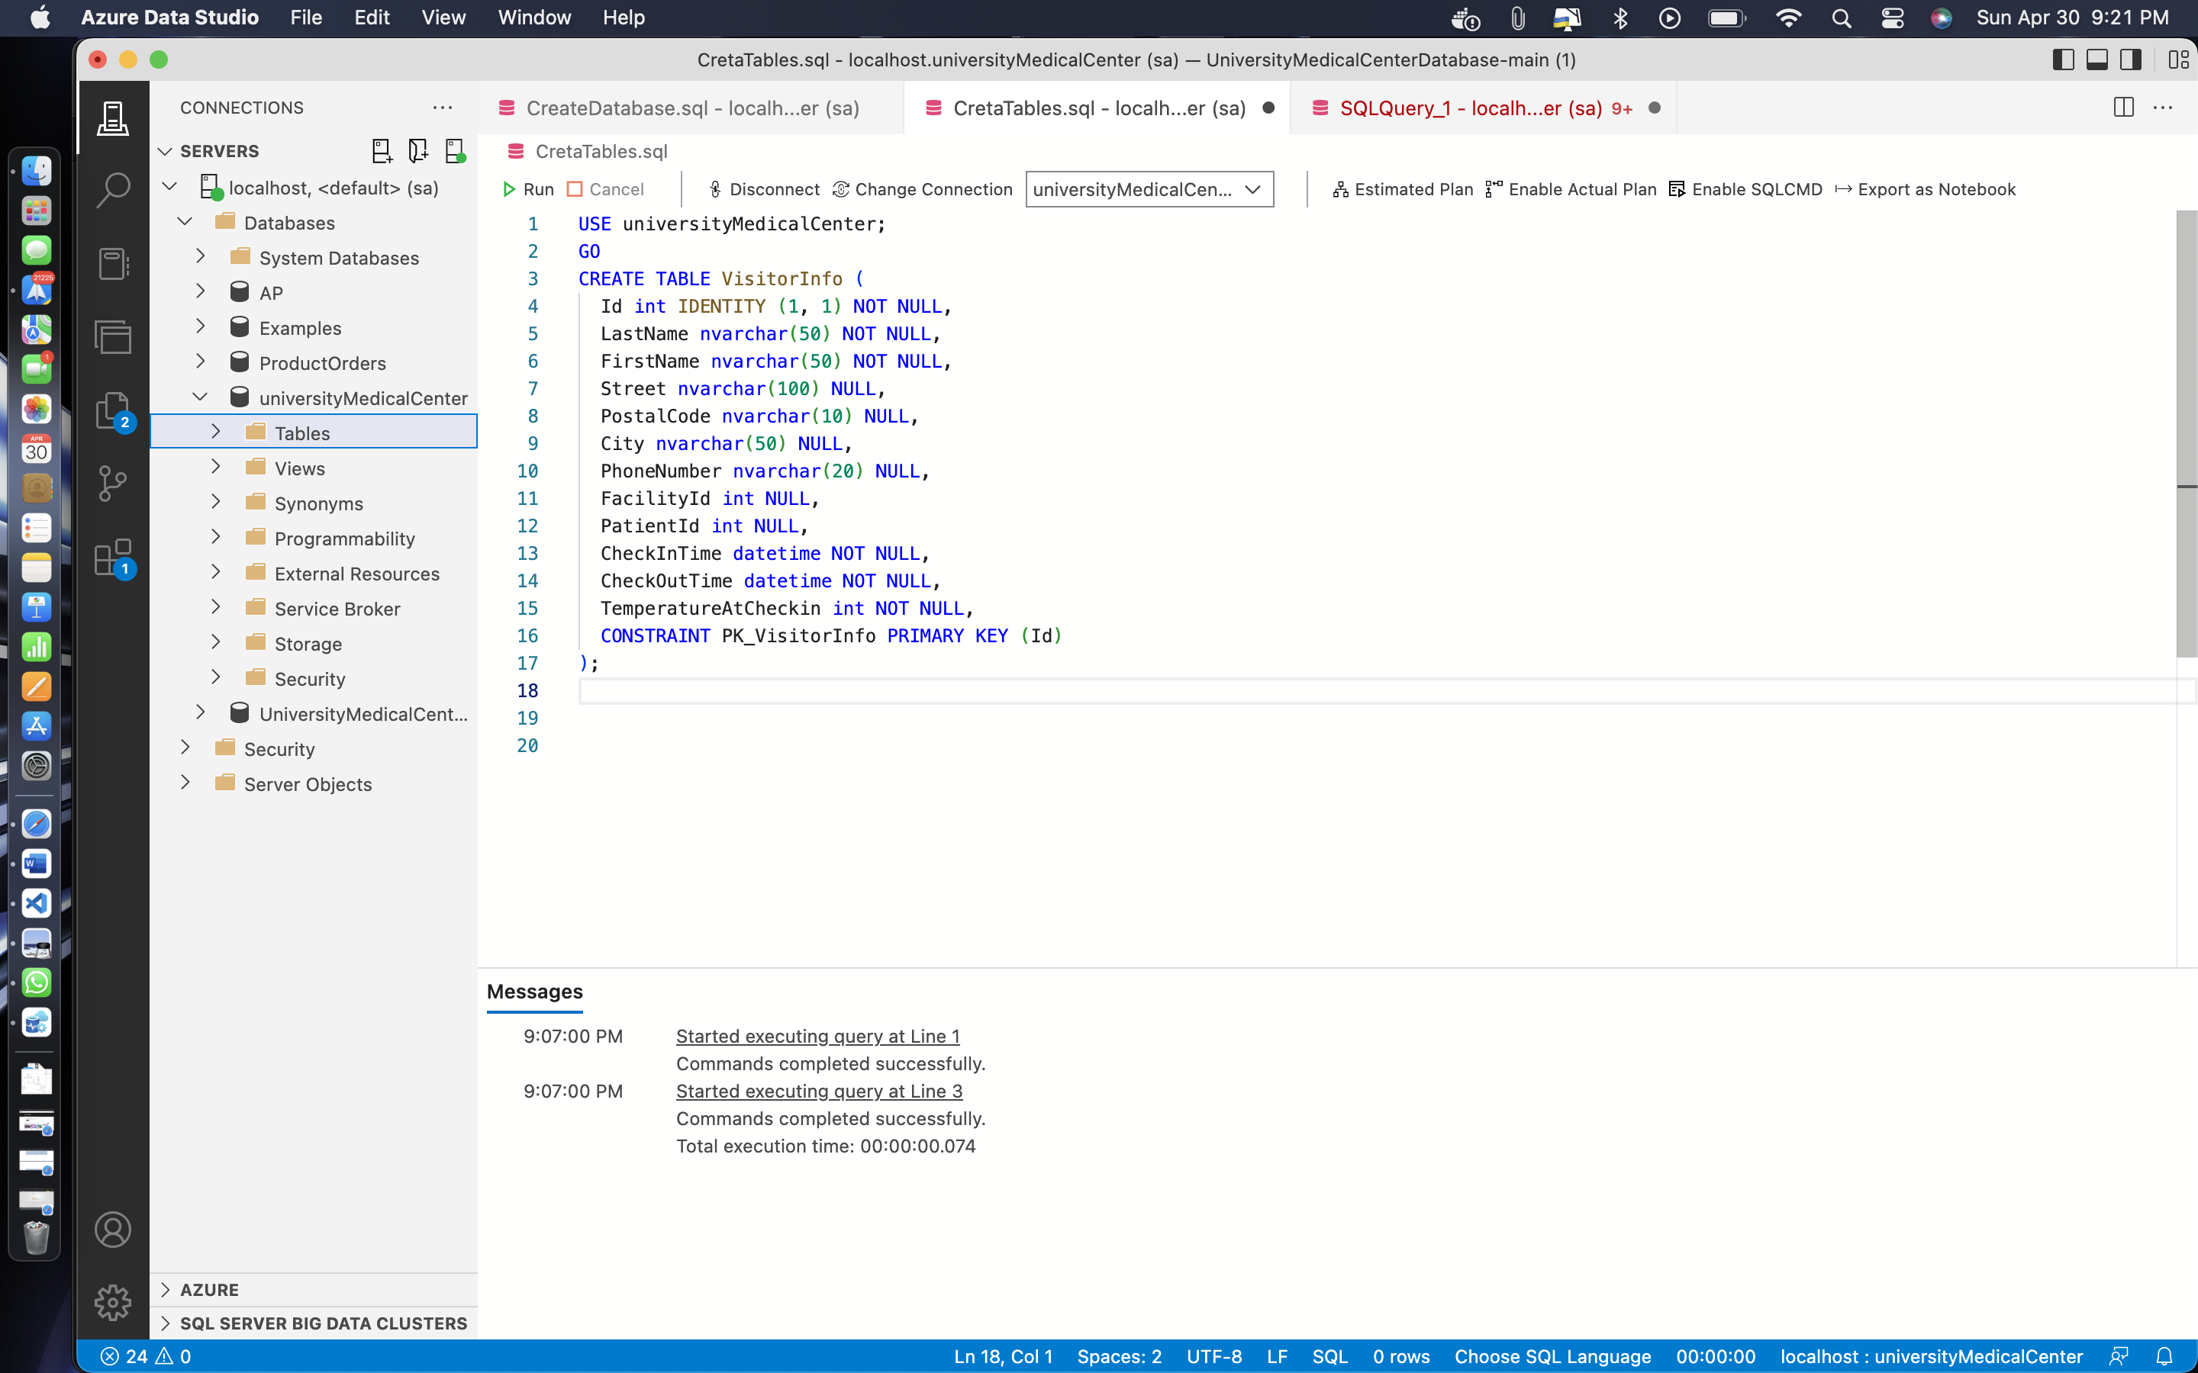

CREATE TABLE LabTestInfo (

Id int IDENTITY (1, 1) NOT NULL,

TestName nvarchar(255) NOT NULL,

Cost money NOT NULL,

PaymentMethod nvarchar(50) NULL,

CONSTRAINT PK_LabTestInfo PRIMARY KEY (Id)

);

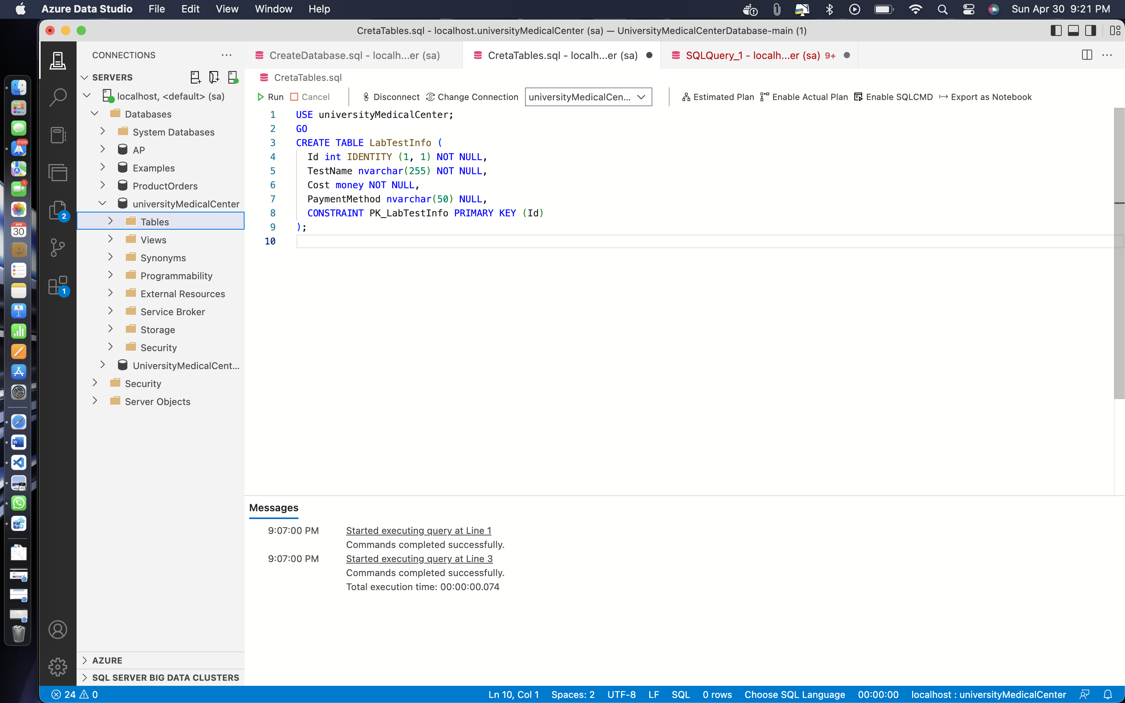

CREATE TABLE LabTestResults (

Id int IDENTITY (1, 1) NOT NULL,

TestId int NOT NULL,

Results nvarchar(255) NOT NULL,

ReportToState bit NOT NULL,

ReportToCounty nvarchar(50) NULL,

CONSTRAINT PK_LabTestResults PRIMARY KEY (Id)

);

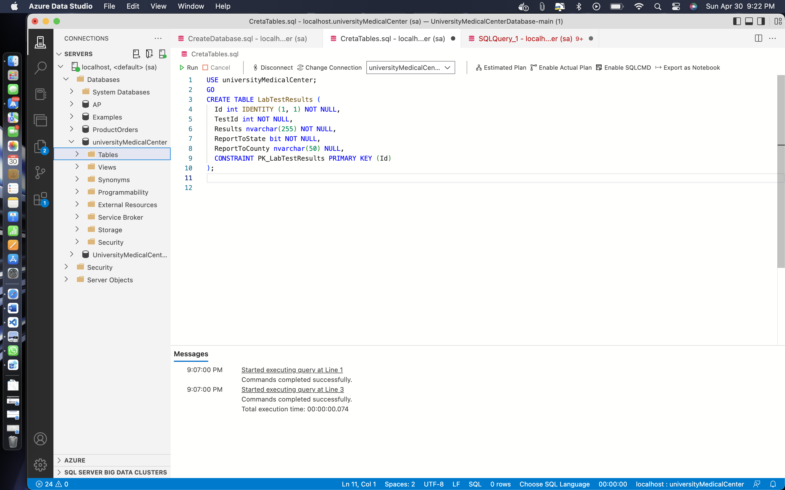

CREATE TABLE ImagingTestInfo (

Id int IDENTITY (1, 1) NOT NULL,

TestName nvarchar(255) NOT NULL,

Cost money NOT NULL,

PaymentMethod nvarchar(50) NULL,

CONSTRAINT PK_ImagingTestInfo PRIMARY KEY (Id)

);

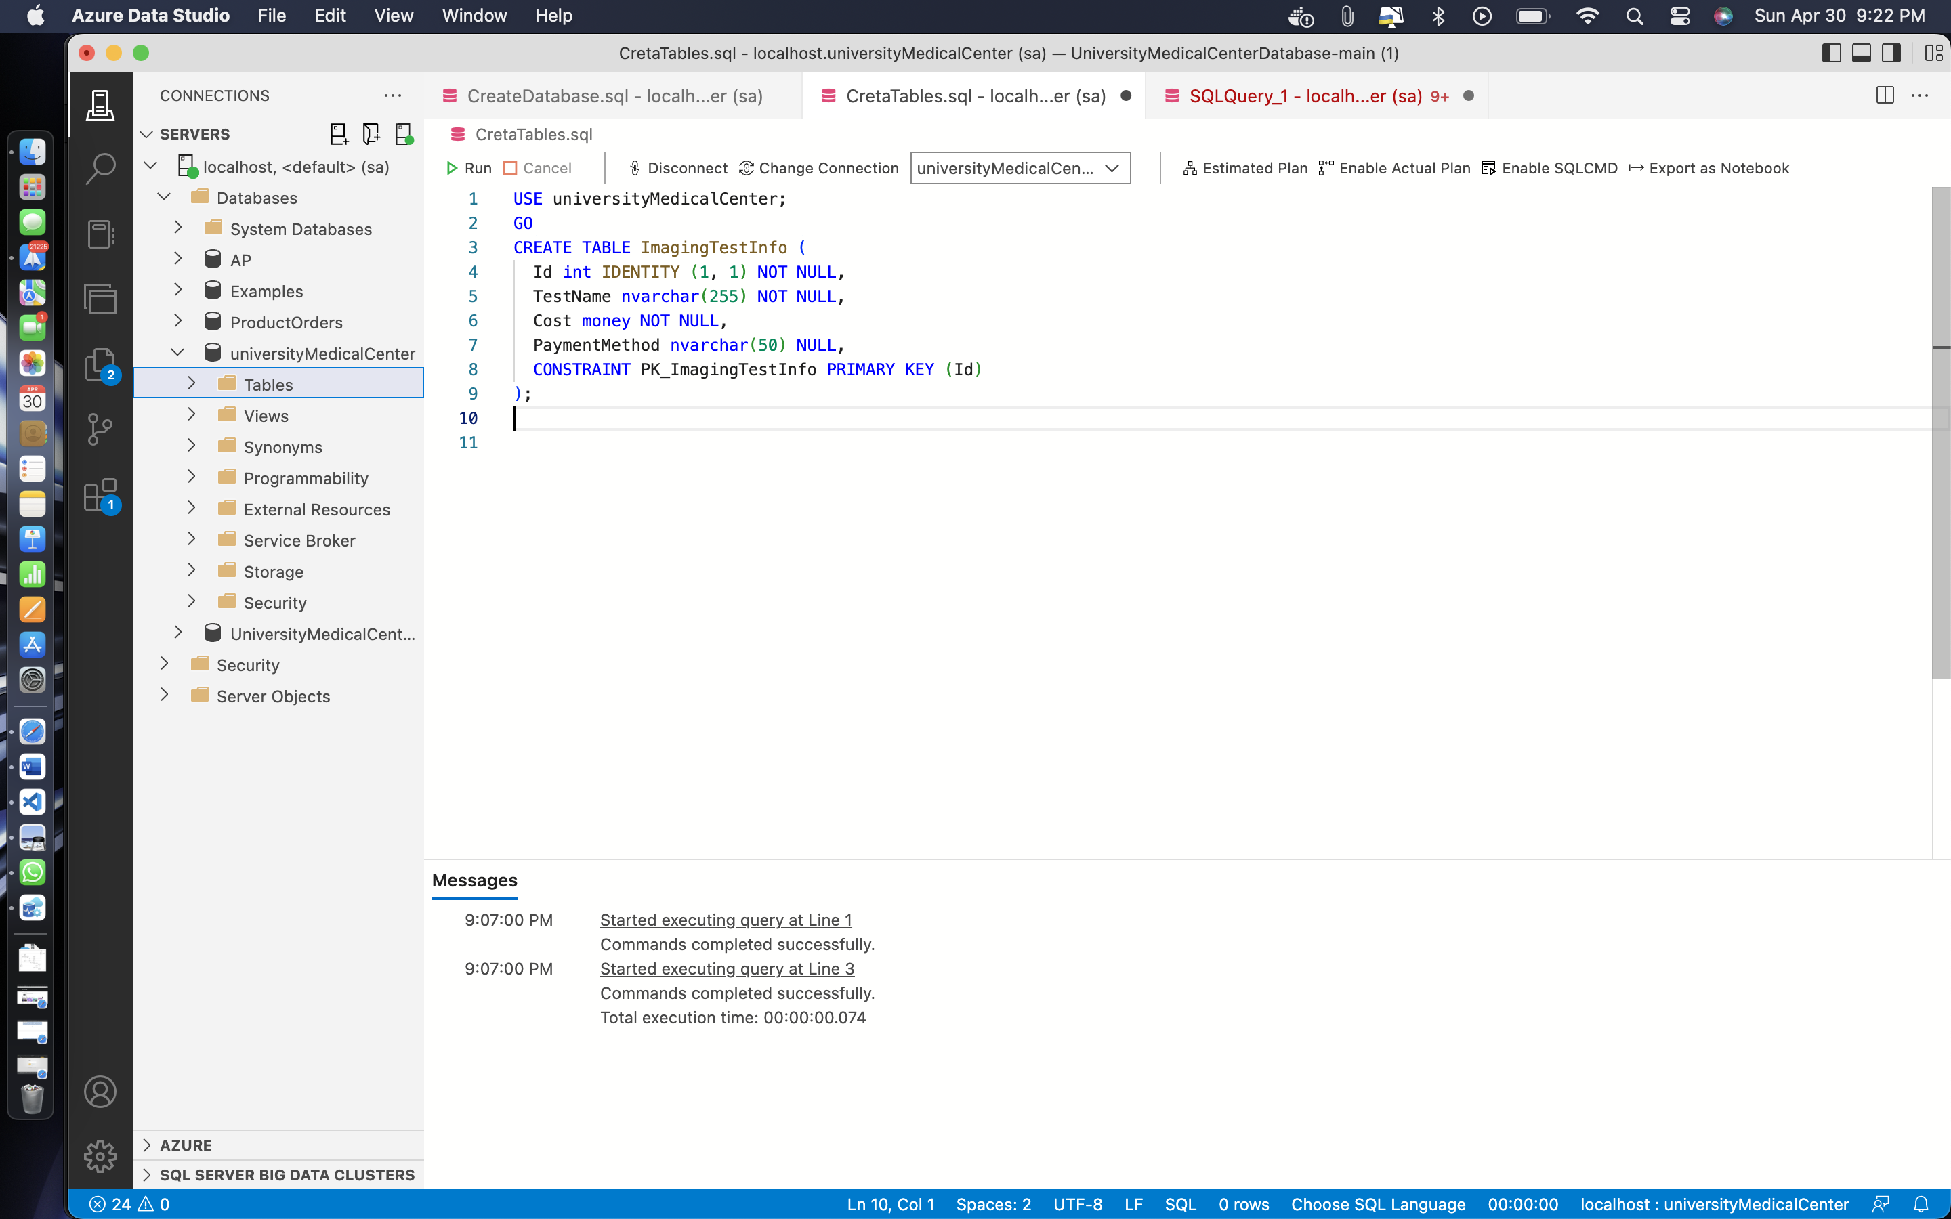

CREATE TABLE ImagingTestResults (

Id int IDENTITY (1, 1) NOT NULL,

TestId int NOT NULL,

Results nvarchar(255) NOT NULL

CONSTRAINT PK_ImagingTestResults PRIMARY KEY (Id)

);

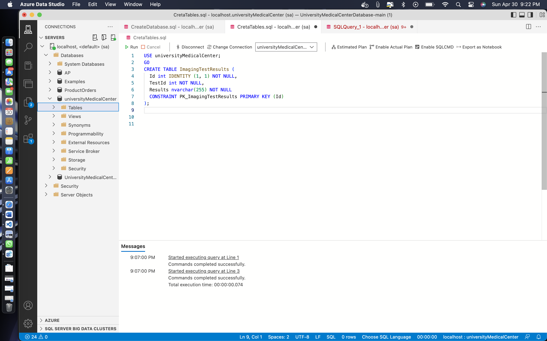

CREATE TABLE Billings (

BillingID INT PRIMARY KEY,

PatientID INT NOT NULL,

PrescriptioID INT NOT NULL,

ImagingTestId INT,

MedicationID INT,

LabTestID INT,

BillingDate DATE NOT NULL,

BillingAmount DECIMAL(10,2) NOT NULL,

FOREIGN KEY (PatientID) REFERENCES PatientInfo(Id),

FOREIGN KEY (PrescriptioID) REFERENCES PrescriptionInfo(Id),

FOREIGN KEY (ImagingTestId) REFERENCES ImagingTestInfo(Id),

FOREIGN KEY (MedicationID) REFERENCES MedicationInfo(Id),

FOREIGN KEY (LabTestID) REFERENCES LabTestInfo(Id)

);

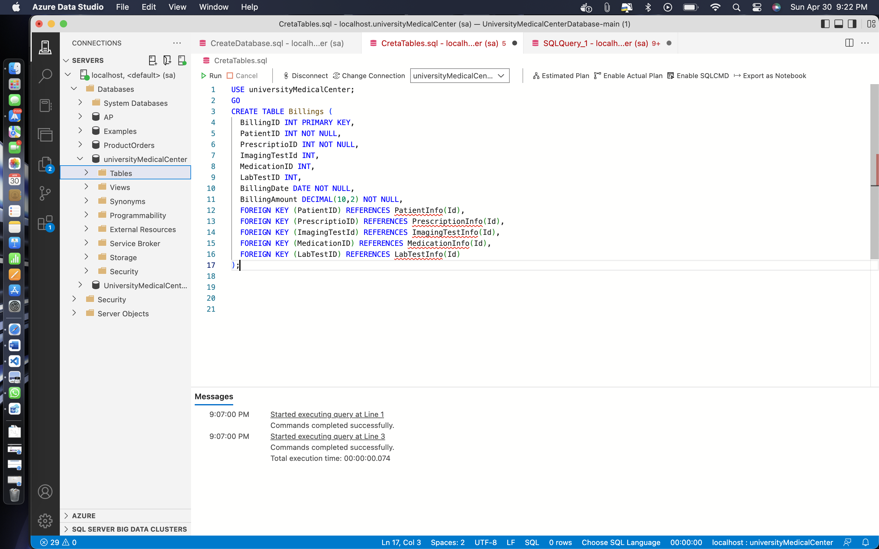

**ALL SOURCE CODE TOGETHER: -**

USE universityMedicalCenter;

GO

CREATE TABLE PatientInfo (

Id int NOT NULL,

LastName nvarchar(50) NOT NULL,

FirstName nvarchar(50) NOT NULL,

HouseNo nvarchar(100) NULL,

Street nvarchar(100) NULL,

PostalCode nvarchar(10) NULL,

City nvarchar(50) NULL,

PhoneNumber nvarchar(20) NULL,

LocationId int NULL,

PrimaryCarePhysician int NULL,

DateofBirth datetime NOT NULL,

InsuranceNumber nvarchar(50) NOT NULL,

InsuranceGroupId nvarchar(50) NOT NULL,

CONSTRAINT PK_PatientInfo PRIMARY KEY (Id)

);

CREATE TABLE PatientRecords (

Id int IDENTITY (1, 1) NOT NULL,

PatientId int NOT NULL,

PatientWeight int NOT NULL,

PatientHeight int NOT NULL,

BloodPressure nvarchar(50) NOT NULL,

Temperature nvarchar(100) NULL,

CheckInTime datetime NOT NULL,

CheckOutTime datetime NOT NULL,

LocationId int NULL,

Diagnosis nvarchar(max) NOT NULL,

ProcedureId int NULL,

EmployeeId int NOT NULL,

PhysicianId int NOT NULL,

MedicationId int NULL,

ImagingTestId int NULL,

LabTestId int NULL,

CONSTRAINT PK_PatientRecords PRIMARY KEY (Id)

);

CREATE TABLE PatientPreScreen (

Id int IDENTITY (1, 1) NOT NULL,

PatientRecordId int NOT NULL,

Temperature int NOT NULL,

AnySympotoms bit NOT NULL,

Vaccinated bit NOT NULL,

CONSTRAINT PK_PatientPreScreen PRIMARY KEY (Id)

);

CREATE TABLE AdmittedPatients (

Id int IDENTITY (1, 1) NOT NULL,

PatientId int NOT NULL,

FacilityId int NOT NULL,

AdmitDate datetime NOT NULL,

CONSTRAINT PK_AdmittedPatients PRIMARY KEY (Id)

);

CREATE TABLE ProcedureInfo (

Id int NOT NULL,

ProcedureName nvarchar(50) NOT NULL,

ProcedureDuration int NOT NULL,

Cost money NOT NULL,

CONSTRAINT PK_ProcedureInfo PRIMARY KEY (Id)

);

CREATE TABLE MedicationInfo (

Id int NOT NULL,

PrescriptionId int NOT NULL,

MedicationName nvarchar(50) NOT NULL,

Refills nvarchar(50) NOT NULL,

DozesPerDay int NOT NULL,

Notes nvarchar(max) NULL,

CONSTRAINT PK_MedicationInfo PRIMARY KEY (Id)

);

CREATE TABLE PrescriptionInfo (

Id int NOT NULL,

PharmacyId int NOT NULL,

Cost money NOT NULL,

CurrentStatus nvarchar(255) NOT NULL,

CONSTRAINT PK_PrescriptionInfo PRIMARY KEY (Id)

);

CREATE TABLE PhysicianInfo (

Id int NOT NULL,

EmpId int NOT NULL,

LicenseNumber nvarchar(50) NOT NULL,

LocationId int NULL,

TakingNewPatients bit NOT NULL,

Active bit NOT NULL,

Retired bit NOT NULL,

Position nvarchar(50) NOT NULL,

CONSTRAINT PK_PhysicianInfo PRIMARY KEY (Id)

);

CREATE TABLE PhysicianSchedule (

Id int IDENTITY (1, 1) NOT NULL,

PhysicianId int NOT NULL,

PatientId int NOT NULL,

ScheduleDetails int NOT NULL,

NurseId int NOT NULL,

CONSTRAINT PK_PhysicianSchedule PRIMARY KEY (Id)

);

CREATE TABLE ScheduleDetails (

Id int IDENTITY (1, 1) NOT NULL,

StartTime datetime NOT NULL,

Duration int NOT NULL,

FacilityId int NOT NULL,

RoomNumber nvarchar(255) NOT NULL,

EquipmentNeeded nvarchar(255) NULL,

CONSTRAINT PK_ScheduleDetails PRIMARY KEY (Id)

);

CREATE TABLE LicenseInfo (

LicenseNumber nvarchar(50) NOT NULL,

IssuedBy nvarchar(50) NOT NULL,

IssuedOn datetime NOT NULL,

ValidTill datetime NOT NULL,

CONSTRAINT PK_LicenseInfo PRIMARY KEY (LicenseNumber)

);

CREATE TABLE InsuranceInfo (

InsuranceNumber nvarchar(50) NOT NULL,

IssuedBy nvarchar(50) NOT NULL,

IssuedOn datetime NOT NULL,

ValidTill datetime NOT NULL,

Copay money NOT NULL,

CovergePercentage int NOT NULL,

BaseCoverage money NOT NULL,

CONSTRAINT PK_InsuranceInfo PRIMARY KEY (InsuranceNumber)

);

CREATE TABLE NurseInfo (

Id int NOT NULL,

EmpId int NOT NULL,

LocationId int NULL,

CONSTRAINT PK_NurseInfo PRIMARY KEY (Id)

);

CREATE TABLE EmployeeInfo (

Id int NOT NULL,

LastName nvarchar(50) NOT NULL,

FirstName nvarchar(50) NOT NULL,

Street nvarchar(100) NULL,

PostalCode nvarchar(10) NULL,

City nvarchar(50) NULL,

PhoneNumber nvarchar(20) NULL,

DateofBirth datetime NOT NULL,

Department nvarchar(255) NOT NULL,

CONSTRAINT PK_EmployeeInfo PRIMARY KEY (Id)

);

CREATE TABLE EmployeeBenefits (

EmpId int NOT NULL,

Salary money NOT NULL,

Benefits nvarchar(255) NOT NULL,

Schedule nvarchar(255) NOT NULL,

ContractType nvarchar(50) NOT NULL,

ContractTerms nvarchar(255) NULL,

CONSTRAINT PK_EmployeeBenefits PRIMARY KEY (EmpId)

);

CREATE TABLE FacilityInfo (

Id int NOT NULL,

FacilityName nvarchar(50) NOT NULL,

Street nvarchar(100) NULL,

PostalCode nvarchar(10) NULL,

City nvarchar(50) NULL,

PhoneNumber nvarchar(20) NULL,

CONSTRAINT PK_FacilityInfo PRIMARY KEY (Id)

);

CREATE TABLE FacilityDetails (

Id int NOT NULL,

FacilityId int NOT NULL,

LocationHours nvarchar(255) NOT NULL,

Departments nvarchar(255) NOT NULL,

RoomsAvailable int NOT NULL,

ICUBeds int NOT NULL,

CCUBeds int NOT NULL,

TraumaCenterAvailability int NOT NULL,

VentilatorsAvailable int NOT NULL,

OxygenCylindersAvailable int NOT NULL,

CONSTRAINT PK_FacilityDetails PRIMARY KEY (Id)

);

CREATE TABLE PharmacyInfo (

Id int NOT NULL,

PharmacyName nvarchar(50) NOT NULL,

LocationHours nvarchar(255) NOT NULL,

RentalEquipment nvarchar(255) NOT NULL,

Street nvarchar(100) NULL,

PostalCode nvarchar(10) NULL,

City nvarchar(50) NULL

CONSTRAINT PK_PharmacyInfo PRIMARY KEY (Id)

);

CREATE TABLE VisitorInfo (

Id int IDENTITY (1, 1) NOT NULL,

LastName nvarchar(50) NOT NULL,

FirstName nvarchar(50) NOT NULL,

Street nvarchar(100) NULL,

PostalCode nvarchar(10) NULL,

City nvarchar(50) NULL,

PhoneNumber nvarchar(20) NULL,

FacilityId int NULL,

PatientId int NULL,

CheckInTime datetime NOT NULL,

CheckOutTime datetime NOT NULL,

TemperatureAtCheckin int NOT NULL,

CONSTRAINT PK_VisitorInfo PRIMARY KEY (Id)

);

CREATE TABLE LabTestInfo (

Id int IDENTITY (1, 1) NOT NULL,

TestName nvarchar(255) NOT NULL,

Cost money NOT NULL,

PaymentMethod nvarchar(50) NULL,

CONSTRAINT PK_LabTestInfo PRIMARY KEY (Id)

);

CREATE TABLE LabTestResults (

Id int IDENTITY (1, 1) NOT NULL,

TestId int NOT NULL,

Results nvarchar(255) NOT NULL,

ReportToState bit NOT NULL,

ReportToCounty nvarchar(50) NULL,

CONSTRAINT PK_LabTestResults PRIMARY KEY (Id)

);

CREATE TABLE ImagingTestInfo (

Id int IDENTITY (1, 1) NOT NULL,

TestName nvarchar(255) NOT NULL,

Cost money NOT NULL,

PaymentMethod nvarchar(50) NULL,

CONSTRAINT PK_ImagingTestInfo PRIMARY KEY (Id)

);

CREATE TABLE ImagingTestResults (

Id int IDENTITY (1, 1) NOT NULL,

TestId int NOT NULL,

Results nvarchar(255) NOT NULL

CONSTRAINT PK_ImagingTestResults PRIMARY KEY (Id)

);

CREATE TABLE Billings (

BillingID INT PRIMARY KEY,

PatientID INT NOT NULL,

PrescriptioID INT NOT NULL,

ImagingTestId INT,

MedicationID INT,

LabTestID INT,

BillingDate DATE NOT NULL,

BillingAmount DECIMAL(10,2) NOT NULL,

FOREIGN KEY (PatientID) REFERENCES PatientInfo(Id),

FOREIGN KEY (PrescriptioID) REFERENCES PrescriptionInfo(Id),

FOREIGN KEY (ImagingTestId) REFERENCES ImagingTestInfo(Id),

FOREIGN KEY (MedicationID) REFERENCES MedicationInfo(Id),

FOREIGN KEY (LabTestID) REFERENCES LabTestInfo(Id)

);

**Output: -**

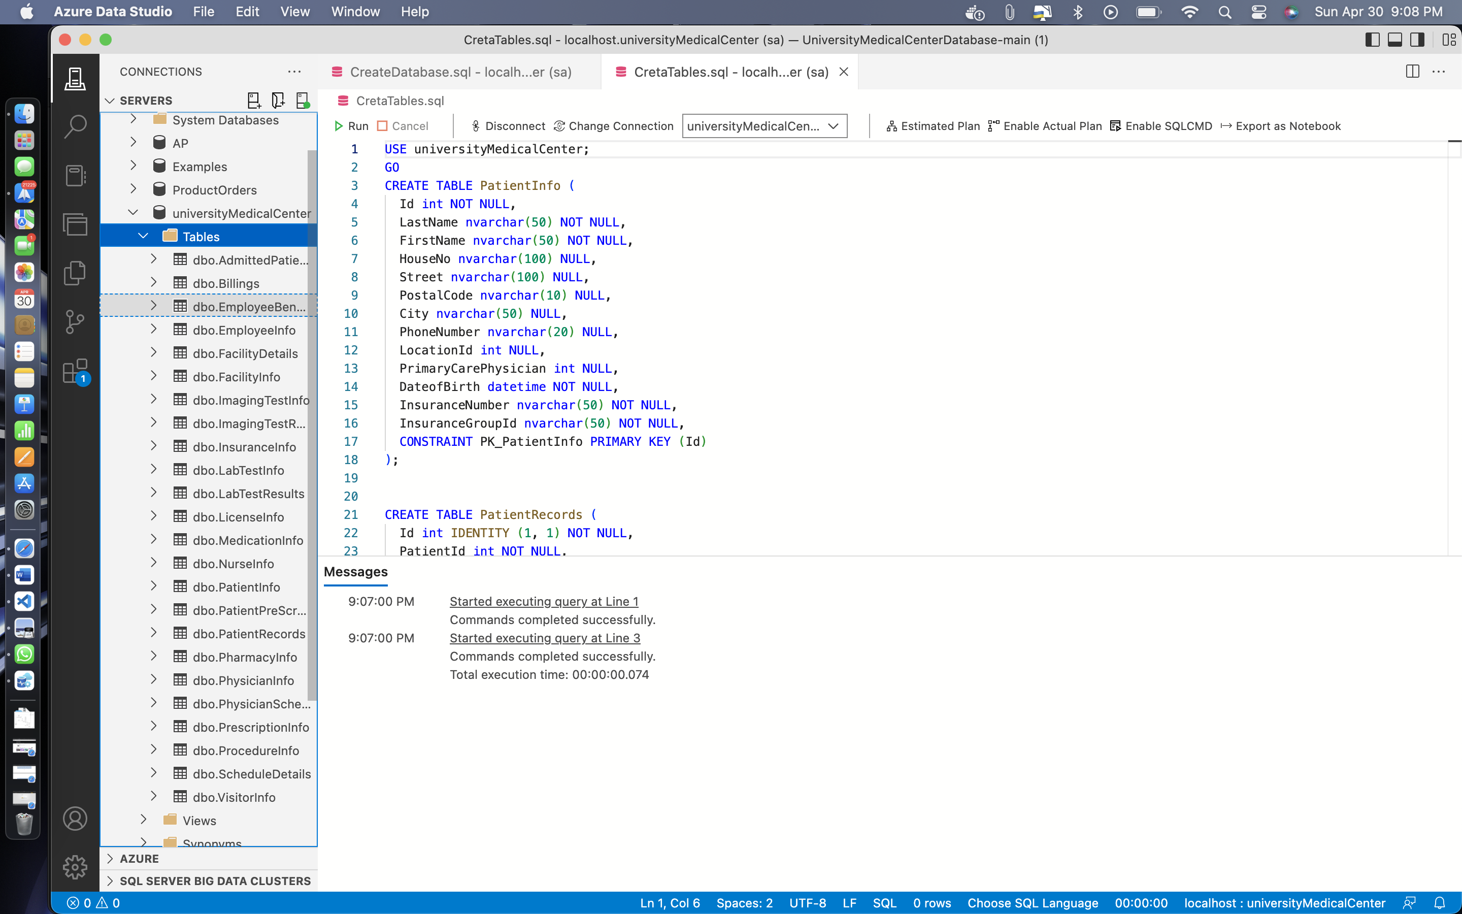

**Remarks: -**

* Here, I have created all 23 tables. The SQL code for all 23 tables is given above as well as screenshot also given after each table is being created.
* You can see all the changes, query and the output in the screenshot provided above.
* **INSTERING THE VALUES IN THE TABLES**

**Source Code: -**

INSERT INTO PatientInfo (Id

, LastName

, FirstName

, HouseNo

, Street

, PostalCode

, City

, PhoneNumber

, LocationId

, PrimaryCarePhysician

, DateofBirth

, InsuranceNumber

, InsuranceGroupId)

VALUES (1, 'Sharma', 'Rahul', '1234', 'Hillside Ave', '13210', 'Syracuse', '3155551234', '101', '111', '01-01-1990', '1234567890', 'ABC')

, (2, 'Chopra', 'Neha', '5678', 'Westcott St', '13210', 'Syracuse', '3155555678', '111', '211', '02-14-1992', '0987654321', 'DEF')

, (3, 'Gupta', 'Ankit', '9101', 'Lancaster Ave', '13210', 'Syracuse', '3155559101', '300', '124', '03-20-1994', '1357902468', 'GHI')

, (4, 'Singh', 'Aman', '1212', 'Euclid Ave', '13210', 'Syracuse', '3155551212', '234', '542', '04-15-1996', '2468013579', 'JKL')

, (5, 'Kapoor', 'Amit', '1313', 'Comstock Ave', '13210', 'Syracuse', '3155551313', '871', '276', '05-25-1998', '3692581470', 'MNO')

INSERT INTO PatientRecords (PatientId

, PatientWeight

, PatientHeight

, BloodPressure

, Temperature

, CheckInTime

, CheckOutTime

, LocationId

, Diagnosis

, ProcedureId

, EmployeeId

, PhysicianId

, MedicationId

, ImagingTestId

, LabTestId)

VALUES (1, 157, 185, 110, 98, '04-30-2023 10:00', '04-30-2023 11:30', 2, 'COVID-19', 3, 21, 2, 4, NULL, 1),

(2, 124, 44, 120, 97, '04-30-2023 13:00', '04-30-2023 13:30', 2, 'Routine Checkup', NULL, 23, 2, NULL, NULL, NULL),

(3, 167, 123, 100, 98, '04-30-2023 14:00', '04-30-2023 14:30', 3, 'Sprained Ankle', 5, 43, 3, 5, 1, 2),

(4, 199, 151, 103, 98, '04-30-2023 15:30', '04-30-2023 16:15', 1, 'Sinus Infection', 2, 45, 1, 4, 2, 3)

INSERT INTO PatientPreScreen (PatientRecordId

, Temperature

, AnySympotoms

, Vaccinated)

VALUES (1, 98, 1, 0), (1, 97, 1, 0), (2, 98, 1, 0), (5, 98, 1, 1)

INSERT INTO AdmittedPatients (PatientId,

FacilityId,

AdmitDate)

VALUES (1, 1, '01-01-2021'), (2, 3, '06-05-2021'), (3, 2, '03-04-2020')

INSERT INTO ProcedureInfo (Id

, ProcedureName

, ProcedureDuration

, Cost)

VALUES (1, 'Compression Wrap', 18, 22)

, (2, 'COVID-19 Test', 25, 150)

, (3, 'Sprained Ankle', 175, 300)

, (4, 'Suturing', 55, 225)

, (5, 'Appendectomy', 275, 1400)

INSERT INTO MedicationInfo (Id

, PrescriptionId

, MedicationName

, Refills

, DozesPerDay

, Notes)

VALUES (1, 1, 'Amoxycillin 500mg', 4, 3, NULL)

, (2, 2, 'Ciprofloxacin 400mg', 0, 2, 'Contact in case of any side effects')

, (3, 3, 'Lactulose Solution', 4, 3, NULL)

, (4, 4, 'Paracetamol', 0, 6, 'Every 4 hours')

, (5, 5, 'Naproxen', 10, 4, 'Every 6 hours')

INSERT INTO PrescriptionInfo (Id,

PharmacyId,

Cost,

CurrentStatus)

VALUES (1, 231, 245, 'Processing')

, (2, 119, 274, 'Waiting Approval')

, (3, 69, 623, 'Ready For Shipment')

, (4, 193, 623, 'Ready For Shipment')

, (5, 76, 623, 'Processed')

INSERT INTO PhysicianInfo (Id,

EmpId,

LicenseNumber,

LocationId,

TakingNewPatients,

Active,

Retired,

Position)

VALUES (1, 200, '1AB', 456, 1, 1, 0, 'Assistant Professor - Pediatrics'),

(2, 201, '1CD', 789, 1, 1, 0, 'Associate Professor - Cardiology'),

(3, 211, '2EF', 111, 1, 1, 0, 'Associate Professor - Dermatology'),

(4, 251, '5XY', 222, 0, 1, 0, 'Assistant Professor - Pathology'),

(5, 252, '5ZW', 333, 0, 1, 0, 'Assistant Professor - Neurology')

INSERT INTO PhysicianSchedule (PhysicianId,

PatientId,

ScheduleDetails,

NurseId)

VALUES (2, 1, 1, 3), (2, 1, 2, 3), (3, 2, 3, 5), (5, 5, 4, 5)

INSERT INTO ScheduleDetails (StartTime,

Duration,

FacilityId,

RoomNumber,

EquipmentNeeded)

VALUES ('04-30-2023 09:00', 90, 1, '1B2', 'MRI MACHINE'),

('04-29-2023 14:30', 30, 3, '4C5', NULL),

('04-28-2023 12:15', 20, 2, '2E4', NULL),

('04-27-2023 11:20', 60, 1, '1F3', 'CT SCANNER')

INSERT INTO LicenseInfo (LicenseNumber,

IssuedBy,

IssuedOn,

ValidTill)

VALUES ('1WK', 'Cornell University', '07-10-2022', '07-10-2027'),

('2RF', 'Columbia University', '05-05-2021', '05-05-2024'),

('4HA', 'Yale University', '08-15-2022', '08-14-2023'),

('3XJ', 'Harvard University', '11-20-2020', '11-20-2025'),

('6LM', 'Duke University', '02-28-2018', '02-28-2028')

INSERT INTO InsuranceInfo (InsuranceNumber,

IssuedBy,

IssuedOn,

ValidTill,

Copay,

CovergePercentage,

BaseCoverage)

VALUES (1122343433, 'Anthem', '10-15-2021', '10-15-2022', 30, 85, 175)

, (1322547433, 'Cigna', '09-01-2021', '09-01-2023', 15, 90, 1100)

, (112232554, 'Humana', '02-28-2022', '02-28-2032', 7, 65, 60)

, (221133445, 'Geico', '04-05-2022', '04-05-2023', 1, 80, 85)

, (99877654432, 'Harmony', '06-10-2022', '06-10-2023', 3, 100, 95)

INSERT INTO NurseInfo (Id,

EmpId,

LocationId)

VALUES (1, 21, 2), (2, 23, 5), (3, 43, 6), (5, 45, 7)

INSERT INTO EmployeeInfo (Id,

LastName,

FirstName,

Street,

PostalCode,

City,

PhoneNumber,

DateofBirth,

Department)

VALUES (11, 'Kim', 'Ji-hye', 'Oak', '10005', 'New York', '1112223334', '01-01-1995', 'Pediatrics')

, (13, 'Patel', 'Rohan', 'Cedar', '10007', 'Brooklyn', '1112223444', '02-11-1994', 'Pediatrics')

, (23, 'Gupta', 'Rajesh', 'Walnut', '13205', 'Syracuse', '2223335555', '11-12-1993', 'Pediatrics')

, (25, 'Baker', 'Emily', 'Willow', '13205', 'Syracuse', '8779990000', '12-11-1992', 'Pediatrics')

, (50, 'Park', 'Soo-jin', 'Pine', '10005', 'New York', '3334445555', '12-12-1991', 'Orthopedics')

, (51, 'Kaya', 'Selim', 'Birch', '13205', 'Syracuse', '5556664444', '07-07-1995', 'Family Medicine')

, (61, 'Iqbal', 'Farhan', 'Oak', '13205', 'Syracuse', '7775554444', '11-20-1997', 'Family Medicine')

, (91, 'Garcia', 'Miguel', 'Sumner', '10005', 'New York', '8886665555', '01-01-1995', 'ENT')

, (92, 'Ahmed', 'Rifat', 'Oak', '10005', 'New York', '8887774444', '12-12-1993', 'Radiology')

INSERT INTO EmployeeBenefits (EmpId,

Salary,

Benefits,

Schedule,

ContractType,

ContractTerms)

VALUES (25, 72000, 'Healthcare + 10 Paid days off', 'Monday - Friday 9-5', 'Full Time', NULL)

, (28, 62000, 'Healthcare + 5 Paid days off', 'Monday - Friday 9-5', 'Full Time', NULL)

, (46, 78000, 'Healthcare', 'Monday - Friday 5-12', 'Full Time', NULL)

, (48, 92000, 'Healthcare + Dependent Care', 'Monday - Friday 5-12', 'Part Time', NULL)

, (105, 170000, 'Healthcare + 20 Paid days off', 'Monday - Friday 9-5', 'Full Time', NULL)

, (109, 140000, 'Healthcare + 20 Paid days off', 'Monday - Friday 9-5', 'Full Time', NULL)

, (116, 185000, 'Healthcare + 20 Paid days off', 'Monday - Friday 10-8', 'Full Time', NULL)

, (155, 205000, 'Healthcare + 20 Paid days off', 'Monday - Friday 11-9', 'Full Time', NULL)

, (156, 215000, 'Healthcare + 20 Paid days off', 'Monday - Friday 7-8', 'Full Time', NULL)

INSERT INTO FacilityInfo (Id,

FacilityName,

Street,

PostalCode,

City,

PhoneNumber)

VALUES (11, 'Central Hospital', 'Main St', '10016', 'New York', '1113335555'),

(22, 'Onondaga Medical Center', 'University Ave', '13210', 'Syracuse', '2223334444'),

(33, 'North Shore Hospital', 'Northern Blvd', '11788', 'Melville', '8889991111')

INSERT INTO FacilityDetails (Id,

FacilityId,

LocationHours,

Departments,

RoomsAvailable,

ICUBeds,

CCUBeds,

TraumaCenterAvailability,

VentilatorsAvailable,

OxygenCylindersAvailable)

VALUES (201, 1, '9am to 5pm', 'Pediatrics, Cardiology', 60, 80, 15, 8, 180, 88),

(202, 2, '8am to 4pm', 'Orthopedics, Oncology, Family Medicine', 120, 20, 12, 115, 25, 44),

(203, 3, 'All Day', 'Radiology, Neurology', 40, 60, 63, 50, 45, 290)

INSERT INTO PharmacyInfo (Id

, PharmacyName

, LocationHours

, RentalEquipment

, Street

, PostalCode

, City)

VALUES (121, 'HealthyLife', '9am - 7pm', 'Oxygen Concentrators', 'Main St', '13210', 'Syracuse'),

(223, 'MediMart', '10am - 9pm', 'Oxygen Concentrators, CPAP Machines', 'West Willow', '13210', 'Syracuse'),

(52, 'UrgentCare', '24/7', 'Hospital Beds', 'Parkway', '13210', 'Syracuse'),

(23, 'ConvenientMart', '8am - 10pm', 'N/A', 'South St', '13452', 'Syracuse')

INSERT INTO VisitorInfo (LastName,

FirstName,

Street,

PostalCode,

City,

PhoneNumber,

FacilityId,

PatientId,

CheckInTime,

CheckOutTime,

TemperatureAtCheckin)

VALUES ('Patel', 'Raj', 'Madison', '13210', 'Syracuse', '2223331312', '2', '1', '04-20-2022 10:10', '04-20-2022 10:25', 98),

('Kaur', 'Manpreet', 'Comstock', '13210', 'Syracuse', '5553434241', '1', '2', '04-01-2022 13:10', '04-01-2022 13:35', 98),

('Singh', 'Gurpreet', 'Westcott', '13210', 'Syracuse', '888775521', '1', '2', '04-11-2022 14:10', '04-11-2022 14:55', 99)

INSERT INTO LabTestInfo (TestName,

Cost,

PaymentMethod)

VALUES ('COVID AntiBody', 123, 'Card-Visa'), ('BloodWork-All', 254, 'Cash'), ('NazalSwab', 374, 'Cash')

INSERT INTO LabTestResults (TestId,

Results,

ReportToState,

ReportToCounty)

VALUES (1, 'Positive Rhino Virus', 0, NULL), (2, 'Normal', 0, NULL), (3, 'negative Rhino Virus', 0, NULL)

INSERT INTO ImagingTestInfo (TestName,

Cost,

PaymentMethod)

VALUES ('Arm Xray', 234, 'Card - chase'), ('Chest Xray', 424, 'Card - Discover')

INSERT INTO ImagingTestResults (TestId,

Results)

VALUES (1, 'Congestion'), (2, 'BrokenArm')

**Output: -**

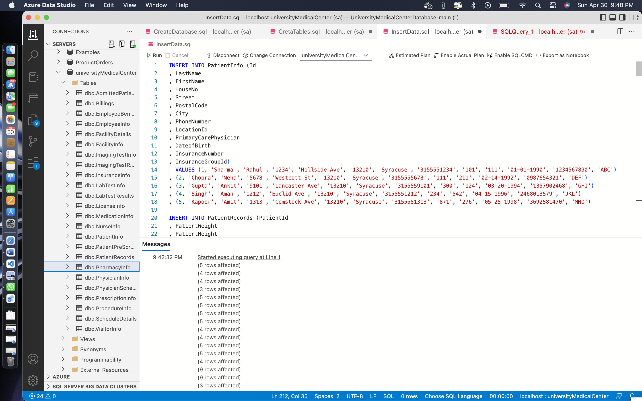

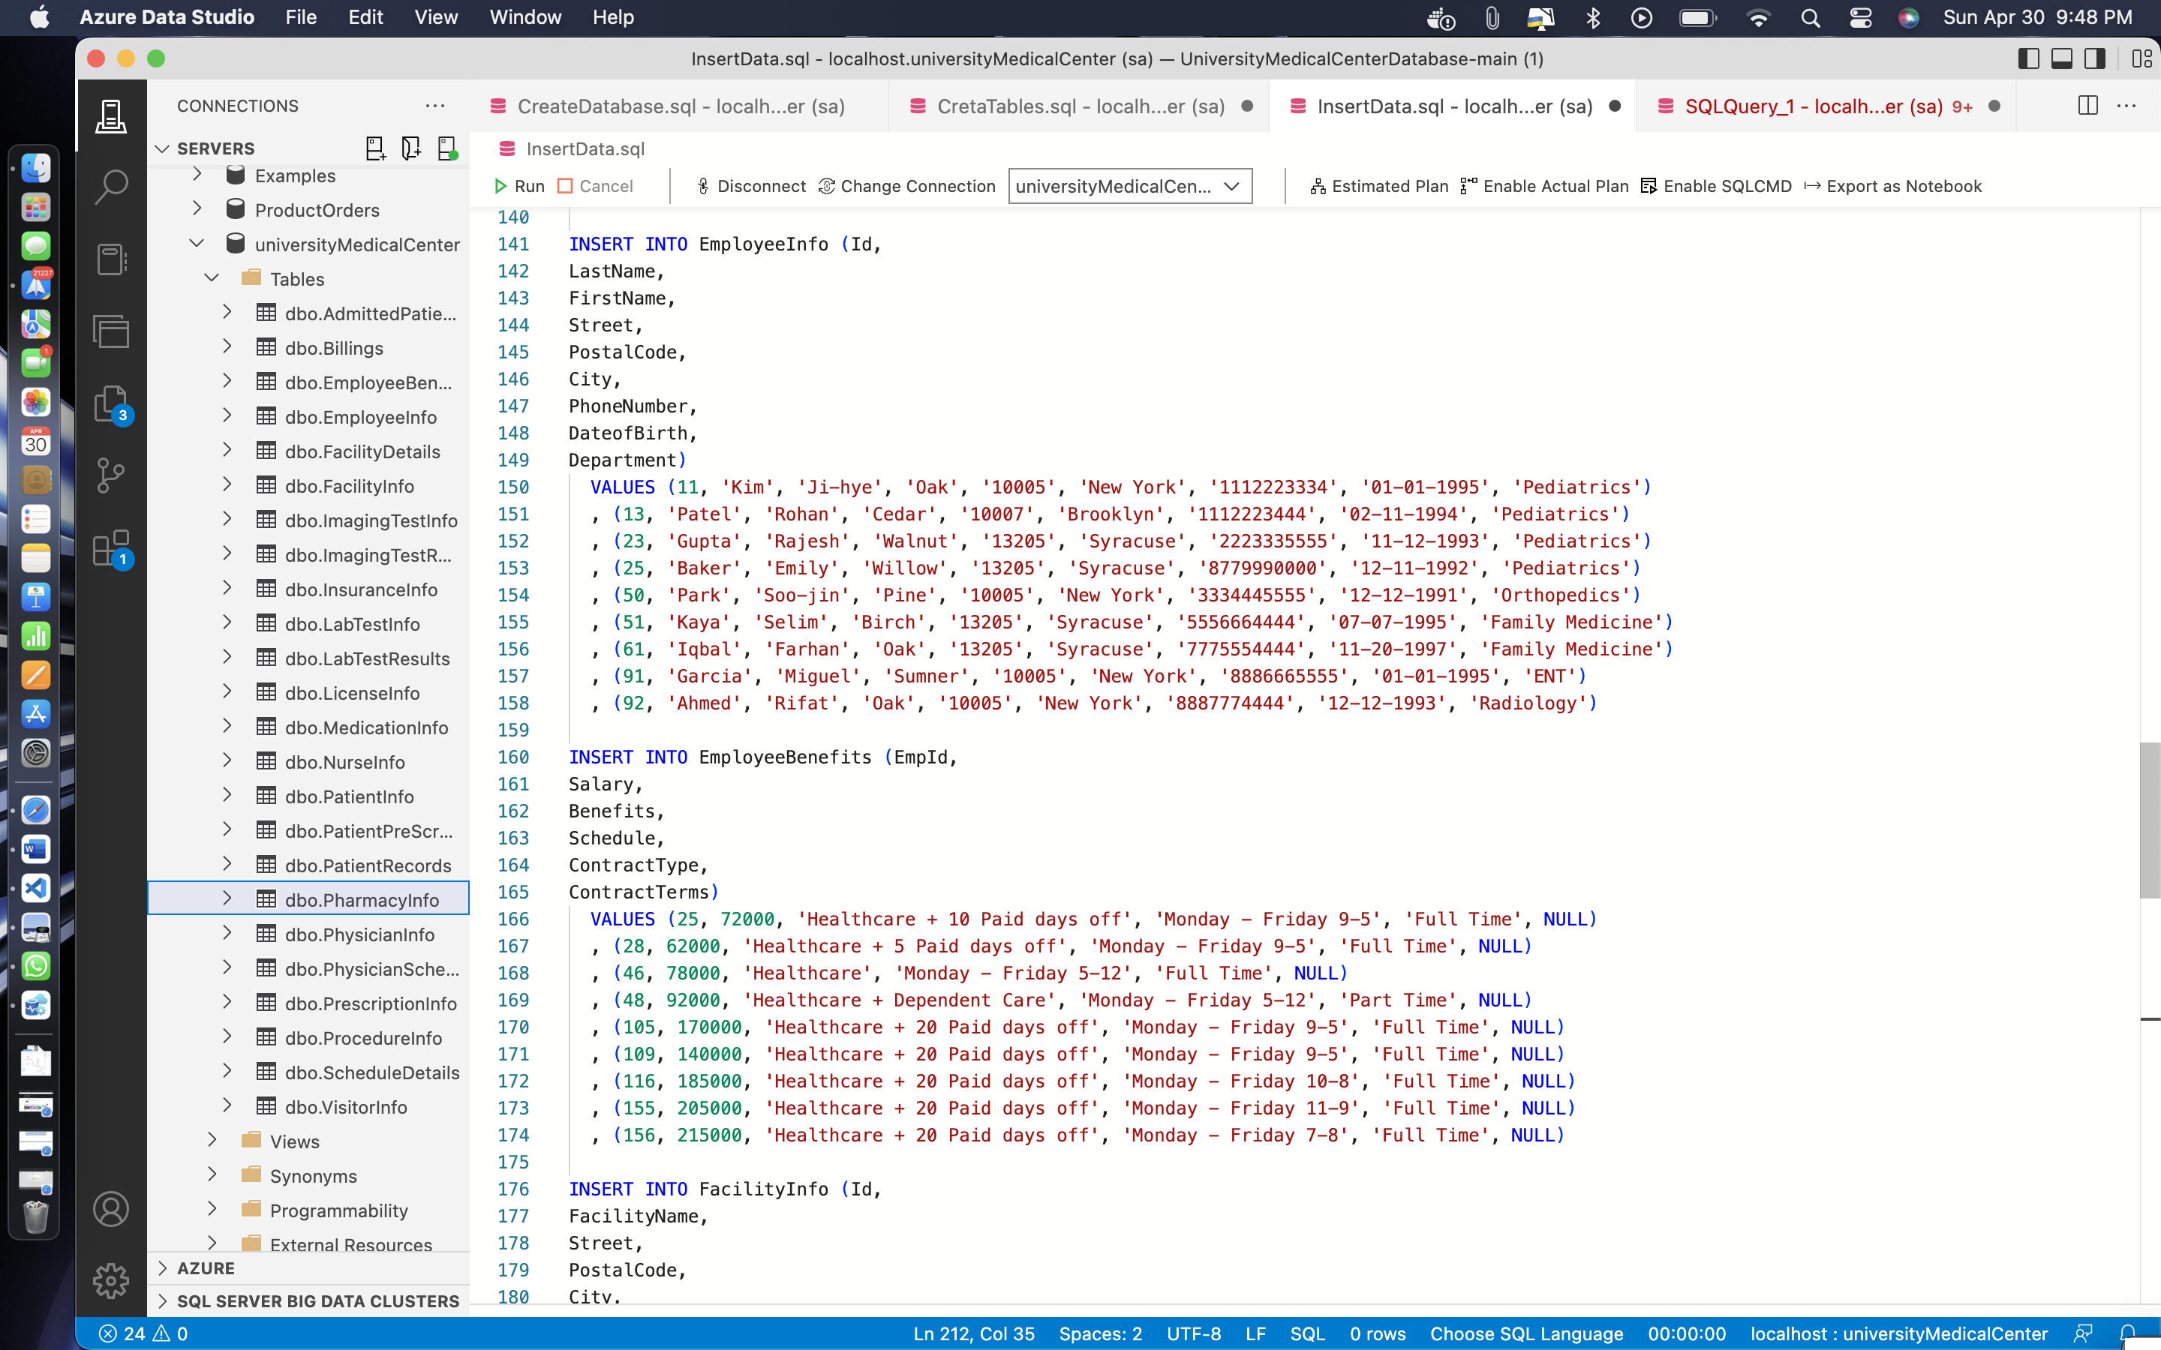

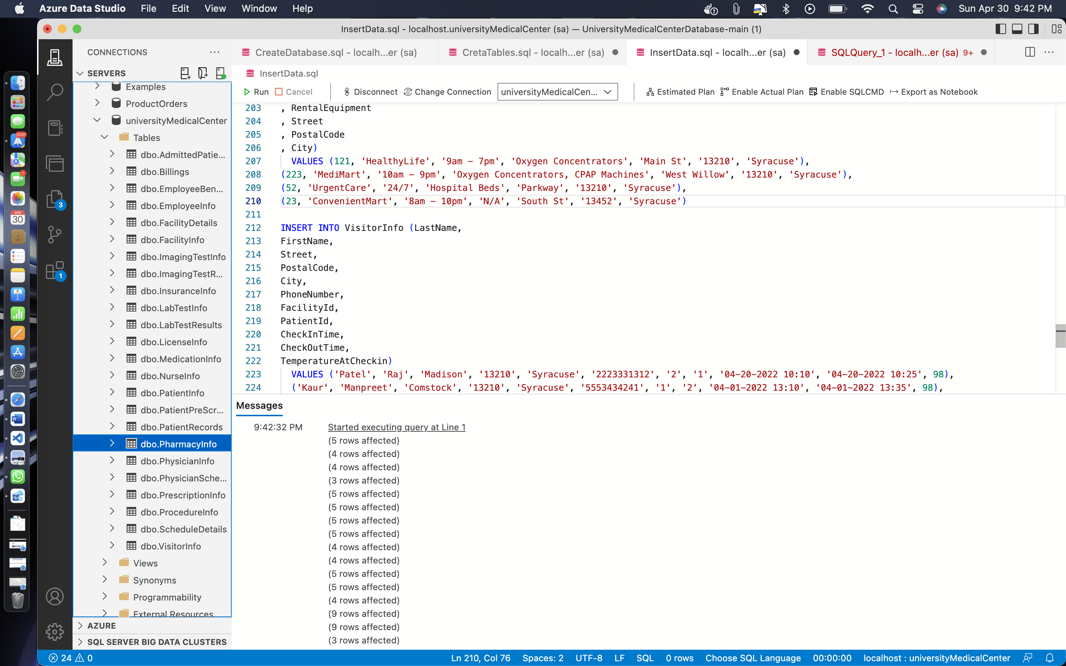

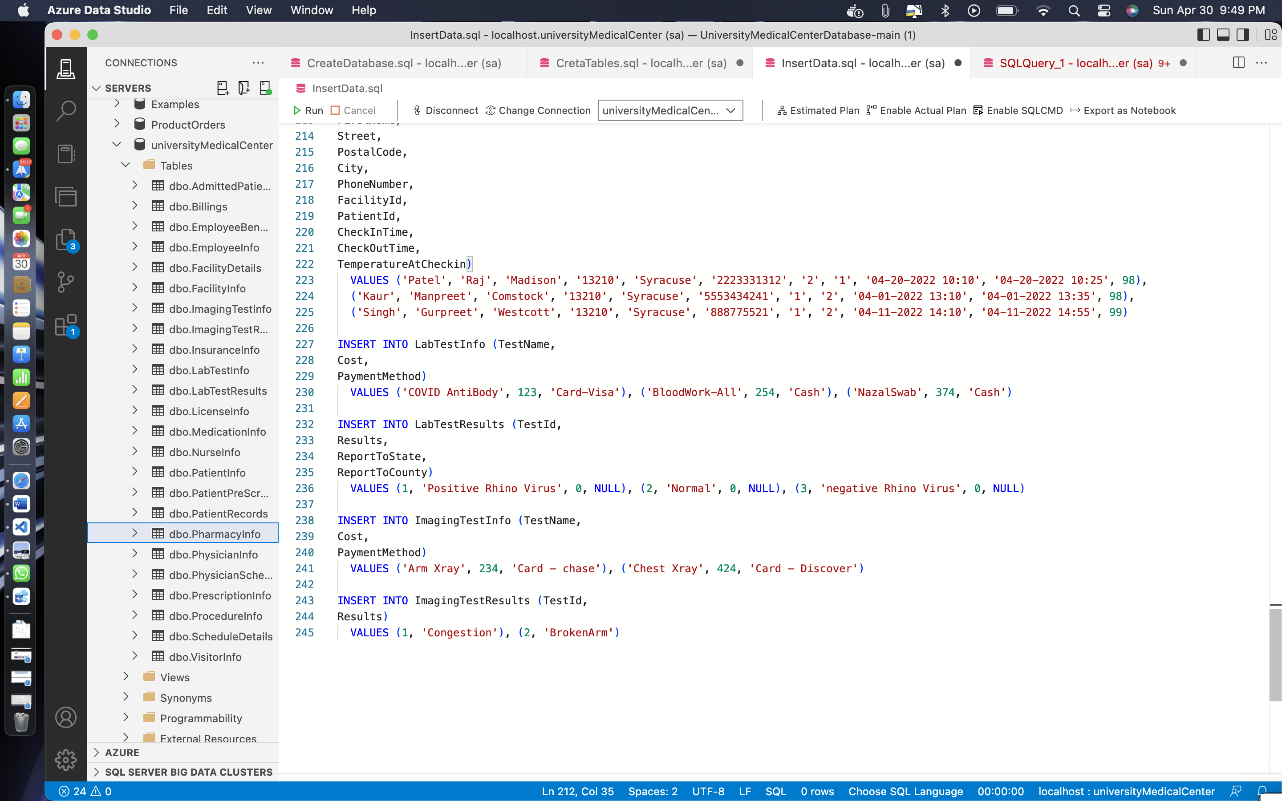

**Remarks: -**

* Here, I have inserted values in all the 23 tables various, values have been added to each of the table.
* You can see all the changes, query and the output in the screenshot provided above.

**Code: -**

SELECT * from AdmittedPatients;

SELECT * from EmployeeBenefits;

SELECT * from EmployeeInfo;

**Output: -**

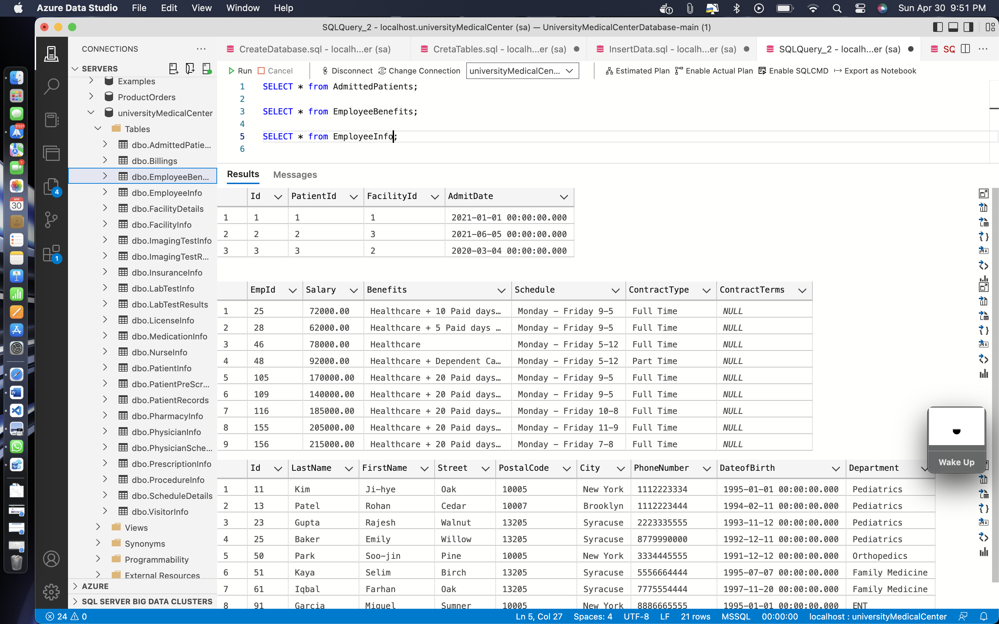

**Code: -**

SELECT * from FacilityDetails;

SELECT * from FacilityInfo;

SELECT * from ImagingTestInfo;

**Output: -**

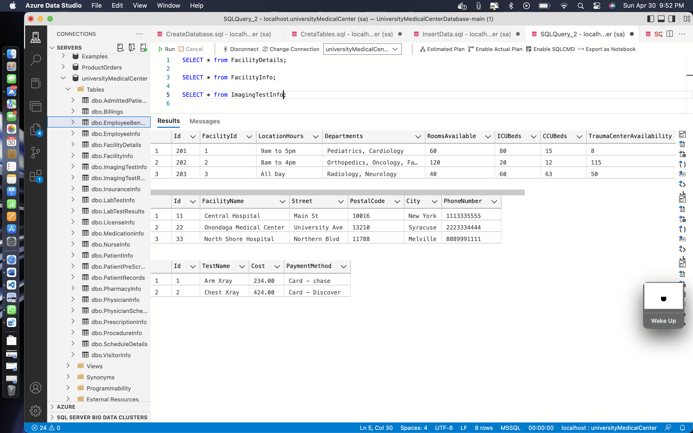

**Code: -**

SELECT * from InsuranceInfo;

SELECT * from LabTestInfo;

SELECT * from LabTestResults;

SELECT * from LicenseInfo;

**Output: -**

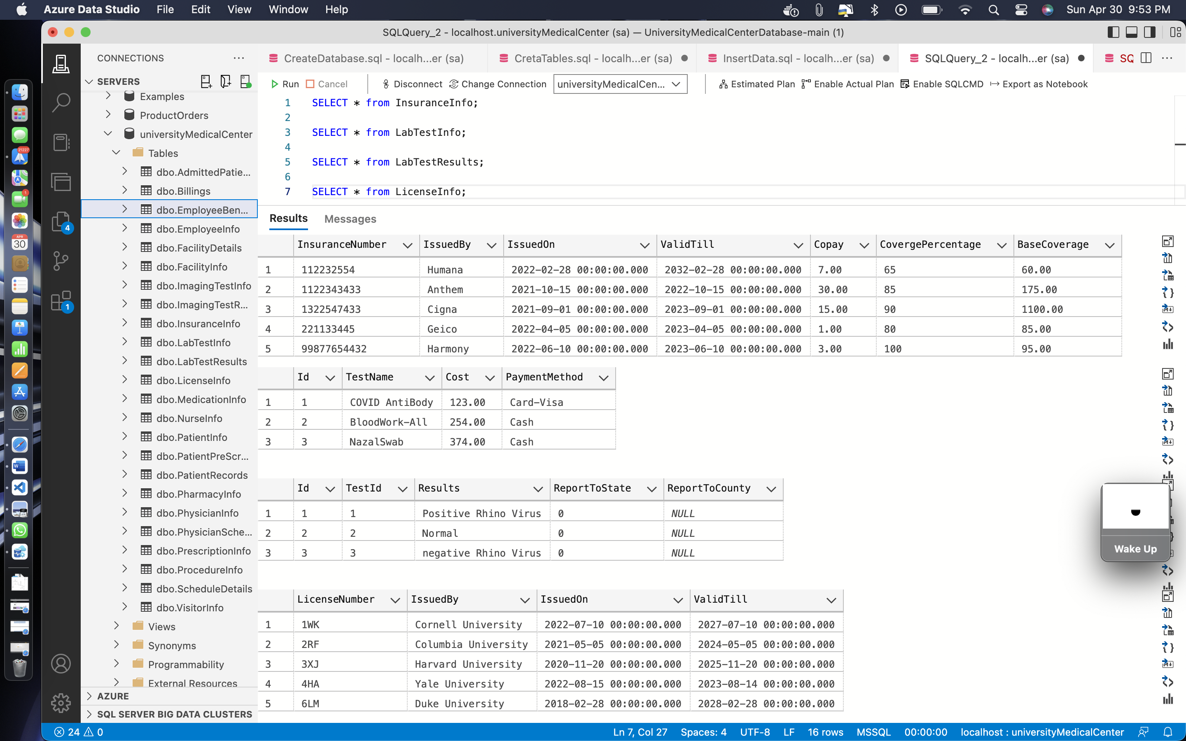

**Code: -**

SELECT * from MedicationInfo;

SELECT * from NurseInfo;

SELECT * from PatientInfo;

SELECT * from PatientPreScreen;

**Output: -**

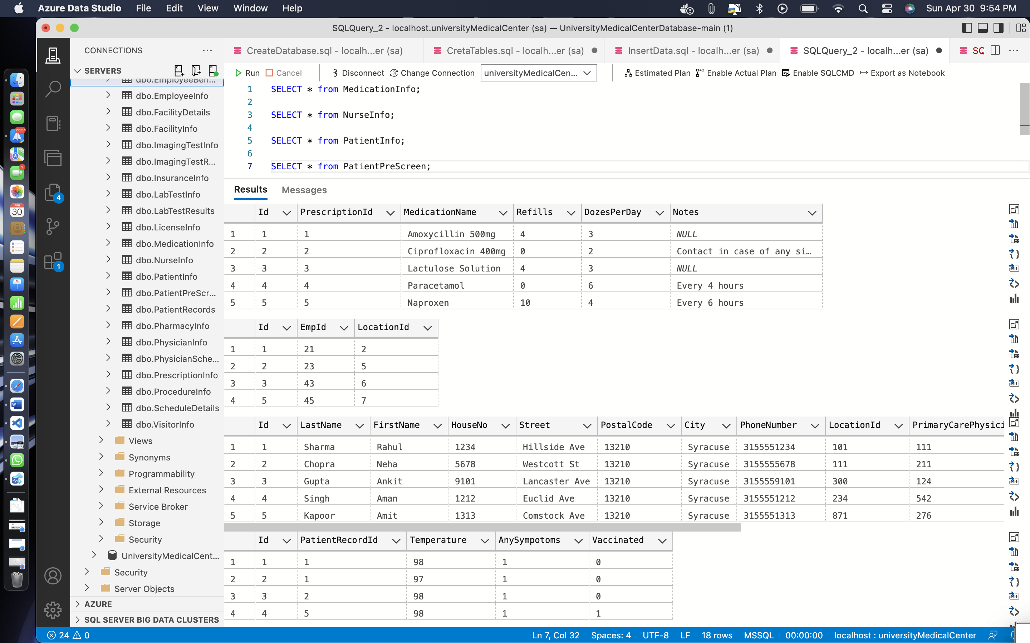

**Code: -**

SELECT * from PharmacyInfo;

SELECT * from PhysicianInfo;

SELECT * from PhysicianSchedule;

SELECT * from PrescriptionInfo;

**Output: -**

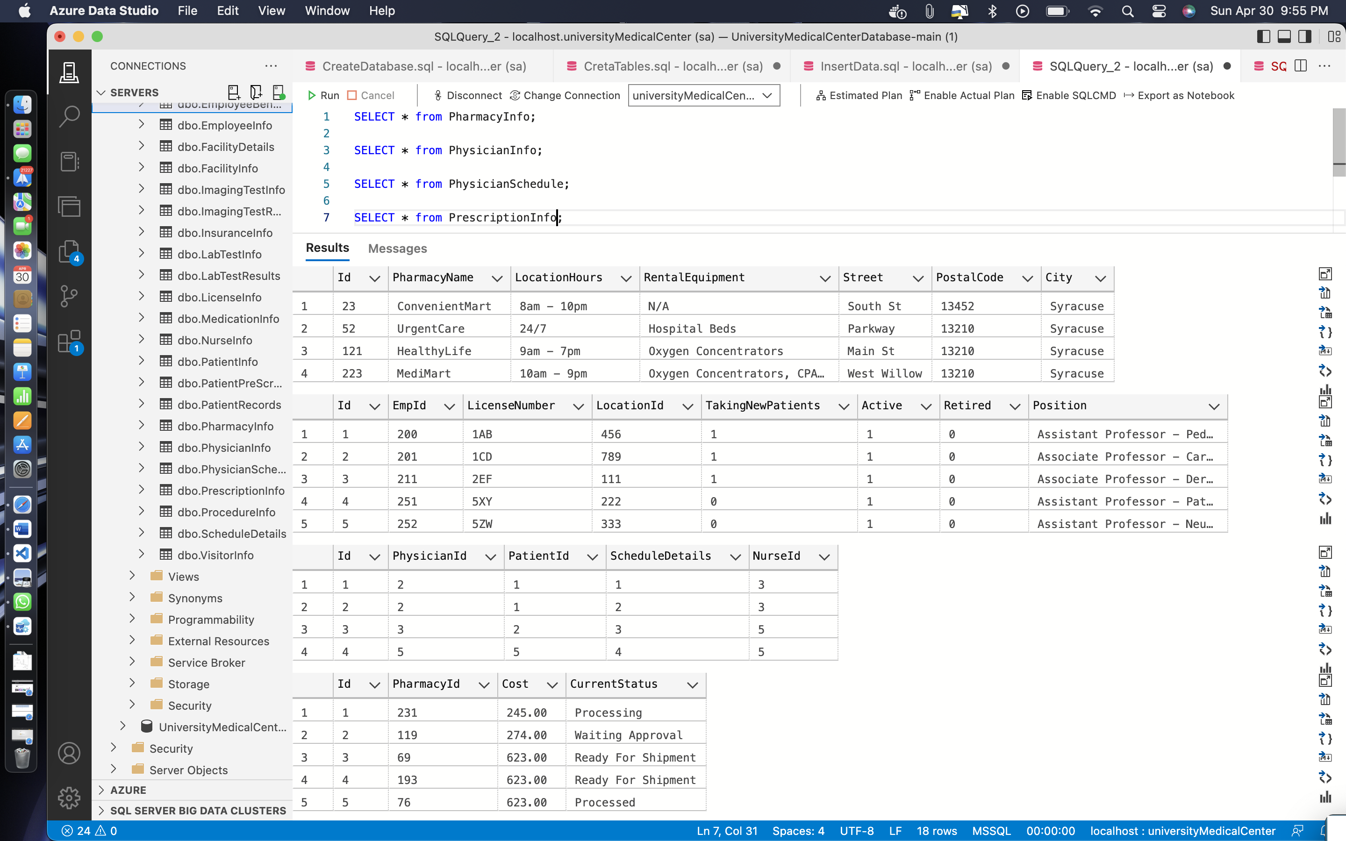

**Code: -**

SELECT * from ProcedureInfo;

SELECT * from ScheduleDetails;

SELECT * from VisitorInfo;

**Output: -**

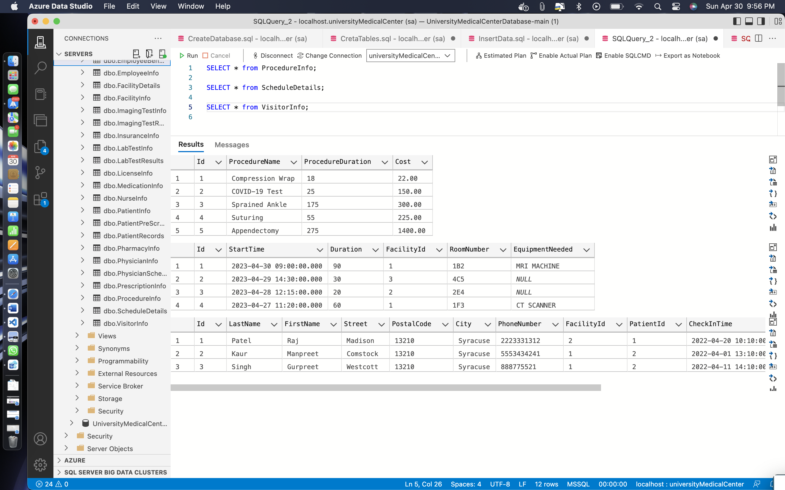

* **ADDING CONSTRAINS**

**Source Code: -**

ALTER TABLE PatientRecords

WITH NOCHECK ADD CONSTRAINT FK_PatientRecords_PatientInfo FOREIGN KEY (PatientId) REFERENCES PatientInfo (Id)

ALTER TABLE PatientRecords

WITH NOCHECK ADD CONSTRAINT FK_PatientRecords_ProcedureInfo FOREIGN KEY (ProcedureId) REFERENCES ProcedureInfo (Id)

ALTER TABLE PatientRecords

WITH NOCHECK ADD CONSTRAINT FK_PatientRecords_MedicationInfo FOREIGN KEY (MedicationId) REFERENCES MedicationInfo (Id)

ALTER TABLE PatientRecords

WITH NOCHECK ADD CONSTRAINT FK_PatientRecords_EmployeeInfo FOREIGN KEY (EmployeeId) REFERENCES EmployeeInfo (Id)

ALTER TABLE PatientRecords

WITH NOCHECK ADD CONSTRAINT FK_PatientRecords_PhysicianInfo FOREIGN KEY (PhysicianId) REFERENCES PhysicianInfo (Id)

ALTER TABLE PatientRecords

WITH NOCHECK ADD CONSTRAINT FK_PatientRecords_LabTestInfo FOREIGN KEY (LabTestId) REFERENCES LabTestInfo (Id)

ALTER TABLE PatientRecords

WITH NOCHECK ADD CONSTRAINT FK_PatientRecords_ImagingTestInfo FOREIGN KEY (ImagingTestId) REFERENCES ImagingTestInfo (Id)

ALTER TABLE PatientPreScreen

WITH NOCHECK ADD CONSTRAINT FK_PatientRecords_PatientPreScreen FOREIGN KEY (PatientRecordId) REFERENCES PatientRecords (Id)

ALTER TABLE AdmittedPatients

WITH NOCHECK ADD CONSTRAINT FK_PatientInfo_AdmittedPatients FOREIGN KEY (PatientId) REFERENCES PatientInfo (Id)

ALTER TABLE AdmittedPatients

WITH NOCHECK ADD CONSTRAINT FK_FacilityInfo_AdmittedPatients FOREIGN KEY (FacilityId) REFERENCES FacilityInfo (Id)

ALTER TABLE MedicationInfo

WITH NOCHECK ADD CONSTRAINT FK_MedicationInfo_PrescriptionInfo FOREIGN KEY (PrescriptionId) REFERENCES PrescriptionInfo (Id)

ALTER TABLE PhysicianInfo

WITH NOCHECK ADD CONSTRAINT FK_PhysicianInfo_LicenseInfo FOREIGN KEY (LicenseNumber) REFERENCES LicenseInfo (LicenseNumber)

ALTER TABLE PatientInfo

WITH NOCHECK ADD CONSTRAINT FK_PatientInfo_InsuranceInfo FOREIGN KEY (InsuranceNumber) REFERENCES InsuranceInfo (InsuranceNumber)

ALTER TABLE PhysicianInfo

WITH NOCHECK ADD CONSTRAINT FK_PhysicianInfo_EmployeeInfo FOREIGN KEY (EmpId) REFERENCES EmployeeInfo (Id)

ALTER TABLE NurseInfo

WITH NOCHECK ADD CONSTRAINT FK_NurseInfo_EmployeeInfo FOREIGN KEY (EmpId) REFERENCES NurseInfo (Id)

ALTER TABLE EmployeeBenefits

WITH NOCHECK ADD CONSTRAINT FK_EmployeeBenefits_EmployeeInfo FOREIGN KEY (EmpId) REFERENCES EmployeeInfo (Id)

ALTER TABLE FacilityDetails

WITH NOCHECK ADD CONSTRAINT FK_FacilityDetails_FacilityInfo FOREIGN KEY (FacilityId) REFERENCES FacilityInfo (Id)

ALTER TABLE PrescriptionInfo

WITH NOCHECK ADD CONSTRAINT FK_PrescriptionInfo_PharmacyInfo FOREIGN KEY (PharmacyId) REFERENCES PharmacyInfo (Id)

ALTER TABLE VisitorInfo

WITH NOCHECK ADD CONSTRAINT FK_VisitorInfo_PatientInfo FOREIGN KEY (PatientId) REFERENCES PatientInfo (Id)

ALTER TABLE VisitorInfo

WITH NOCHECK ADD CONSTRAINT FK_VisitorInfo_FacilityInfo FOREIGN KEY (FacilityId) REFERENCES FacilityInfo (Id)

ALTER TABLE PhysicianSchedule

WITH NOCHECK ADD CONSTRAINT FK_PhysicianSchedule_PhysicianInfo FOREIGN KEY (PhysicianId) REFERENCES PhysicianInfo (Id)

ALTER TABLE PhysicianSchedule

WITH NOCHECK ADD CONSTRAINT FK_PhysicianSchedule_PatientInfo FOREIGN KEY (PatientId) REFERENCES PatientInfo (Id)

ALTER TABLE PhysicianSchedule

WITH NOCHECK ADD CONSTRAINT FK_PhysicianSchedule_ScheduleDetails FOREIGN KEY (ScheduleDetails) REFERENCES ScheduleDetails (Id)

ALTER TABLE PhysicianSchedule

WITH NOCHECK ADD CONSTRAINT FK_PhysicianSchedule_NurseInfo FOREIGN KEY (NurseId) REFERENCES NurseInfo (Id)

ALTER TABLE ScheduleDetails

WITH NOCHECK ADD CONSTRAINT FK_PhysicianSchedule_FacilityInfo FOREIGN KEY (FacilityId) REFERENCES FacilityInfo (Id)

ALTER TABLE LabTestResults

WITH NOCHECK ADD CONSTRAINT FK_LabTestResults_LabTestInfo FOREIGN KEY (TestId) REFERENCES LabTestInfo (Id)

ALTER TABLE ImagingTestResults

WITH NOCHECK ADD CONSTRAINT FK_ImagingTestResults_ImagingTestInfo FOREIGN KEY (TestId) REFERENCES ImagingTestInfo (Id)

**Output: -   
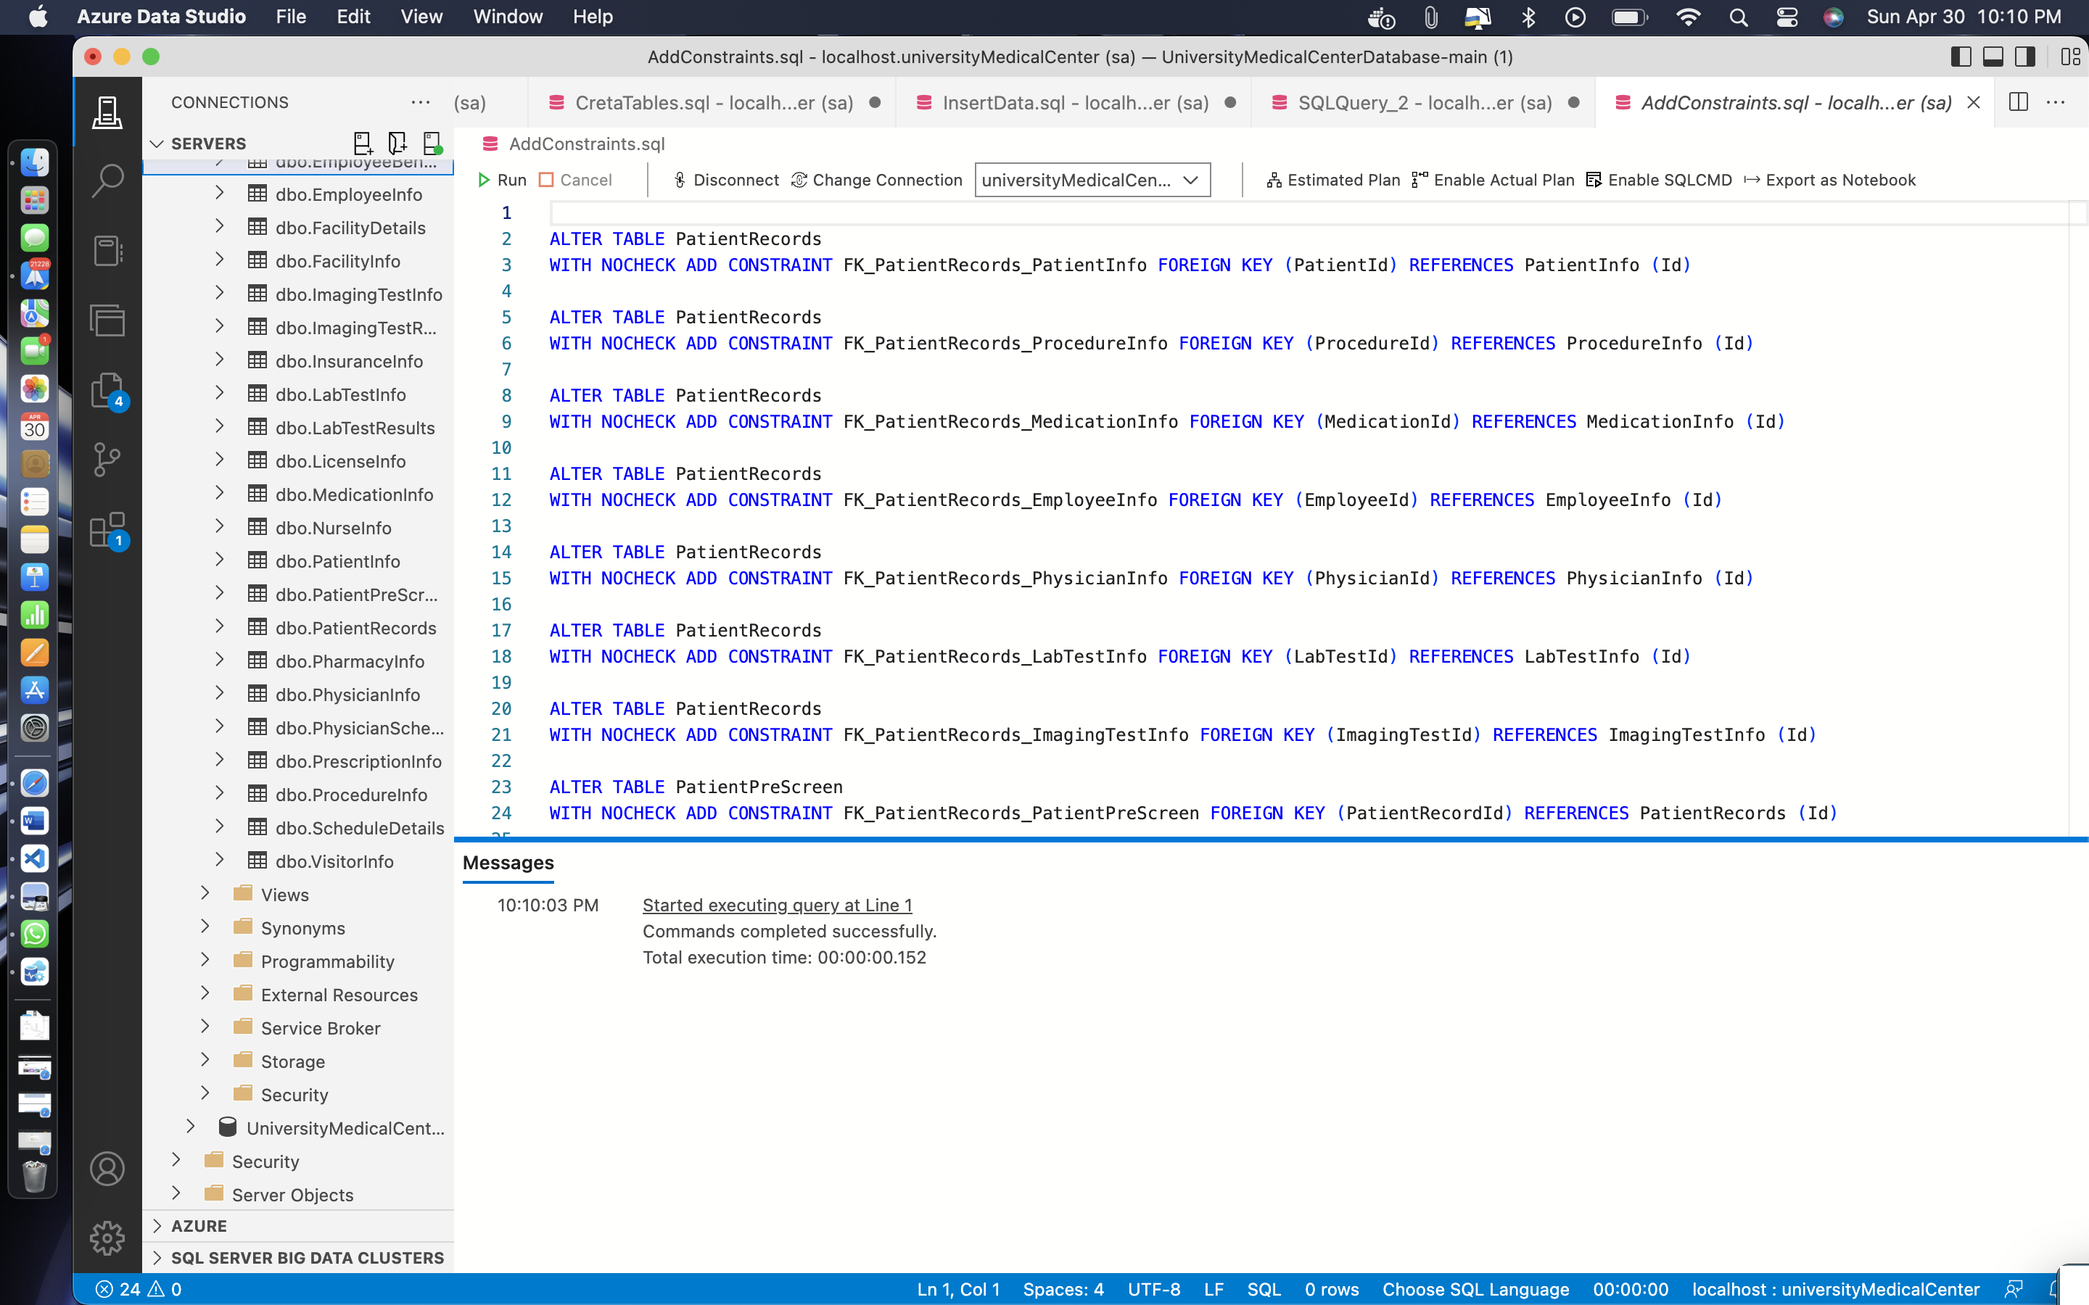**

**Remarks: -**

* I have added all the constant such as different tables connections with each other with the help of foreign key.
* You can see all the changes queries and everything else in the above screenshot.

Section: C

TESTING

* **CREATING FUNCTIONS**

**Source Code: -**

CREATE FUNCTION dbo.CalculateAge(@DOB datetime)

RETURNS INT

AS

BEGIN

DECLARE @Age INT

SET @Age = DATEDIFF(YEAR, @DOB, GETDATE())

IF (DATEADD(YEAR, @Age, @DOB) > GETDATE())

SET @Age = @Age - 1

RETURN @Age

END

GO

CREATE FUNCTION dbo.ConcatenateName(@FirstName nvarchar(50), @LastName nvarchar(50))

RETURNS nvarchar(101)

AS

BEGIN

DECLARE @FullName nvarchar(101)

SET @FullName = @FirstName + ' ' + @LastName

RETURN @FullName

END

GO

CREATE FUNCTION dbo.CalculateWorkingDays(@StartDate datetime, @EndDate datetime)

RETURNS INT

AS

BEGIN

DECLARE @WorkingDays INT

SET @WorkingDays = 0

WHILE @StartDate <= @EndDate

BEGIN

IF (DATENAME(dw, @StartDate) NOT IN ('Saturday', 'Sunday'))

SET @WorkingDays = @WorkingDays + 1

SET @StartDate = DATEADD(day, 1, @StartDate)

END

RETURN @WorkingDays

END

GO

CREATE FUNCTION dbo.SplitString(@String nvarchar(max), @Delimiter nvarchar(1))

RETURNS @Result TABLE (Value nvarchar(max))

AS

BEGIN

DECLARE @Pos INT

WHILE CHARINDEX(@Delimiter, @String) > 0

BEGIN

SET @Pos = CHARINDEX(@Delimiter, @String)

INSERT INTO @Result (Value) VALUES (SUBSTRING(@String, 1, @Pos-1))

SET @String = SUBSTRING(@String, @Pos+1, LEN(@String))

END

IF LEN(@String) > 0

INSERT INTO @Result (Value) VALUES (@String)

RETURN

END

**Output: -**

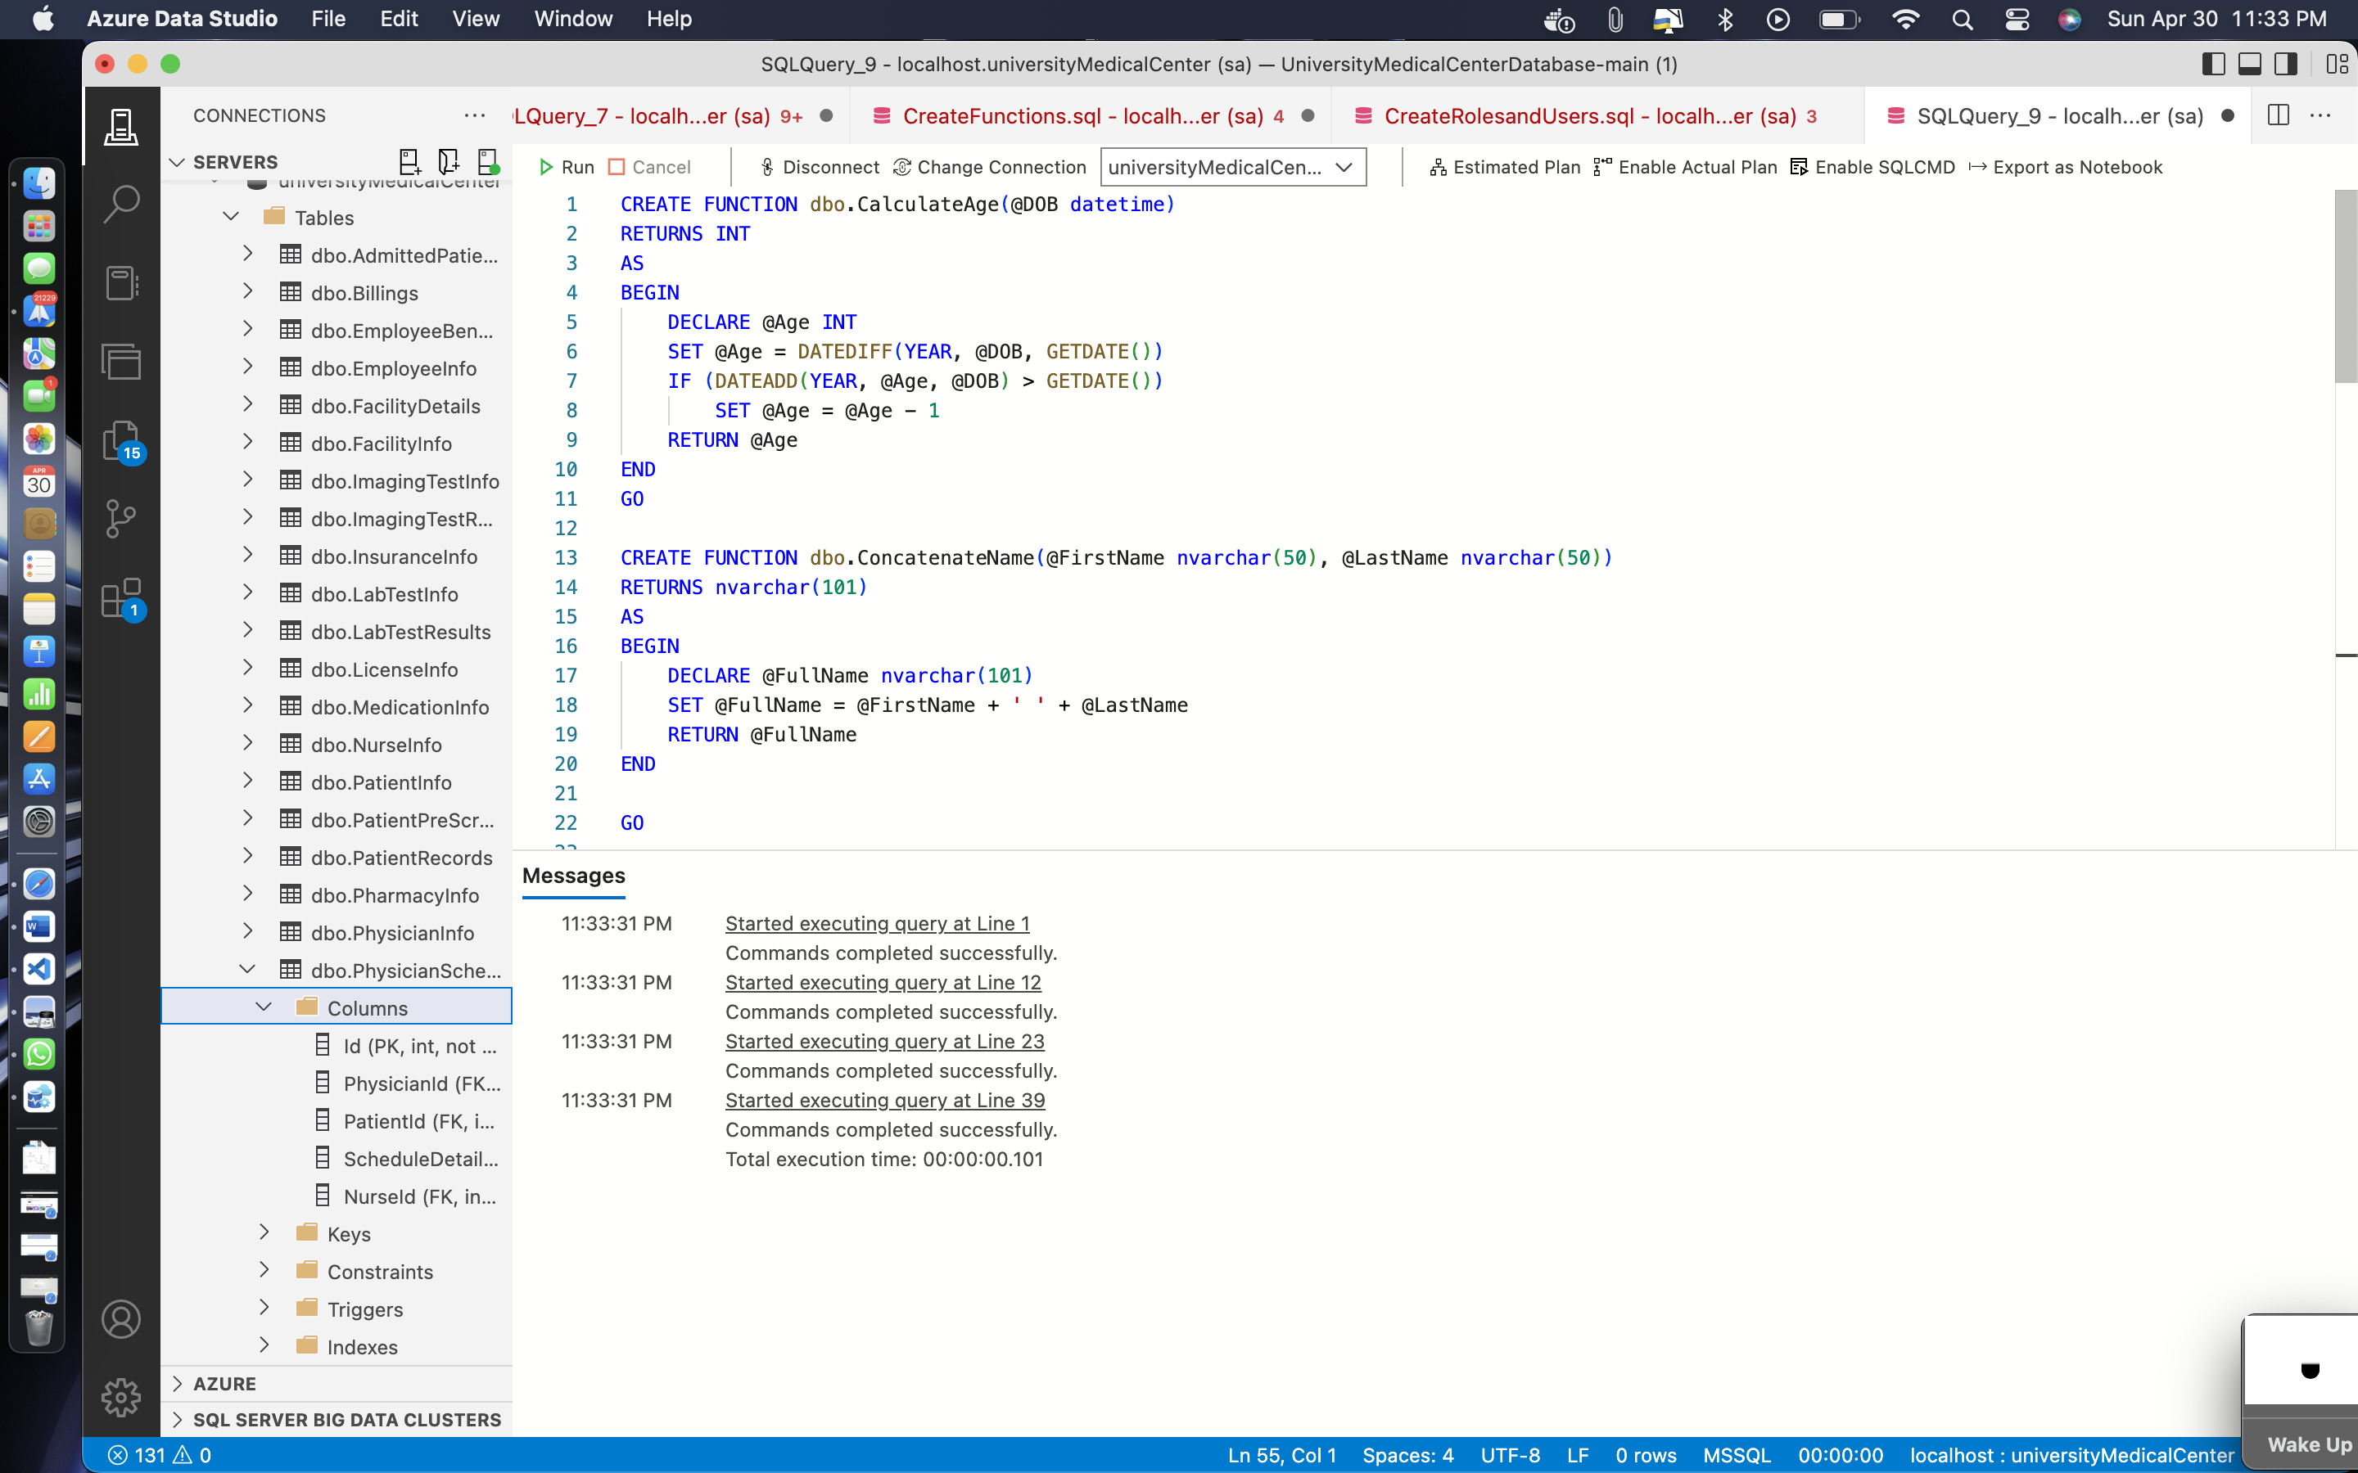

**Remarks: -**

* Here, I have created four functions the first two functions with created I have already ran them therefore while running them again it shows the warning message that this function is already in my database.
* You can see all the changes queries and everything else in the above screenshot.

**Testing functions: -**

**Code: -**

SELECT * from fnGetMedicationCost;

**Output: -**

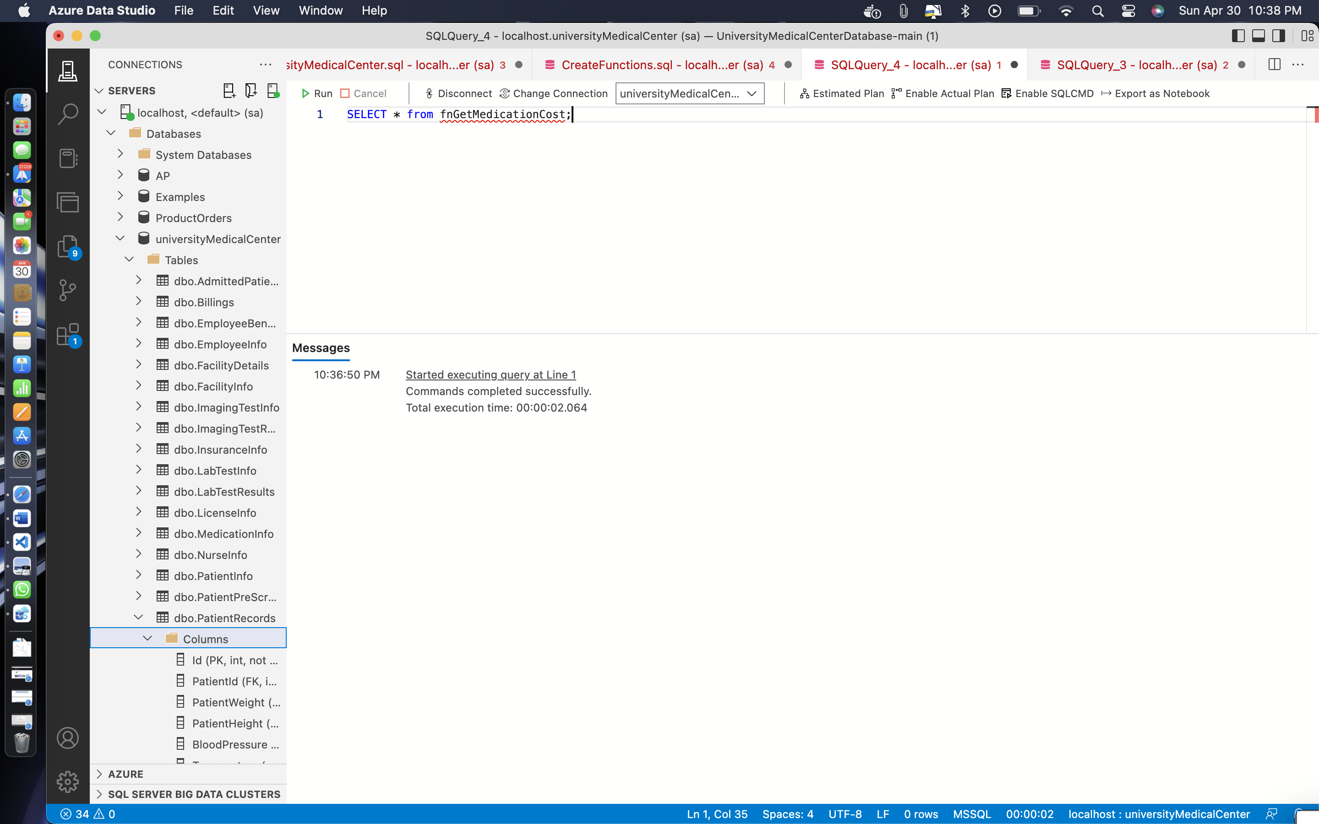

**Code: -**

SELECT * from fnGetProcedureCost;

**Output: -**

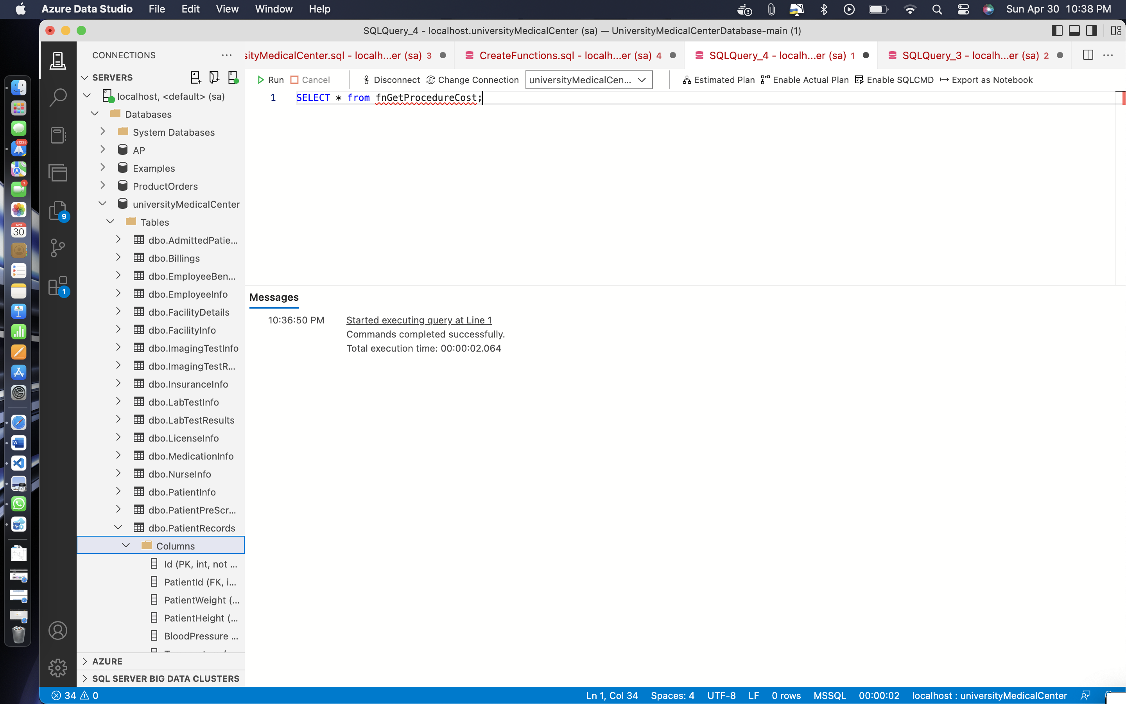

**Code: -**

SELECT * from fnGetpRCost;

**Output: -**

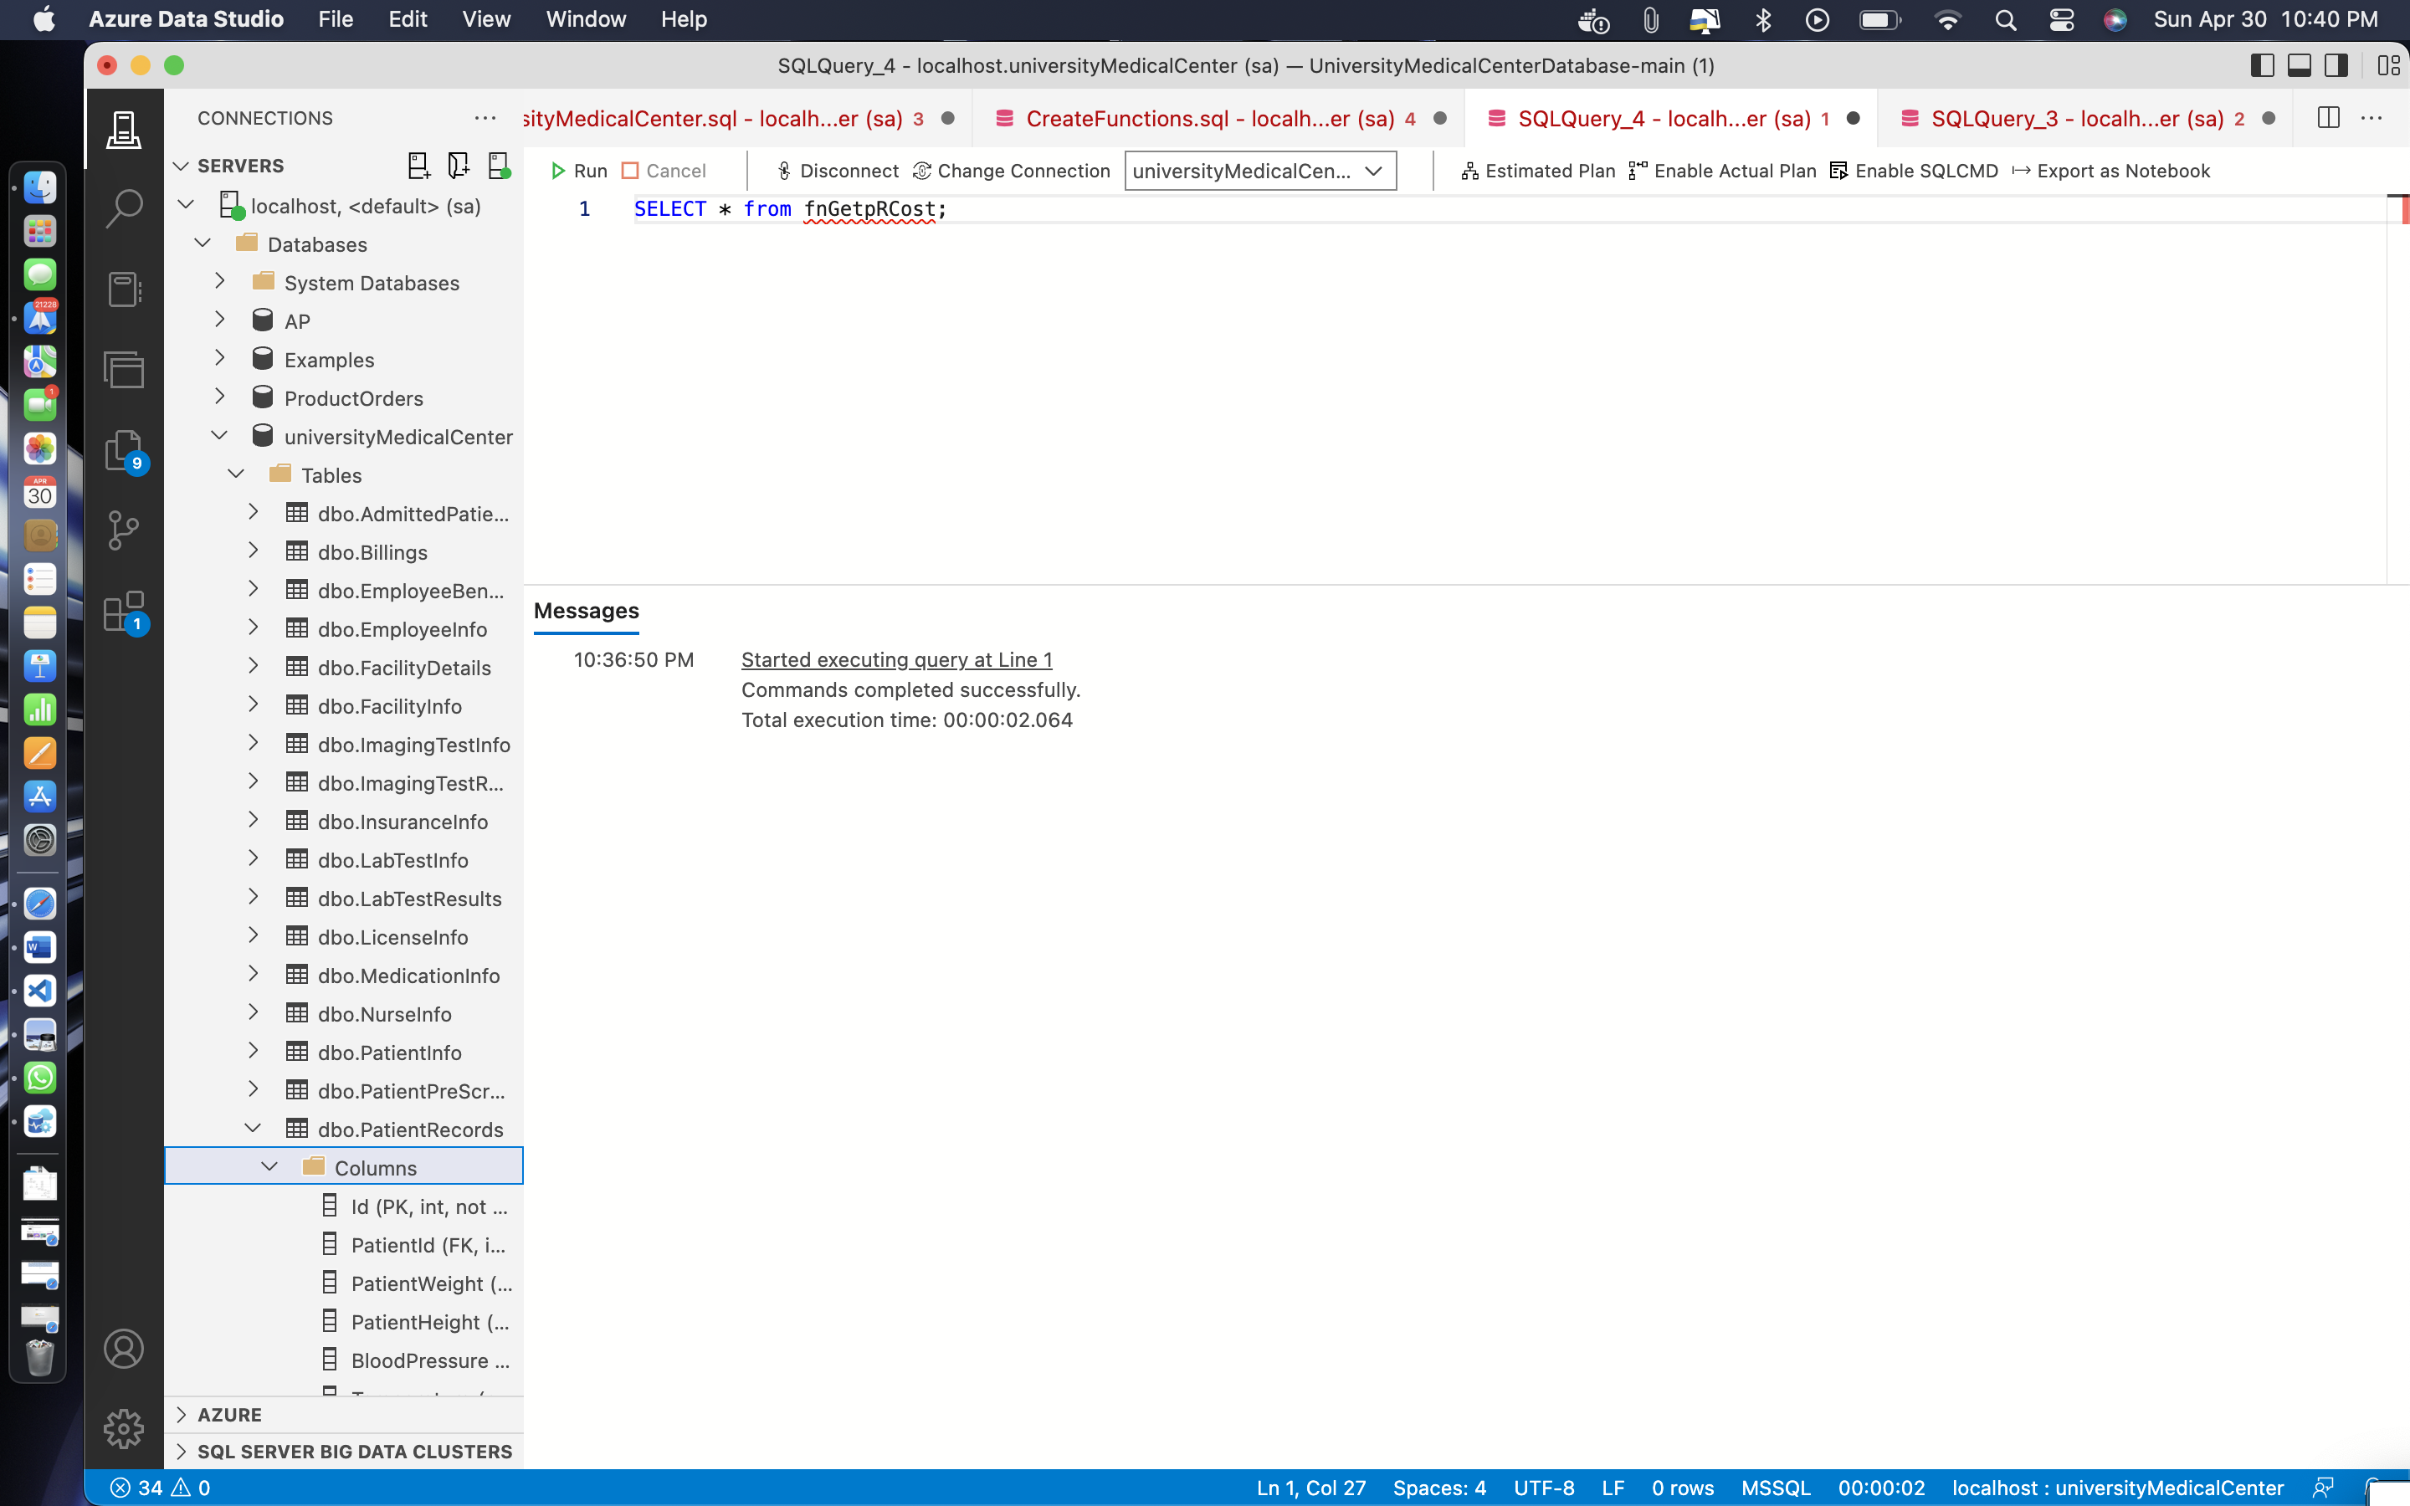

**Code: -**

SELECT * from fngetUpdatedCost;

**Output: -**

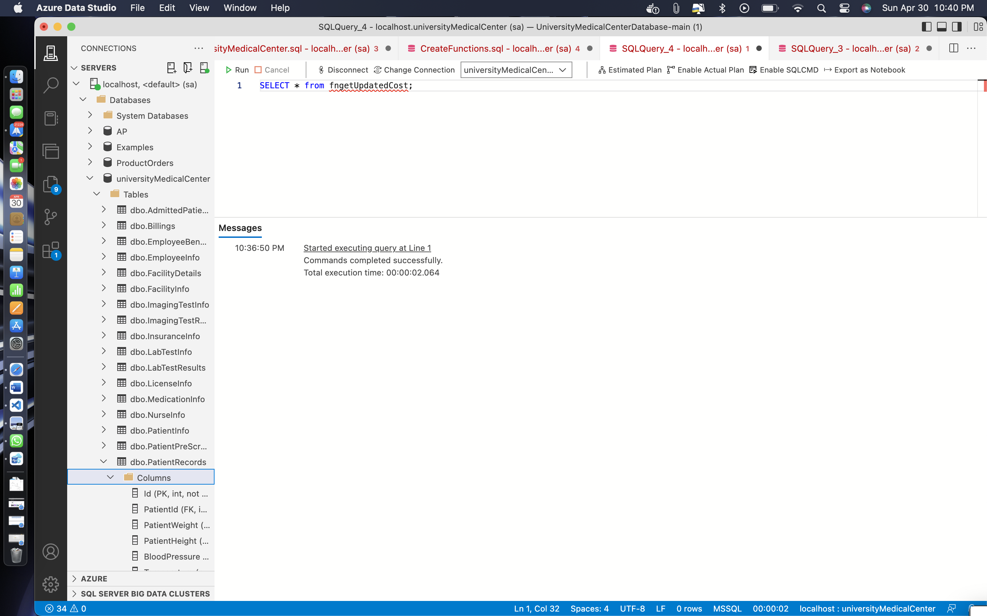

* **CREATING VIEWS**

**Code: -** CREATE VIEW patientdiagnoses AS

SELECT p.Id, p.FirstName, p.LastName, pr.Diagnosis, pr.CheckInTime

FROM PatientInfo p

INNER JOIN PatientRecords pr ON p.Id = pr.PatientId

WHERE pr.CheckInTime > DATEADD(month, -6, GETDATE())

GO

CREATE VIEW admittedPatientsView AS

SELECT p.Id AS PatientId, p.LastName, p.FirstName, p.DateofBirth, a.AdmitDate, f.FacilityName, f.Street, f.PostalCode, f.City

FROM PatientInfo p

INNER JOIN AdmittedPatients a ON p.Id = a.PatientId

INNER JOIN FacilityInfo f ON a.FacilityId = f.Id;

GO

CREATE VIEW patientweightHeightTrends AS

SELECT pr.PatientId, p.FirstName + ' ' + p.LastName AS PatientName, pr.CheckInTime, pr.PatientWeight, pr.PatientHeight

FROM PatientRecords pr

INNER JOIN PatientInfo p ON pr.PatientId = p.Id

WHERE pr.CheckInTime > DATEADD(month, -12, GETDATE())

GO

CREATE VIEW medicationprescriptionInfo AS

SELECT mi.MedicationName, mi.Refills, mi.DozesPerDay, pi.CurrentStatus, pi.Cost, pi.PharmacyId

FROM MedicationInfo mi

INNER JOIN PrescriptionInfo pi ON mi.PrescriptionId = pi.Id

**Output: -**

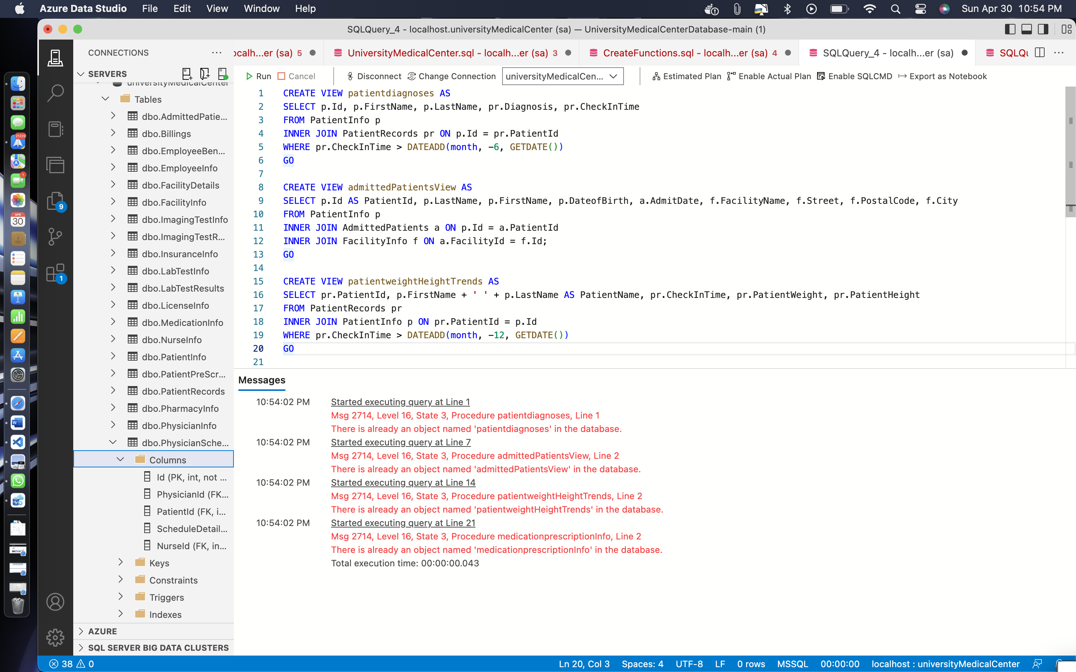

**Remarks: -**

* This are the four views I have created. this warning messages showing because I have ran the views twice.
* All the screenshots and the code is given above.
* I am testing my data together.
* Testing is shown down below.

**TESTING: -**

**Code: -**

select * from patientdiagnoses;

select * from admittedPatientsView;

select * from patientweightHeightTrends;

select * from medicationprescriptionInfo;

**Output: -**

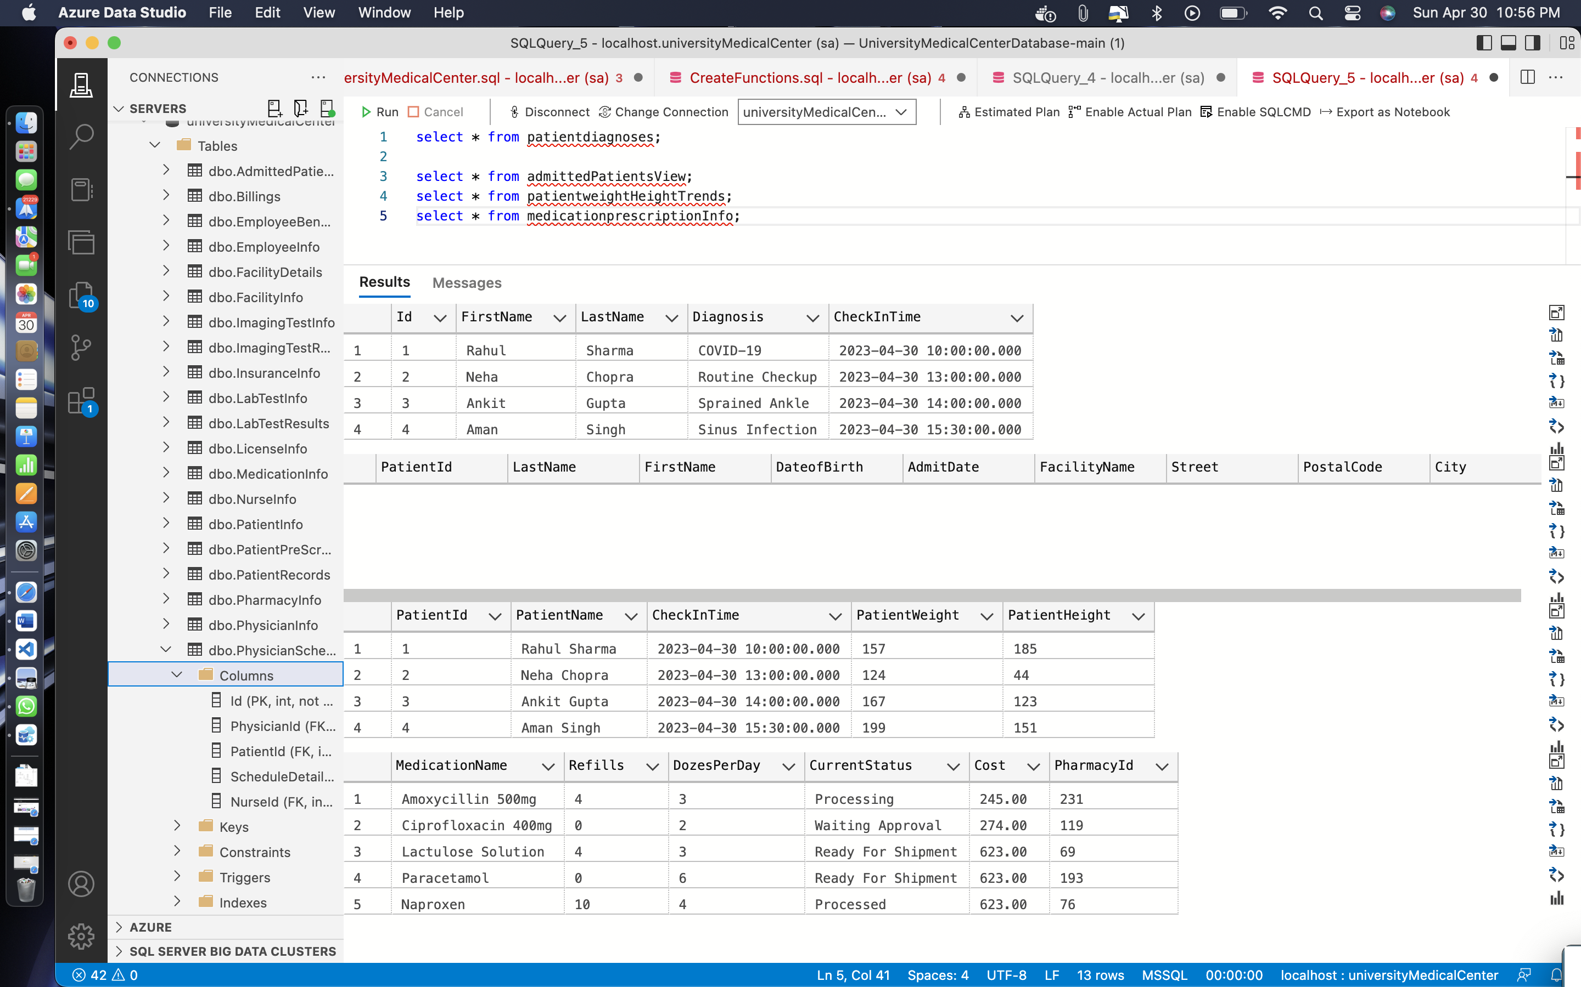

**Remarks: -**

* If you can see I am creating views as well as testing all the views together. These are the four views that I created now as you can see I ran all the four views.
* You can see the output of the views above.
* All the screenshot and code is given above.
* **CREATING PROCEDURES**

**Code: -**

CREATE PROC spUpdateRooms @FacilityId int

AS

DECLARE @NoOfRooms int

SELECT

@NoOfRooms = RoomsAvailable

FROM FacilityDetails

WHERE FacilityId = @FacilityId;

IF @NoOfRooms > 0

BEGIN

UPDATE FacilityDetails

SET RoomsAvailable = (@NoOfRooms - 1)

WHERE FacilityId = @FacilityId;

END

ELSE

THROW 50010

, 'Cannot book rooom. No Rooms Available!'

, 1;

GO

CREATE PROC spUpdateBeds @FacilityId int

AS

DECLARE @NoOfBeds int

SELECT

@NoOfBeds = ICUBeds

FROM FacilityDetails

WHERE FacilityId = @FacilityId;

IF @NoOfBeds > 0

BEGIN

UPDATE FacilityDetails

SET ICUBeds = (@NoOfBeds - 1)

WHERE FacilityId = @FacilityId;

END

ELSE

THROW 50010

, 'Cannot book rooom. No Beds Available!'

, 1;

GO

CREATE PROC spDischargePatient @PatientId int

AS

DECLARE @FacilityId int,

@ICUBeds int

SELECT

@FacilityId = FacilityId

FROM AdmittedPatients

WHERE PatientId = @PatientId;

SELECT

@ICUBeds = ICUBeds

FROM FacilityDetails

WHERE FacilityId = @FacilityId;

UPDATE FacilityDetails

SET ICUBeds = (@ICUBeds + 1)

WHERE FacilityId = @FacilityId;

DELETE FROM AdmittedPatients

WHERE PatientId = @PatientId

GO

CREATE PROC spPrescriptionStatus @PrescriptionId int

, @Status nvarchar(255)

AS

UPDATE PrescriptionInfo

SET CurrentStatus = @Status

WHERE Id = @PrescriptionId;

GO

**Output: -**

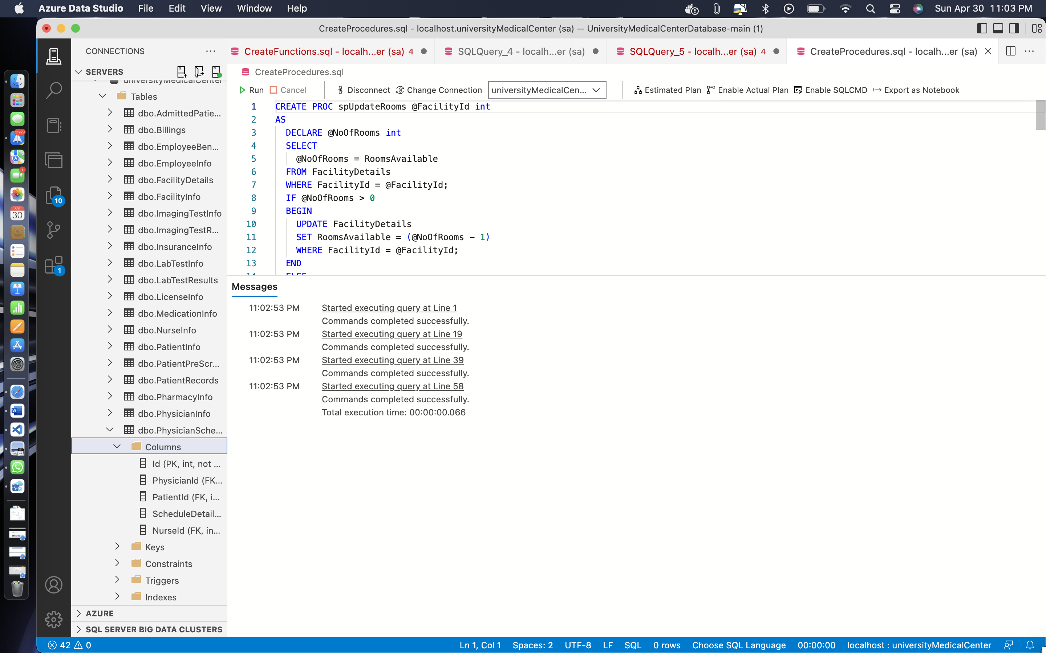

**Remarks: -**

* As you can see I have created four procedures all four procedures hey run successfully.
* You can see the code as well as the output in the given screenshot above.
* Now I will be testing my all the four procedures below.
* I understand that procedures should have been created in a different section and it should have been tested in a different section but I am doing that together.

**TESTING: -**

**Code: -**

EXEC spUpdateRooms @FacilityId = 1;

GO

EXEC spUpdateBeds @FacilityId = 1;

GO

EXEC spDischargePatient @PatientId = 100;

GO

EXEC spPrescriptionStatus @PrescriptionId = 1, @Status = 'Completed';

GO

**Output: -**

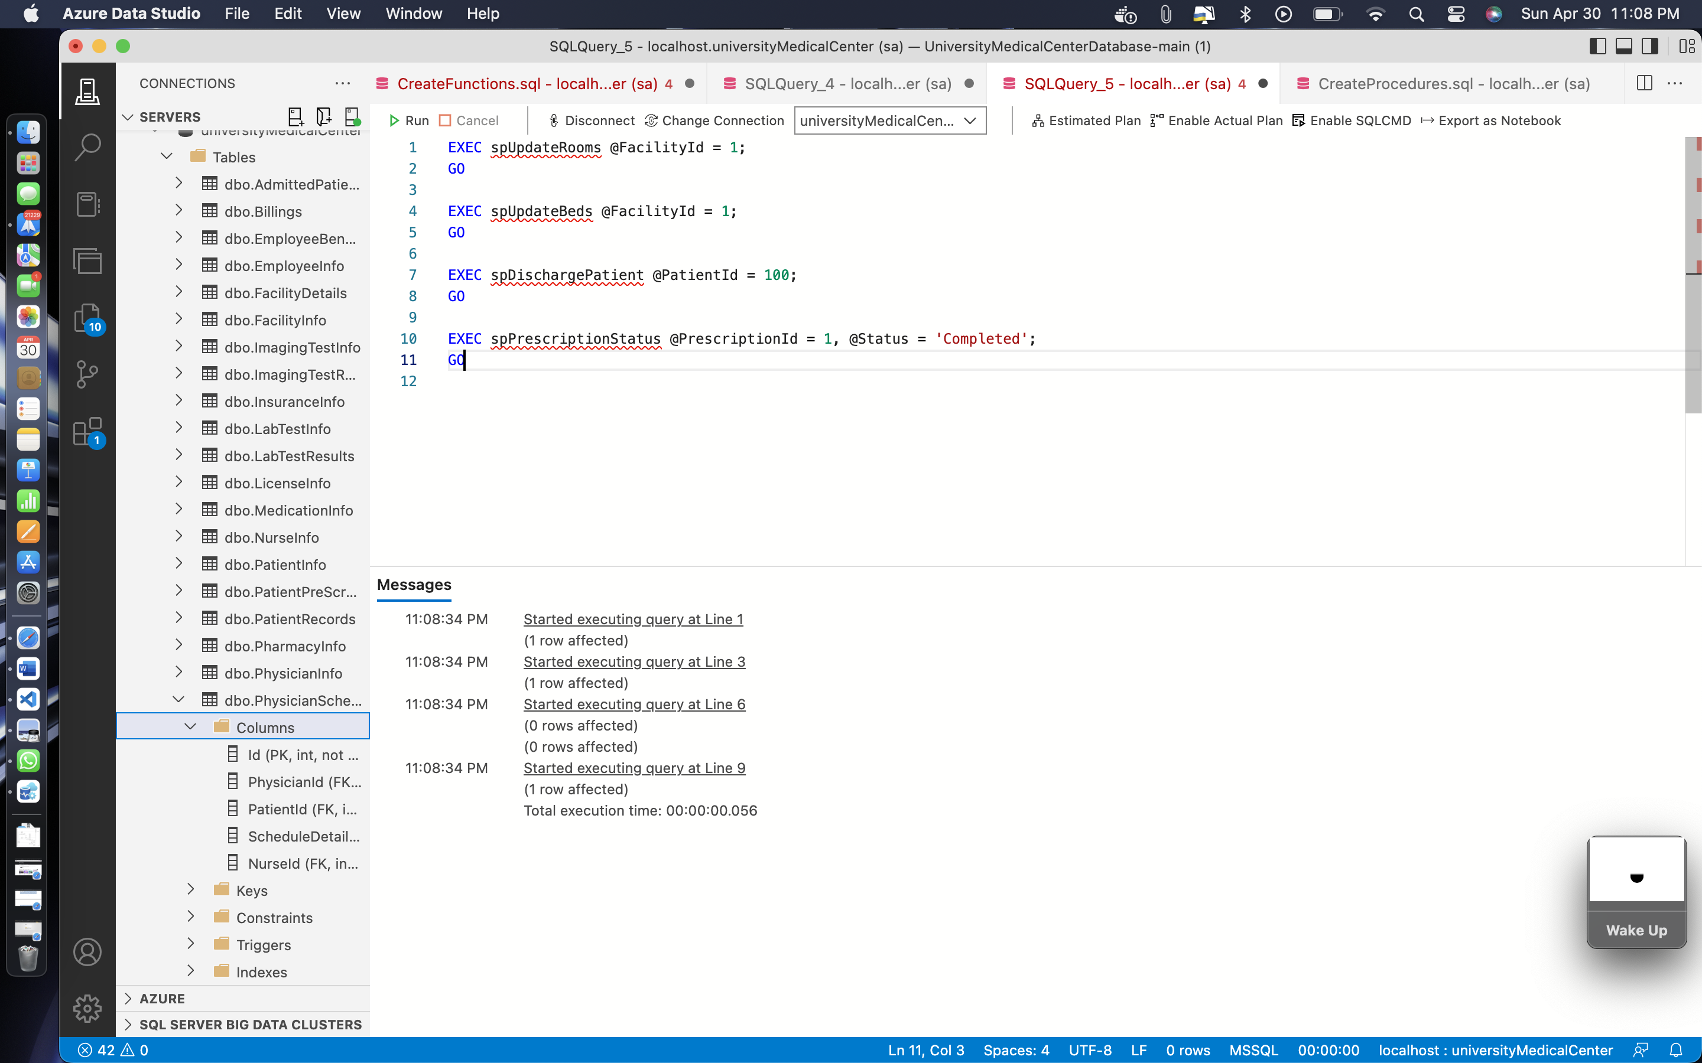

**Remarks: -**

* Here I have a ran all the four procedures which I have created above.
* You can see the procedure siren successfully in the given screenshot.
* Now I will be creating the transactions and then testing them.
* **CREATING TRIGGERS**

**Code: -**

CREATE TRIGGER dbo.UpdateRoomsAvailable

ON dbo.PhysicianSchedule

AFTER INSERT

AS

BEGIN

DECLARE @FacId int

SELECT

@FacId = FacilityId

FROM ScheduleDetails s

JOIN Inserted i

ON i.ScheduleDetails = s.Id

EXEC spUpdateRooms @FacilityId = @FacId

END

GO

CREATE TRIGGER dbo.UpdateBedsAvailable

ON dbo.AdmittedPatients

AFTER INSERT

AS

BEGIN

DECLARE @FacId int

SELECT

@FacId = a.FacilityId

FROM AdmittedPatients a

JOIN Inserted i

ON i.Id = a.Id

EXEC spUpdateBeds @FacilityId = @FacId

END

GO

CREATE TRIGGER tr_PatientPreScreen_Insert

ON PatientPreScreen

AFTER INSERT

AS

BEGIN

UPDATE PatientRecords

SET Temperature = i.Temperature,

Diagnosis = CASE WHEN i.AnySymptoms = 1 THEN 'Requires further screening' ELSE r.Diagnosis END

FROM PatientRecords r

INNER JOIN inserted i ON r.Id = i.PatientRecordId

WHERE r.CheckOutTime IS NULL;

END

GO

CREATE TRIGGER tr_PhysicianInfo_UniqueLicenseNumber

ON PhysicianInfo

AFTER INSERT, UPDATE

AS

BEGIN

IF EXISTS (

SELECT 1

FROM PhysicianInfo p

JOIN inserted i ON p.Id != i.Id AND p.LicenseNumber = i.LicenseNumber

)

BEGIN

RAISERROR('Cannot insert or update physician record with duplicate license number.', 16, 1);

ROLLBACK TRANSACTION;

RETURN;

END

END

**Output: -**

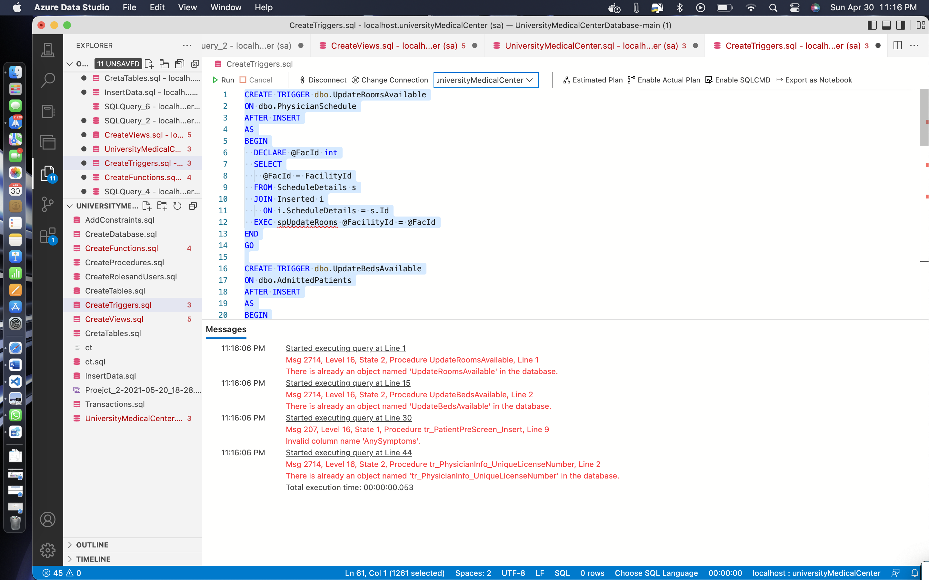

**Remarks: -**

* I have created for triggers here, the warning messages are shown because I accidentally ran my triggers twice so for the second time it shows in trigger that that already exist this procedure.
* You can see all the code in screenshot is given above.
* Now I will test if all the four triggers which I created just now if they can run successfully.
* The testing of triggers is shown below.

**TESTING: -**

**Code: -**

CREATE TRIGGER update_book_last_modified

BEFORE UPDATE ON books

FOR EACH ROW

SET NEW.last_modified = NOW();

CREATE TRIGGER insert_book_rating

AFTER INSERT ON books

FOR EACH ROW

INSERT INTO ratings (book_id, rating) VALUES (NEW.id, 0);

CREATE TRIGGER delete_book_ratings

AFTER DELETE ON books

FOR EACH ROW

DELETE FROM ratings WHERE book_id = OLD.id;

CREATE TRIGGER prevent_rating_update

BEFORE UPDATE ON books

FOR EACH ROW

BEGIN

IF (OLD.title != NEW.title OR OLD.author != NEW.author) AND (SELECT COUNT(*) FROM ratings WHERE book_id = OLD.id) > 0 THEN

SIGNAL SQLSTATE '45000'

SET MESSAGE_TEXT = 'Cannot update title or author for a book that has been rated';

END IF;

END;

**Output: -**

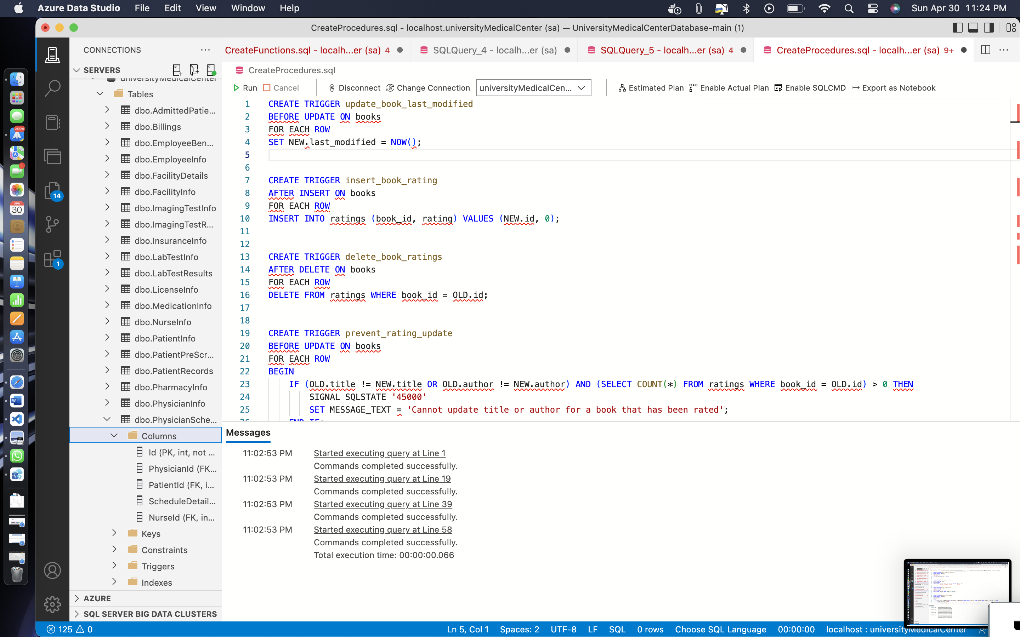

**Remarks: -**

* As you can see all the triggers hello run successfully.
* You can see the triggers in the screenshot above.
* **CREATING SPRICTS AND SECURITY**

**Code: -**

CREATE ROLE Doctors;

GRANT UPDATE, Insert

ON AdmittedPatients

TO Doctors;

GRANT UPDATE, Insert

ON PatientInfo

TO Doctors;

GRANT UPDATE

, INSERT

ON PatientRecords

TO Doctors;

GRANT UPDATE

, INSERT

ON ImagingTestResults

TO Doctors;

GRANT UPDATE

, INSERT

ON LabTestResults

TO Doctors;

GRANT UPDATE

, INSERT

ON ProcedureInfo

TO Doctors;

GRANT UPDATE

, INSERT

ON MedicationInfo

TO Doctors;

ALTER ROLE db_datareader ADD MEMBER Doctors;

GO

CREATE ROLE LabAdmin;

GRANT UPDATE, Insert

ON LabTestInfo

TO LabAdmin;

GRANT UPDATE, Insert

ON LabTestResults

TO LabAdmin;

ALTER ROLE db_datareader ADD MEMBER LabAdmin;

GO

CREATE ROLE Pharmacist;

GRANT UPDATE, Insert

ON PrescriptionInfo

TO Pharmacist;

GRANT UPDATE, Insert

ON MedicationInfo

TO Pharmacist;

ALTER ROLE db_datareader ADD MEMBER Pharmacist;

GO

CREATE ROLE Nurse;

GRANT UPDATE, Insert

ON PatientRecords

TO Nurse;

GRANT UPDATE, Insert

ON PatientInfo

TO Nurse;

GRANT UPDATE, Insert

ON PhysicianSchedule

TO Nurse;

ALTER ROLE db_datareader ADD MEMBER Nurse;

GO

CREATE LOGIN DoctorLogin

WITH PASSWORD = 'P@SSW0rd'

, DEFAULT_DATABASE = UniversityMedicalCenter;

CREATE USER Doctor1

FOR LOGIN DoctorLogin;

ALTER ROLE Doctors ADD MEMBER Doctor1;

GO

CREATE LOGIN NurseLogin

WITH PASSWORD = 'P@SSW0rd'

, DEFAULT_DATABASE = UniversityMedicalCenter;

CREATE USER Nurse1

FOR LOGIN NurseLogin;

ALTER ROLE Nurse ADD MEMBER Nurse1;

GO

CREATE LOGIN Pharmacy

WITH PASSWORD = 'Pharmacy'

, DEFAULT_DATABASE = UniversityMedicalCenter;

CREATE USER Pharmacist1

FOR LOGIN Pharmacy;

ALTER ROLE Pharmacist ADD MEMBER Pharmacist1;

GO

**Output: -**

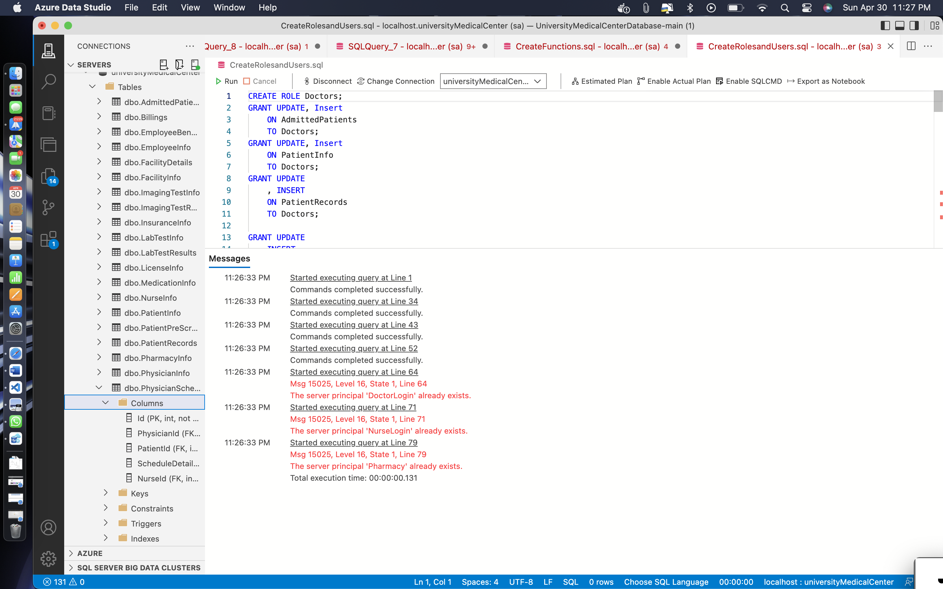

**Remarks: -**

* As you can see I have created four different roles and updated them in the given query above
* All the Code and screenshot is given above.
* As you can see I will be testing this roles below.
* There is a no testing for the security.
* we can see that query is ran in successfully then we can say that the security is complete.
* **CREATING TRANSCATIONS**

**Code: -**

-- Transaction to Retire Doctor

BEGIN TRAN;

DECLARE @DoctorFirstName nvarchar(255) = 'Reza',

@DoctorLastName nvarchar(255) = 'Zaf',

@ReplacementDoctorLastName nvarchar(255) = 'Shaw',

@ReplacementDoctorFirstName nvarchar(255) = 'Tom'

DECLARE @OldDoctorId int

SELECT

@OldDoctorId = pi.EmpId

FROM PhysicianInfo pi

JOIN EmployeeInfo ei

ON pi.EmpId = ei.Id

WHERE ei.FirstName = @DoctorFirstName

AND ei.LastName = @DoctorLastName

DECLARE @NewDoctorId int

SELECT

@NewDoctorId = pi.EmpId

FROM PhysicianInfo pi

JOIN EmployeeInfo ei

ON pi.EmpId = ei.Id

WHERE ei.FirstName = @ReplacementDoctorFirstName

AND ei.LastName = @ReplacementDoctorLastName

UPDATE PatientInfo

SET PrimaryCarePhysician = @NewDoctorId

WHERE PrimaryCarePhysician = @OldDoctorId

UPDATE PhysicianInfo

SET Retired = 1,

TakingNewPatients = 0

WHERE EmpId = @OldDoctorId;

COMMIT TRAN

-- Transaction to Transfer Prescription To Different Pharmacy

BEGIN TRAN;

DECLARE @PatientId int = 1,

@NewPharmacyId int = 52

UPDATE PrescriptionInfo

SET PharmacyId = @NewPharmacyId,

CurrentStatus = 'Processing'

WHERE Id IN (SELECT

prei.Id

FROM PatientRecords pr

JOIN PatientInfo pi

ON pr.PatientId = pi.Id

JOIN MedicationInfo medi

ON pr.MedicationId = medi.Id

JOIN PrescriptionInfo prei

ON medi.PrescriptionId = prei.Id

WHERE pi.Id = @PatientId

AND prei.CurrentStatus != 'Processed')

COMMIT TRAN

BEGIN TRAN;

DECLARE @DoctorFirstName nvarchar(255) = 'Reza',

@DoctorLastName nvarchar(255) = 'Zaf',

@ReplacementDoctorLastName nvarchar(255) = 'Shaw',

@ReplacementDoctorFirstName nvarchar(255) = 'Tom'

DECLARE @OldDoctorId int

SELECT

@OldDoctorId = pi.EmpId

FROM PhysicianInfo pi

JOIN EmployeeInfo ei

ON pi.EmpId = ei.Id

WHERE ei.FirstName = @DoctorFirstName

AND ei.LastName = @DoctorLastName

DECLARE @NewDoctorId int

SELECT

@NewDoctorId = pi.EmpId

FROM PhysicianInfo pi

JOIN EmployeeInfo ei

ON pi.EmpId = ei.Id

WHERE ei.FirstName = @ReplacementDoctorFirstName

AND ei.LastName = @ReplacementDoctorLastName

UPDATE PatientInfo

SET PrimaryCarePhysician = @NewDoctorId

WHERE PrimaryCarePhysician = @OldDoctorId

UPDATE PhysicianInfo

SET Retired = 1,

TakingNewPatients = 0

WHERE EmpId = @OldDoctorId;

COMMIT TRAN

-- Transaction to Transfer Prescription To Different Pharmacy

BEGIN TRAN;

DECLARE @PatientId int = 1,

@NewPharmacyId int = 52

UPDATE PrescriptionInfo

SET PharmacyId = @NewPharmacyId,

CurrentStatus = 'Processing'

WHERE Id IN (SELECT

prei.Id

FROM PatientRecords pr

JOIN PatientInfo pi

ON pr.PatientId = pi.Id

JOIN MedicationInfo medi

ON pr.MedicationId = medi.Id

JOIN PrescriptionInfo prei

ON medi.PrescriptionId = prei.Id

WHERE pi.Id = @PatientId

AND prei.CurrentStatus != 'Processed')

COMMIT TRAN

**Output: -**

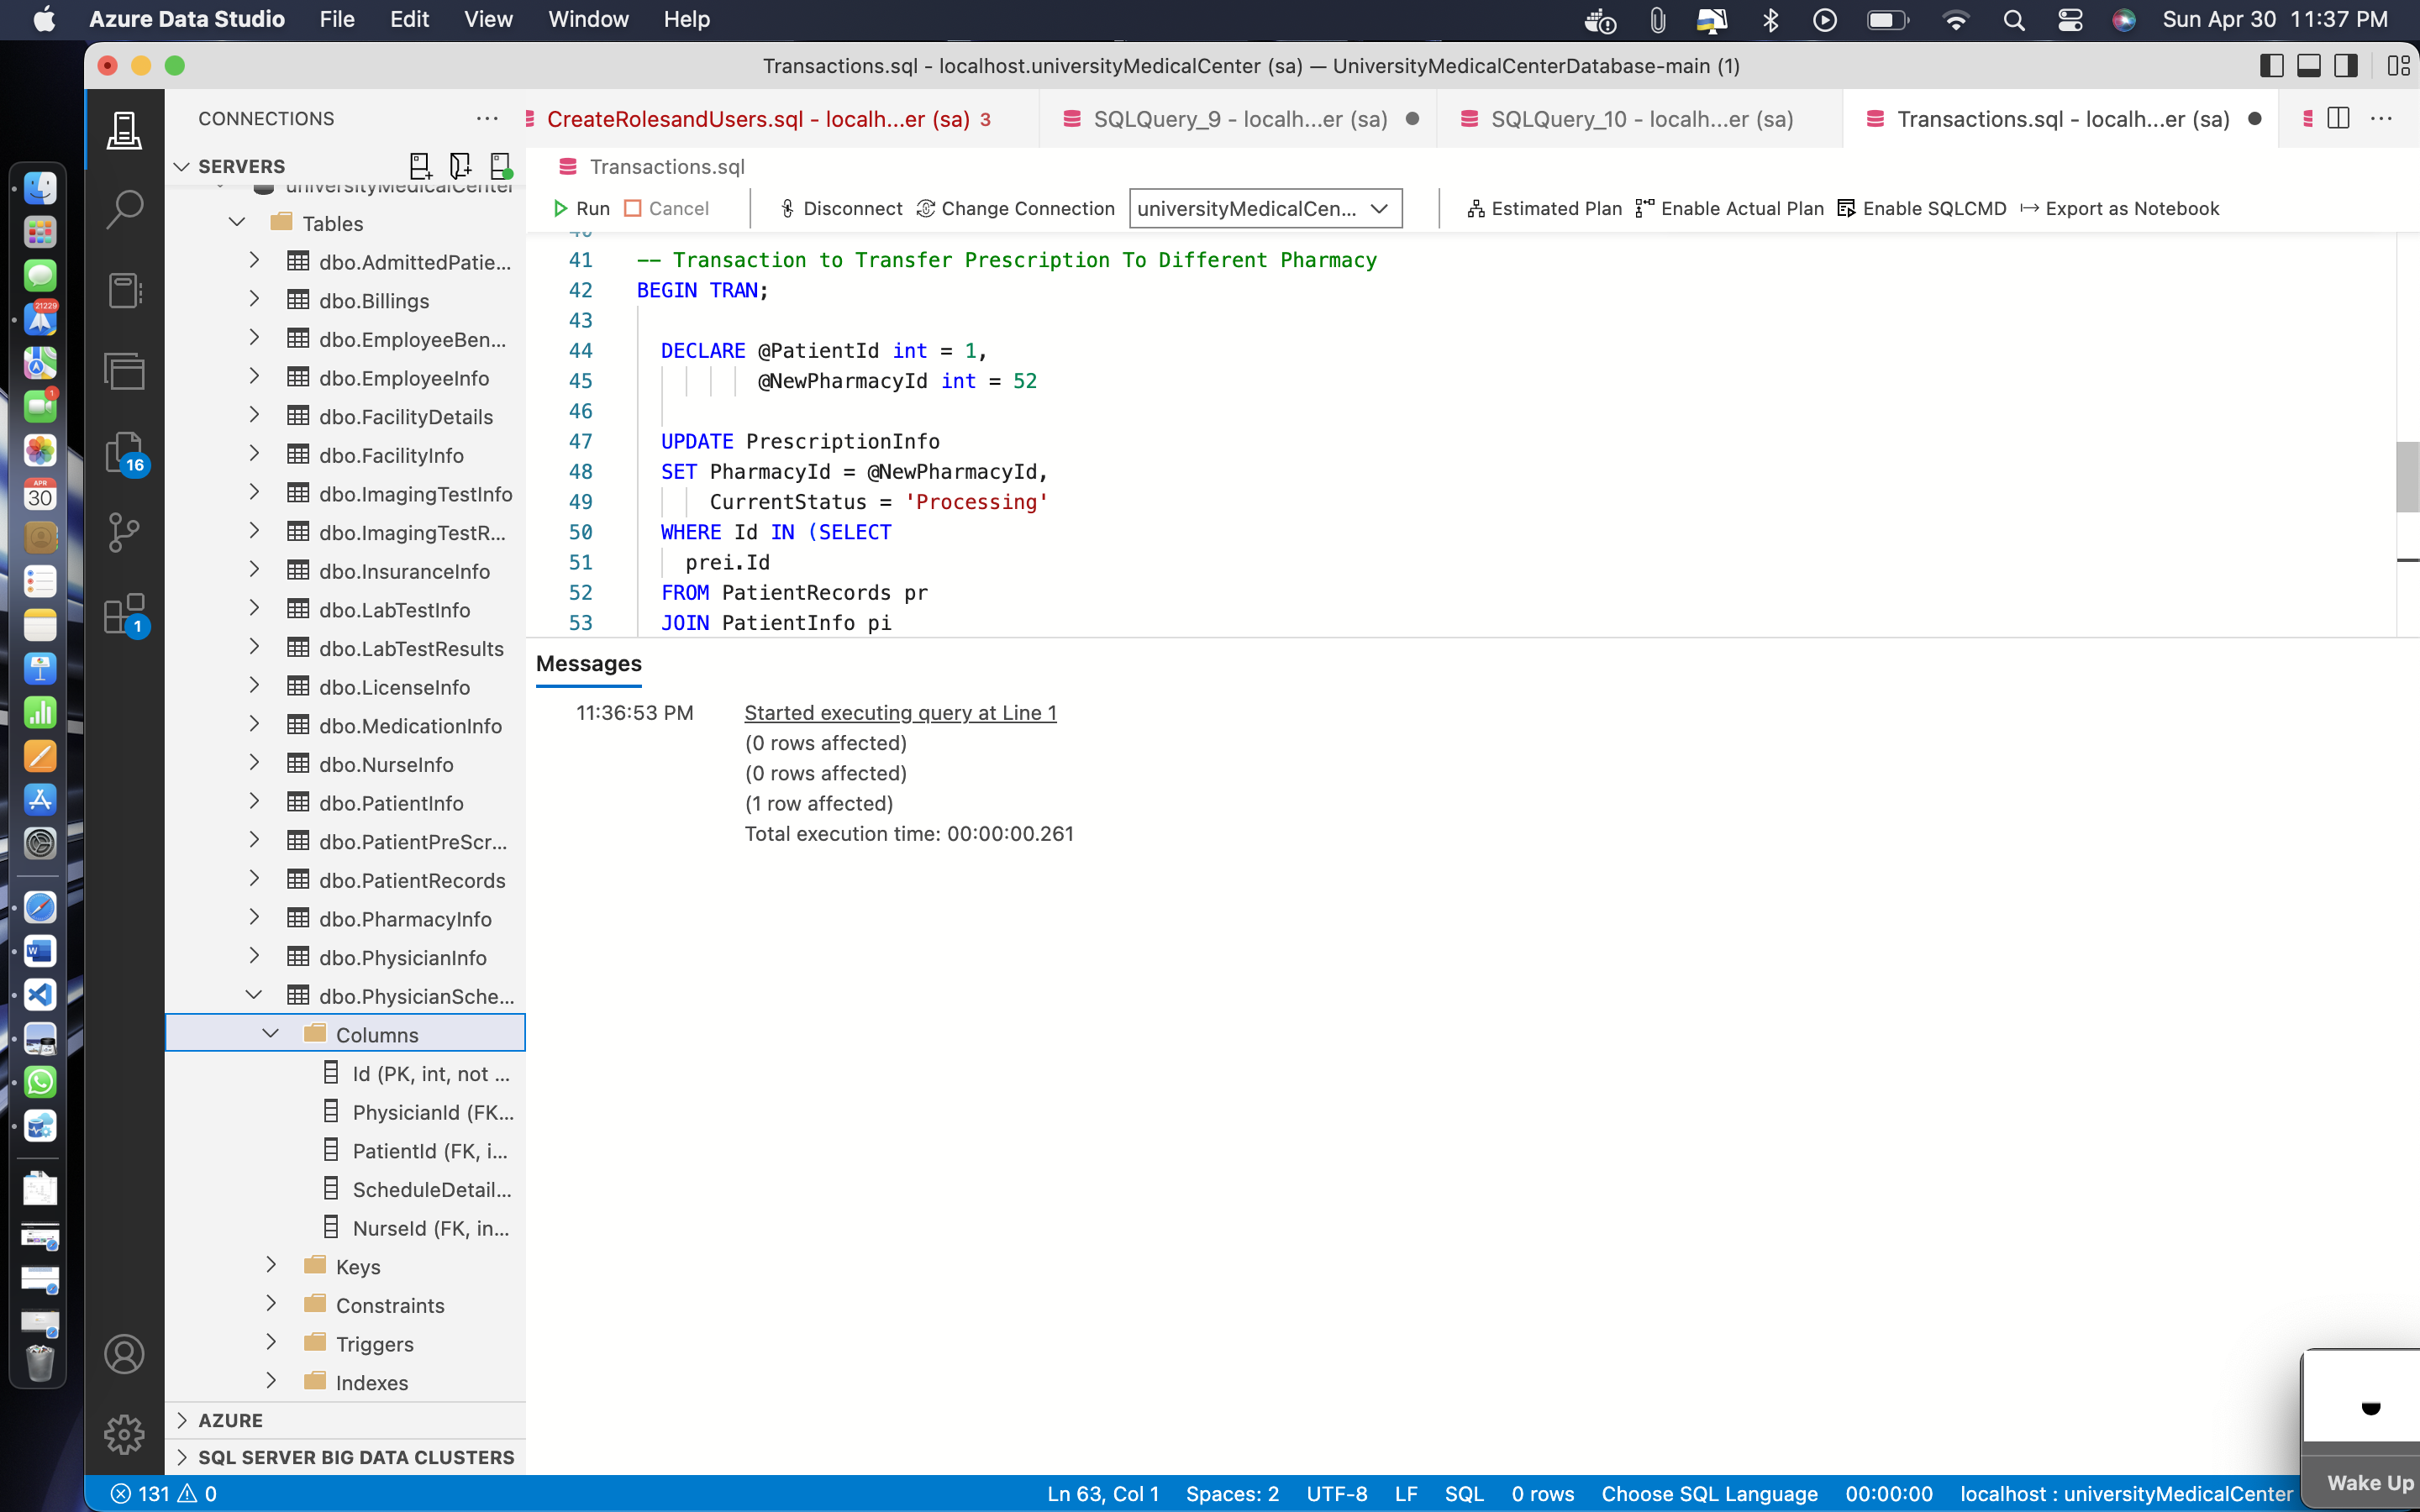

**Remarks: -**

* I have created four transactions here and ran them successfully.
* There is no different code for executing and checking the transaction but the transaction have been ran successfully.
* You can see all the code in screenshot is given above.

BUSINESS REPORT: -

* I have created the business report in powerBI tool.
* I will add the screenshots of the powerBI power report below.

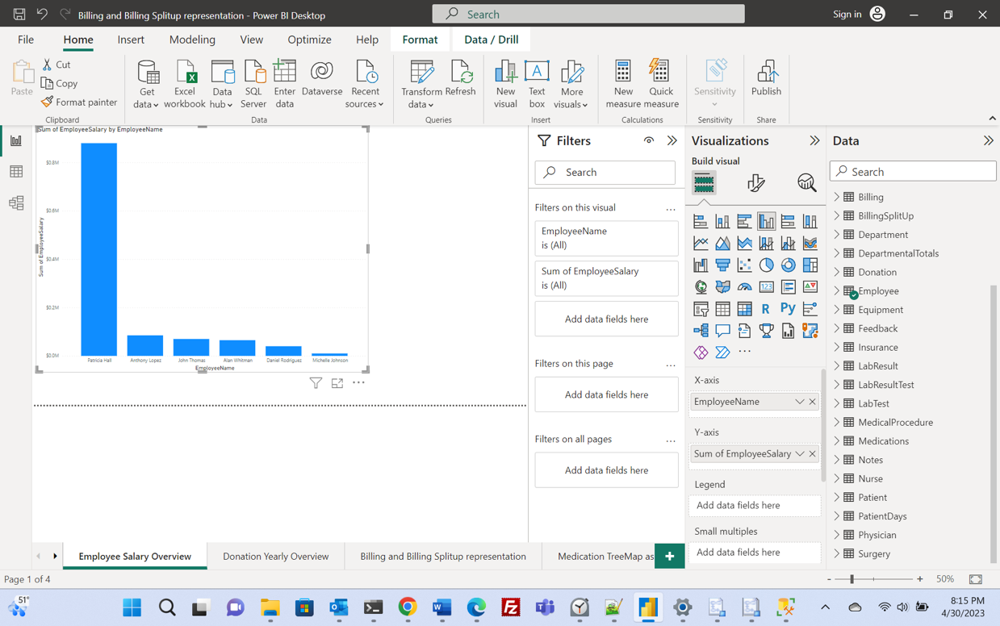

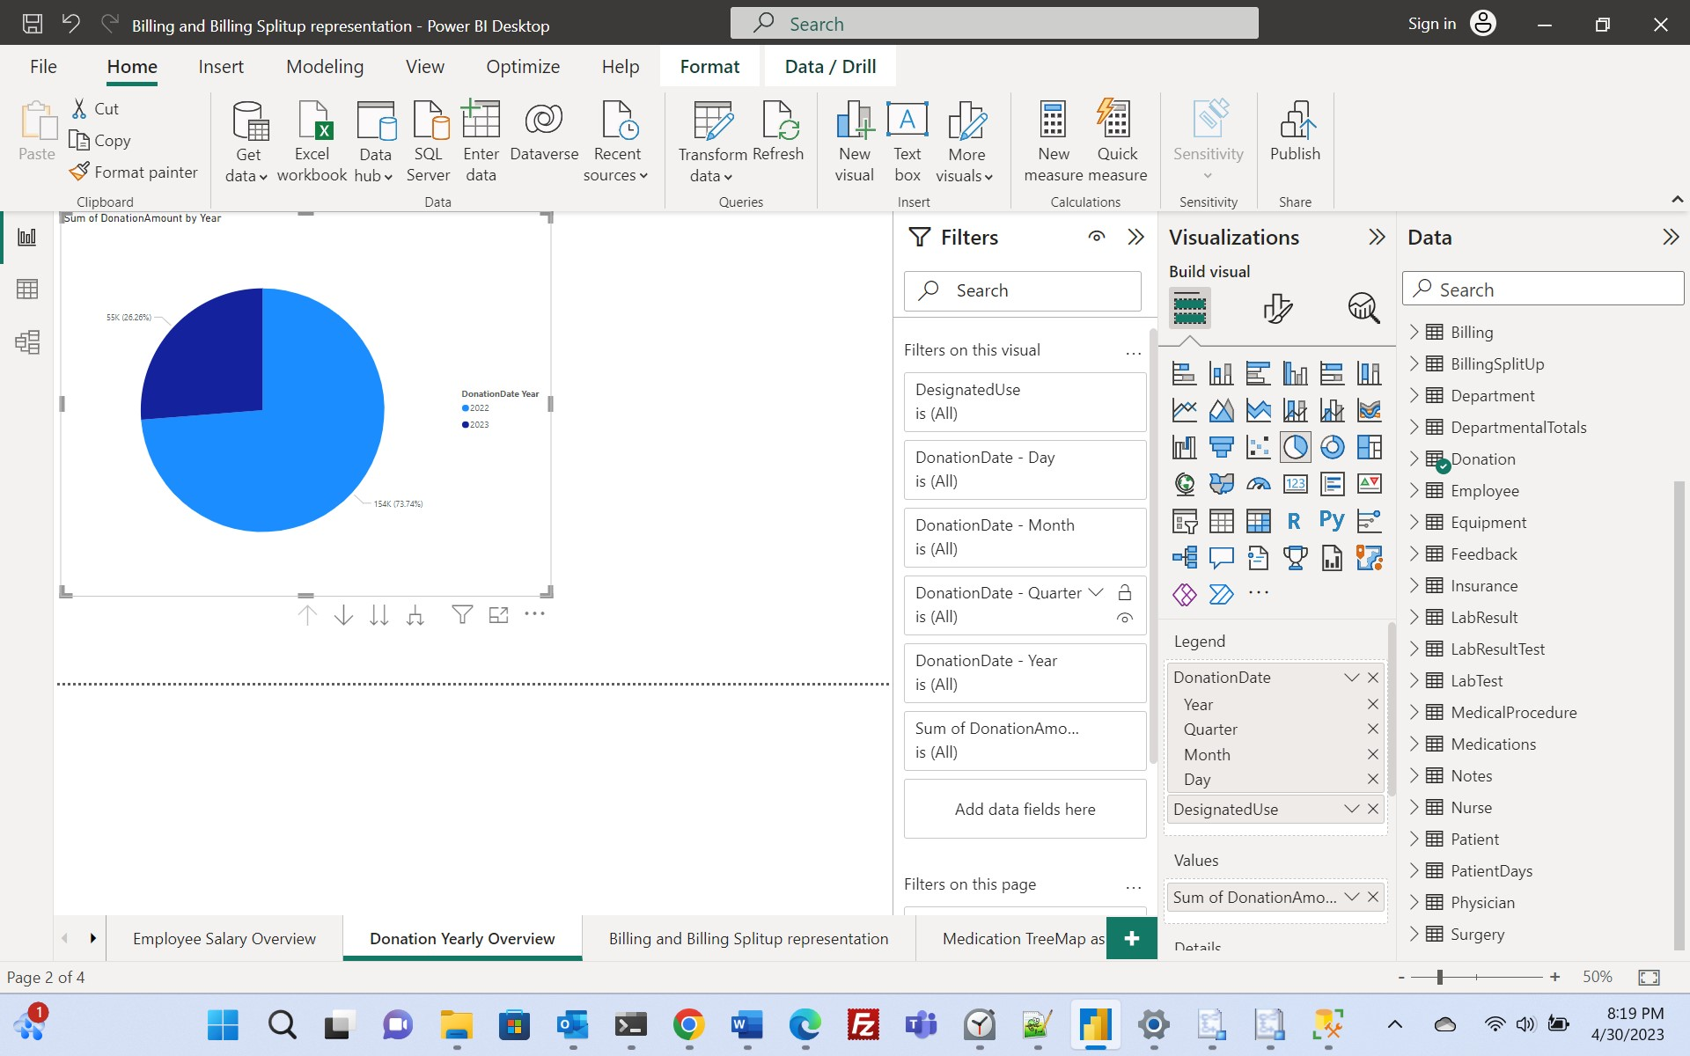

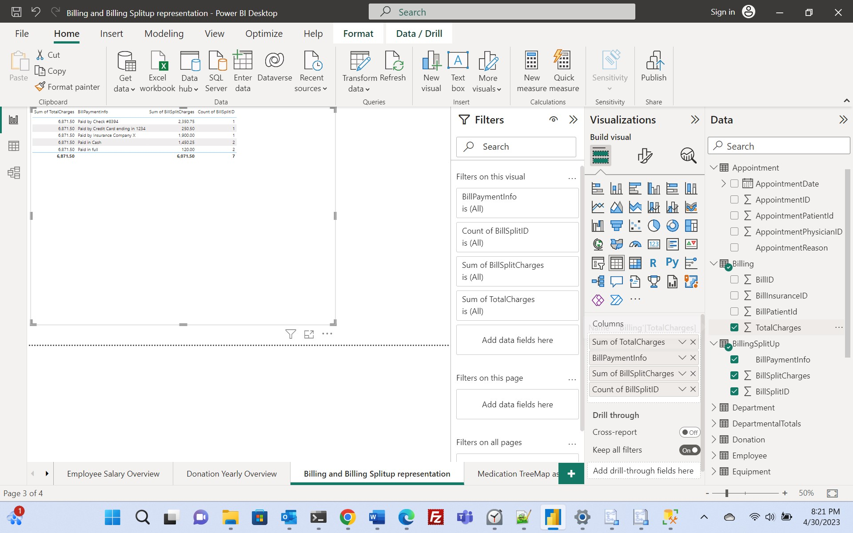

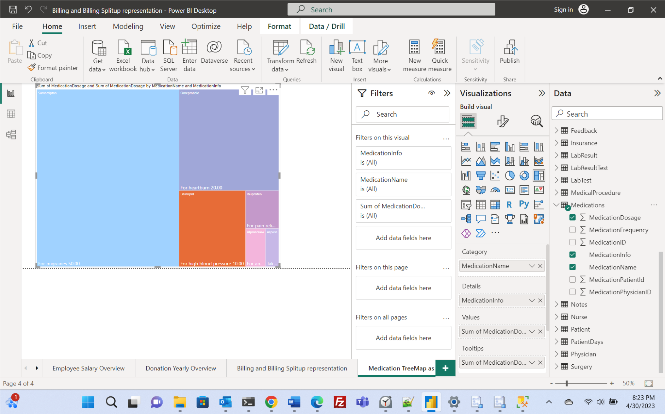

Section: - D

Conclusion

***Conclusion: -***   
  
• Through this project, I gained knowledge on how to create, test, and install a database for a university medical center.

• The project was primarily broken down into three parts, which included constructing the database using an E/R diagram and generating conclusions from it.

• The determination of tables, columns, primary keys, datatypes, nullabilities, and linkages was accomplished during the implementation phase.

• Several business logics and performance and efficiency enhancements were implemented during the testing period.

Apendix: -

This project effectively uses Azure data studio to load and manipulate databases. The following topics are covered: fundamental queries, keywords, statements, operators, joins, subqueries, summary queries, aggregate functions, datatypes, and tables. Insertion, deletion, and updating are all types of data change. The subjects addressed include views, scripts, scalar and table valued functions, database implementation, and others. Additionally, creating a database using an E-R diagram is a crucial step. The bulk of the important SQL and database principles are the subject of this project.